The second world War and India

- The Second World War broke out in September 1939 when Nazi (Germany) invaded Poland in pursuance of Hitler’s scheme of German expansion.
- The Government of India immediately joined the war without consulting the National Congress or the elected members of the central legislature.
- The Congress leaders demanded that India must be declared free or at least effective power put in Indian hands before it could actively participate in the war. The British Government refused to accept this demand the Congress ordered its ministries to resign.
- In October 1940, Gandhi gave the call for a limited Satyagraha by a few selected individuals.
- By March 1942, Japan quickly overran the Philippines, Indo-China, Indonesia, Malaya, and Burma and occupied Rangoon. This brought the war to India’s door-step.
- The British Government now desperately wanted the active cooperation of Indians in the war effort.

Cripps Mission
- To secure this cooperation, British Government sent to India a mission headed by a Cabinet Minister, Sir Stafford Cripps in March 1942.
- Cripps declared that the aim of British policy in India was "the earliest possible realization of self-government in India," but detailed negotiations between the British Government and the Congress leaders broke down, as the British Government refused to accept the Congress demand for the immediate transfer of effective power to Indians.

Quit India Movement
- The All India Congress Committee met at Bombay on August 8, 1942. It passed the famous 'Quit India' Resolution and proposed the starting of a non-violent mass struggle under Gandhiji’s leadership to achieve this aim.
- Early in the morning of August 9, Gandhiji and other Congress leaders were arrested and the Congress was once again declared illegal.
- The news of these arrests left the country aghast, and a spontaneous movement of protest arose everywhere, giving expression to the pent up anger of the people.
- All over the country there were strikes in factories, schools and colleges, and demonstrations which were lathi-charged and fired upon.
- The Government on its part went all out to crush the 1942 movement. Its repression knew no bounds. The press was completely muzzled. The demonstrating crowds were machine-gunned and even bombed from the air.
- In the end, the Government succeeded in crushing the movement. The Revolt of 1942, as it has been termed, was in fact short-lived.
- After the suppression of the Revolt of 1942, there was hardly any political activity inside the country till the war ended in 1945.
- The established leaders of the national movement were behind the bars, and no new leaders arose to take their place or to give a new lead to the country.
- In 1943, Bengal was plunged into the worst famine in recent history. Within a few months over three million people died because of starvation. There was deep anger among the people for the Government could have pre-vented the famine from taking such a heavy toll of life.

Azad Hind Fauj
- The national movement, however, found a new expression outside the country's frontiers. Subhas Chandra Bose bad escaped from India in March 1941, went the Soviet Union for help. But when the Soviet Union joined the allies in June 1941, he went to Germany.
- In February 1943, Bose left for Japan to organize an armed struggle against British rule with Japanese help.
- In Singapore, Bose formed the Azad Hind Fauj (Indian National Army or INA) to conduct a military campaign for the liberation of India. He was assisted by Rash Behari Bose, an old terrorist revolutionary.
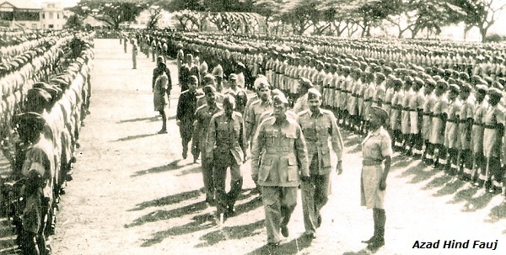
- Before the arrival of Subhash Bose, steps towards the organization of the INA had been taken by General Mohan Singh (at that time, he was a captain of the British Indian army).
- Subhash Bose, who was now called Netaji by the soldiers of the INA, gave his followers the battle cry of 'Jai Hind'.
- The INA joined the Japanese army in its march on India from Burma. Inspired by the aim of freeing their homeland, the soldiers and officers of the INA hoped to enter India as its liberators with Subhash Bose at the head of the Provisional Government of Free India.
- With the collapse of Japan in the War during 1944-45, the INA too met defeat, and Subhash Bose was died in an airplane accident on his way to Tokyo.

