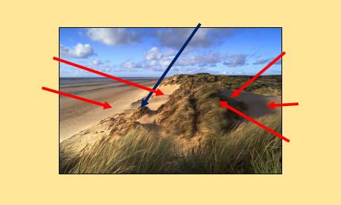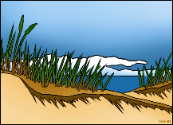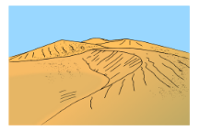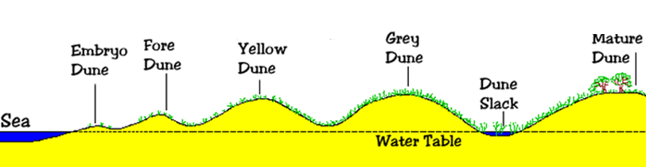

**Example question:** Explain the formation and development of coastal sand dunes (7)

Explain the formation of sand dunes.

Identify the characteristics of sand dunes. Add the characteristics in the correct places.

**Sand Dunes**

**Study the photograph showing sand dunes near Studland, Dorset. Annotate the photograph to show the different characteristics of sand dunes. Explain the formation of sand dunes.**