1989: Earthquake hits San Francisco

Date: October 17, 1989, 5:04 p.m.
Magnitude: 6.9
Dead: 63
Injured: Nearly 3,800
Homeless: Over 12,000 people were made homeless by the earthquake. Some were eventually able to return to their homes following extensive repairs.

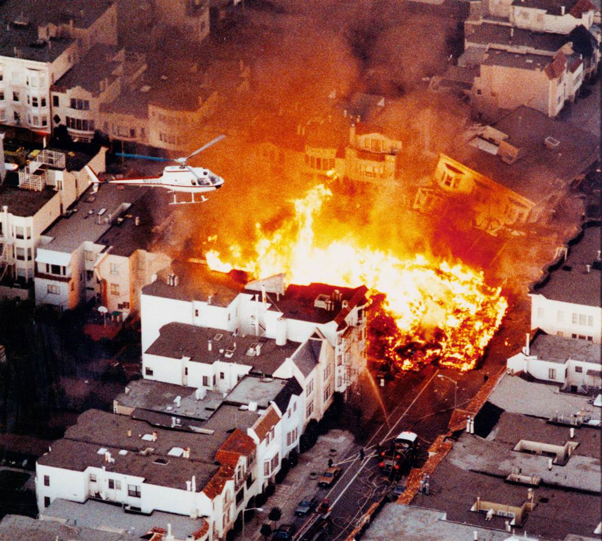
Tremors from the quake, which lasted 15 seconds, were reported 400 miles away in Los Angeles and 200 miles away in Reno, Nevada. The quake struck at 1704 local time as people were making their way home after work. Traffic was brought to a standstill and many homes left without power.
The two-tier Bay Bridge and Nimitz freeway both partially collapsed and rescuers are waiting to rescue people from cars crushed by the quake.

A massive rescue effort is now underway in what experts believe is the second biggest earthquake ever to hit the United States. Officials have reported "unbelievable damage to infrastructure" with collapsed bridges and freeways, fires, shattered buildings, gaping cracks in roads and landslides.

Fans waiting to see the baseball World Series match at Candlestick Park were also caught up in the quake. Supporters ran onto the pitch as the whole stadium swayed.

Hospitals have been flooded with injured victims. Ambulance worker Kimberly Kelly said: "We're getting mainly shock, cuts and shortness of breath."

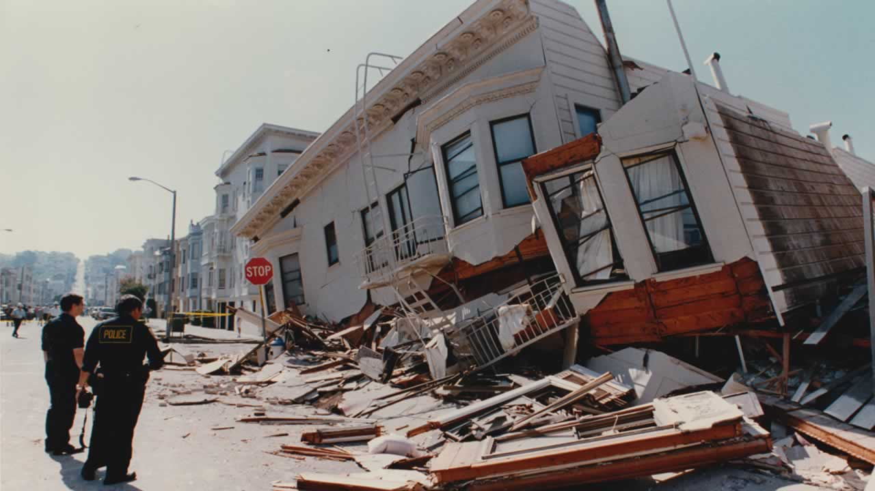
Officials are said to be shocked at the amount of damage as freeways (motorways) and buildings are supposed to be earthquake-proof.

The Governor of California said: "I had been under the impression that the highways had been constructed to deal with any severe earthquake and I am very surprised to see what has happened to some of those. I think we are going to have some kind of inquiry to determine why they did not survive a quake of the severity of this one.
http://news.bbc.co.uk/onthisday/hi/dates/stories/october/17/newsid_2491000/2491211.stm

Glossary

Infrastructure: the basic equipment and structures (such as roads and bridges) that are needed for a country, region, or organization to function properly.

