River landforms revision booklet
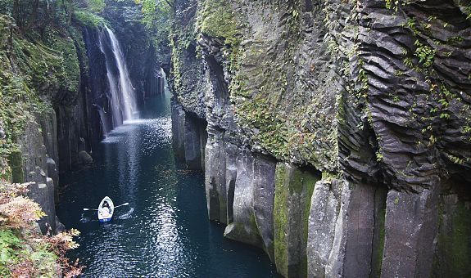

Can you identify the river features/landforms shown below?

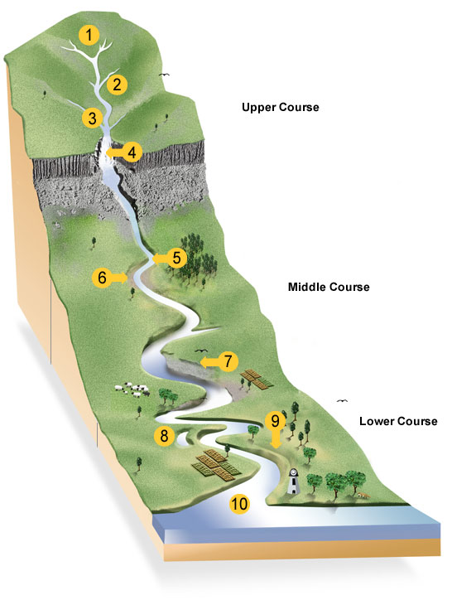

Upper Course River landforms
Upper course river landforms include:
- v-shaped valleys
- interlocking spurs
- waterfalls
- potholes
These are largely landforms of erosion, though there are other processes taking place such as weathering and mass movement.

Exam questions:
With the aid of an annotated diagram/s, explain the formation of a v-shaped valley (4)

__________________________________________________________________________________________________________________________________________________________________________________________________________________________________________________________________________________________________________________________________________________________________________________________________________________________________________________________________________________________________________________________________________________________________________________________________________________________________________________________________________________________________________________________________________________________________________________________________

With the aid of an annotated diagram/s, explain the formation of interlocking spurs (4)

__________________________________________________________________________________________________________________________________________________________________________________________________________________________________________________________________________________________________________________________________________________________________________________________________________________________________________________________________________________________________________________________________________________________________________________________________________________________________________________________________________________________________________________________________________________________________________________________________

With the aid of an annotated diagram/s, explain the formation of a potholes (4)

__________________________________________________________________________________________________________________________________________________________________________________________________________________________________________________________________________________________________________________________________________________________________________________________________________________________________________________________________________________________________________________________________________________________________________________________________________________________________________________________________________________________________________________________________________________________________________________________________

Middle Course River landforms
As the course of a river approaches its middle stages it flows over flatter land. Lateral erosion dominates as the river swings in large bends known as meanders.

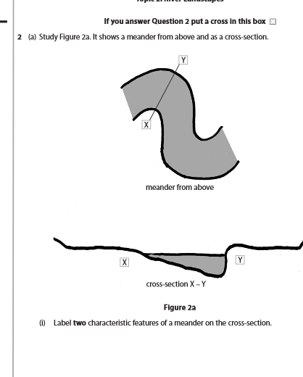

Re-organise these statements to explain the formation of an oxbow lake

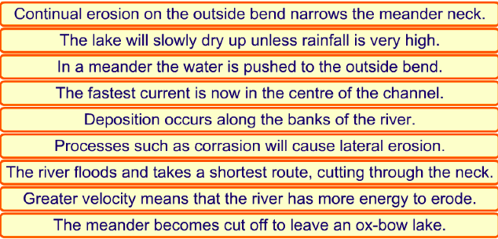

Explain the formation of an ox-bow lake. You may use a diagram(s) in your answer (5)

__________________________________________________________________________________________________________________________________________________________________________________________________________________________________________________________________________________________________________________

Lower Course River landforms
In its lower courses, the river is deep and wide and has a high discharge. During times of river flooding characteristic landforms are created, largely through deposition.

Explain the formation of levees and floodplain. You may use a diagram(s) in your answer (6)

____________________________________________________________________________________________________________________________________________________________________________________________________________________________________________________________________________________________________________________
____________________________________________________________________________________________________________________________________________________________________________________________________________________________________________________________________________________________________________________
____________________________________________________________________________________________________________________________________________________________________________________________________________________________________________________________________________________________________________________

