What questions would the historian now ask?

What can you infer (work out) from this?

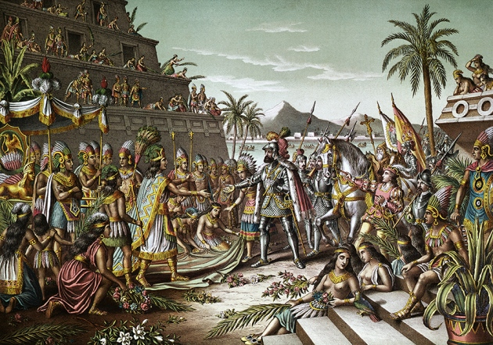
What can you see?

