Revenues

- What is meant by the term Total Revenue.
- How to illustrate Total Revenue.
- Average Revenue
- Marginal Revenue

- What do you understand by the term ‘Total Revenue?’

____________________________________________________________

- How do you calculate Total Revenue?

___________________________________________________________

- Why is revenue not the same thing as profit?

________________________________________________________________________________________________________________________

- Illustrate Total Revenue on the Demand and Supply diagram below.

Quantity Demanded/Supplied
Price

- Using the table below calculate the Total Revenue :-

Price | Sales (Number of units 000’s) | Total Revenue | Average Revenue | Marginal Revenue
22 | 0
20 | 1
18 | 2
16 | 3
14 | 4
12 | 5
10 | 6
8 | 7
6 | 8
4 | 9
2 | 10
0 | 12

- Plot the Total Revenue, Average Revenue and Marginal Revenue on the graph paper.

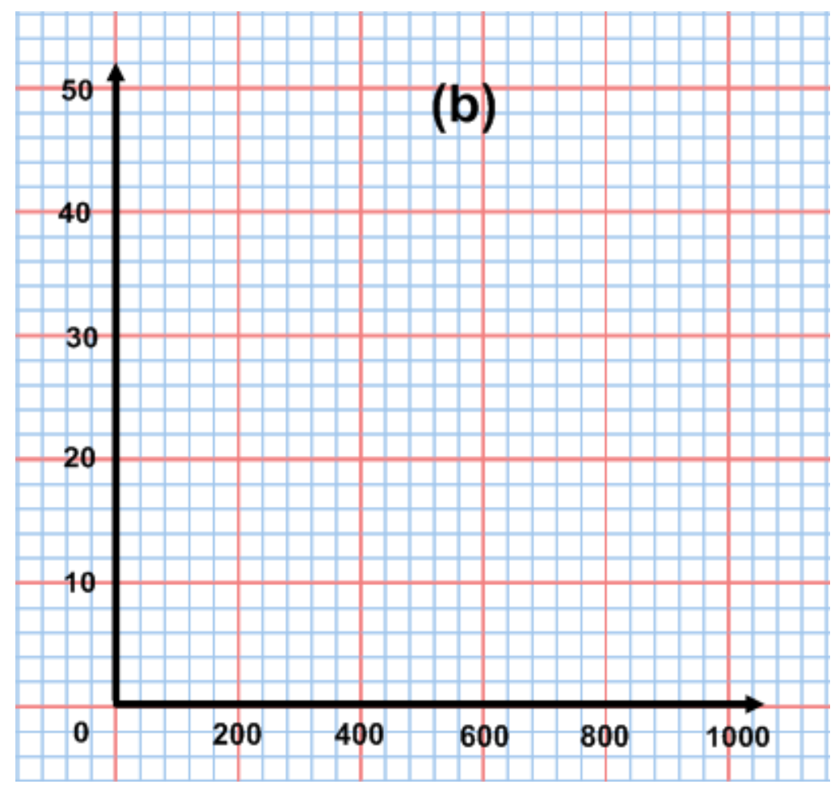

- What do you notice about the Total, Average and Marginal Revenue curves ?

____________________________________________________________________________________________________________________________________________________________________________________

Average and Marginal Revenue

- Average Revenue in imperfectly competitive markets
- Marginal Revenue in imperfectly competitive markets

- What do you understand by the term ‘Average Revenue’?

________________________________________________________________________________________________________________________
- What do you understand by the term ‘Marginal Revenue’?

________________________________________________________________________________________________________________________
  - What do you notice about the Marginal Revenue Curve with respect to the Average Revenue Curve?

____________________________________________________________________________________________________________________
- The Average Revenue curve is also called the :-

_________________________________________________________

- Why is the mid-point of the Average Revenue curve significant in the case of imperfectly competitive markets (hint: elasticities)?

____________________________________________________________________________________________________________________
- On the diagram below sketch the three curves and identify the elasticities of demand on the AR curve.

Output
Average,
Marginal,Total
Revenue

- Average Revenue in perfectly competitive markets
- Marginal Revenue in perfectly competitive markets

Price | Sales (Number of units 00’s) | Total Revenue | Average Revenue | Marginal Revenue
5 | 0
5 | 1
5 | 2
5 | 3
5 | 4
5 | 5
5 | 6
5 | 7
5 | 8
5 | 9

Price Elasticity of Demand

Price | Sales (Number of units 00’s) | Total Revenue | Average Revenue | Marginal Revenue | PED  Value
20 | 1
18 | 2
16 | 3
14 | 4
12 | 5
10 | 6
8 | 7
6 | 8
4 | 9

In the elastic region of the demand curve, as price falls, total revenue______________________

In the inelastic region of the demand curve, as price falls, total revenue______________________

Total revenue is maximised when PED is equal to _______ and where marginal revenue is _____________

- What is the value of Price Elasticity of Demand on the top half of the demand curve (Average Revenue curve).

_______________________________________________________

- What will happen to Total Revenue if you reduce prices?

_______________________________________________________

- What will happen to the Total Revenue if you raise prices?

_______________________________________________________

- What is the value of Price Elasticity of Demand on the bottom part of the demand curve?

_______________________________________________________

- What will happen if you reduce prices?

_______________________________________________________

- What will happen if you increase prices?

_________________________________________________________

