Religion in India
Polytheistic Religion
Polytheism, the belief in many gods. Polytheism characterizes virtually all religions other than Judaism, Christianity, and Islam, which share a common tradition of monotheism, the belief in one God.

Religious sensitivities and tensions run through the entire history of colonial India and beyond. Religion is also a key motivating factor in the subsequent development of a nationalist movement.
The relations between religious groups are referred to as communal politics.
Communal Politics - The use of religion in politics, where one religion is shown as superior to other religions is called communal politics. Here, one religious group is against the other religious group and the demands of one religious group are against the demands of the other religious group. Communal politics is based on the idea that religion is the only basis of forming a community. In an extreme case of communalism, it follows that people from different religions are not equal citizens and cannot live together within one nation, which leads to partition of that country

The three basic premises are:
(1) Belief that people who follow the same religion has common political, economic, cultural and social interests,
(2) Belief in a notion that in a multi-religious society like India, the common interests of the followers of one religion are dissimilar and divergent from the interests of the followers of another religion, and
(3) Belief that the interests of the followers of different religions or different communities are seen to be mutually incompatible, antagonistic and hostile”.

Hindus were the predominant Indian religious group with significant groups of Muslims and Sikhs in particular regions.

Hindu Religion
The Hindu religion is one of the oldest in the world. It is difficult to provide adequate history of Hinduism because it has no specific founder or theology. The development of this religion was influenced when light-skinned nomadic Aryan Indo-European tribes invaded Northern India BC from Russia and Central Asia attacking the Harappan people who lived there in 1500. The word, Hinduism, comes from the word, Indus, which is the name of an Indian River that existed about 5000 years ago.

The Caste System
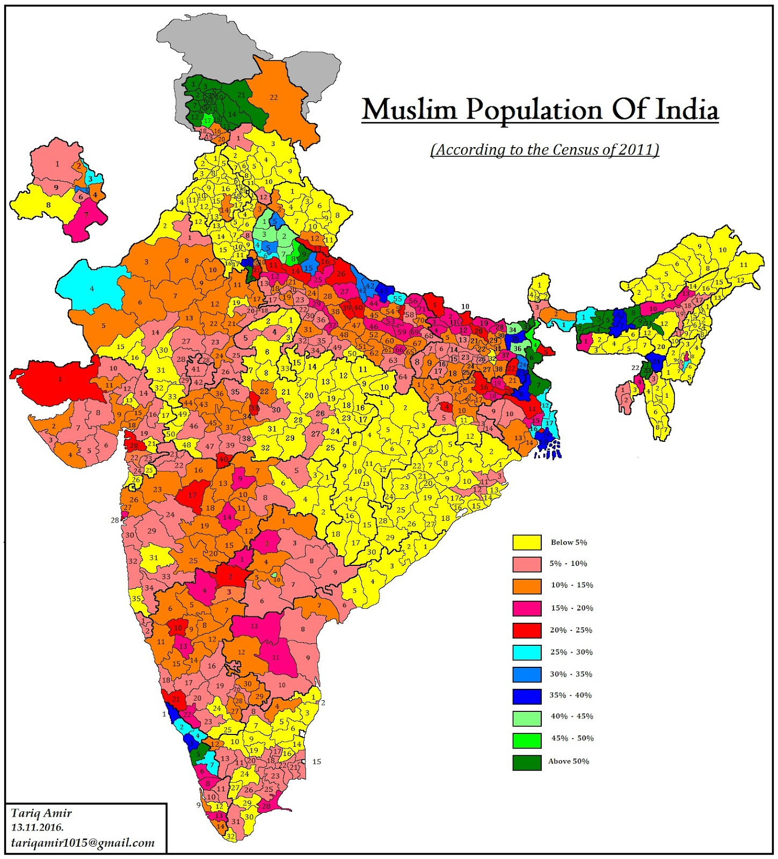
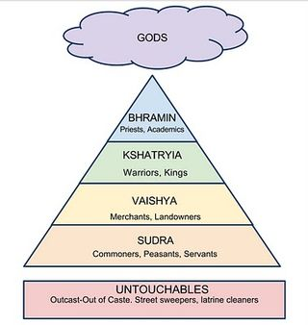
The Aryan group developed what is called the caste system, which ranked society according to occupational class. That system is as follows: Brahmins are priests; Kshatriyas are soldiers, king-warrior class; Vaishyas are merchants, farmers, Sutras laborers and craftspeople; Harijahns are "untouchables" -- those thought to be descended from the Harappan aboriginal people who are extremely poor and discriminated against. Caste membership was largely determined by birth and determined what occupations people could have, who one could marry and even the extent that one might appear in public. The higher the person's caste, the more the person is blessed with the benefits and luxuries of life. The system was outlawed in 1948, but it is still important to the Hindu people and recognized as the proper way to categorize society.

Islam arrived in India mainly from the north west, modern day Pakistan and Afghanistan. Turkic invasions from the 12th to 16th centuries resulted in the Mughal Dynasty who ruled a united India up to 1707 when it began to decline, shrinking into a small state, finally ending in the 19th century following the arrival of the British.

In the 16th century, in the Punjab region a fusion of Hinduism and Islam appeared in the form of Sikhism. Overtime Punjab became Sikh and Muslim with almost no Hindus. In Punjab and Bengal many people converted to Islam to escape the low status in the caste system – in Islam a greater emphasis on the equality of believers was attractive to low status Hindus and the area became predominately Muslim.

In the 19th century, India was fighting the British in a war of ideas. One battle was over religion: Christian missionaries believed it was their sacred duty to convert all Indians. Another was over colonialism: the British were ruling India by military force, supported by the idea that they were a superior race. Many thinkers and activists, key among them Swami Vivekananda and Mahatma Gandhi, challenged these ideas. Today nearly all colonies have been freed. Few countries, if any, would claim a moral right to colonize another. But religious conflict remains a crucial issue. Vivekananda’s teaching of equal respect for all religions is more relevant today than ever before.
A Young Monk with a Message of Tolerance
The story of Swami Vivekananda (1863–1902) starts with a temple priest named Sri Ramakrishna (1836-1886) who lived near Calcutta. He was a mystic, a person who had visions of God and many profound spiritual experiences. Though not formally educated, he attracted followers from the city’s prominent families. One was an 18-year-old college student named Narendranath Dutta. When they first met, Narendra asked Ramakrishna why he believed in God. Ramakrishna replied, “Because I see Him just as I see you here, only in a much more intense sense.” Narendra took Ramakrishna as his guru and was trained by him for the next five years.
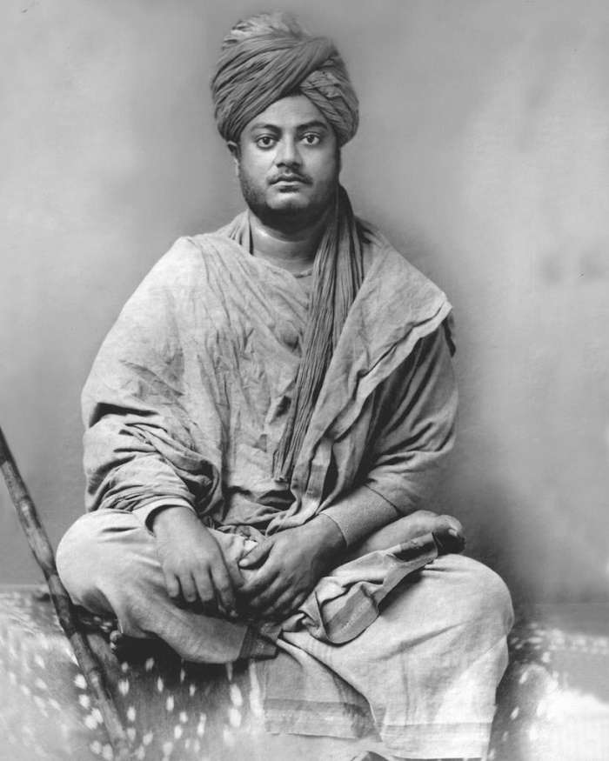
After Ramakrishna’s death, Narendra took vows as a Hindu monk, becoming Swami Vive- kananda. He gave up his further education and instead set off on pilgrimage across India. He deeply impressed many people in Madras. They raised money door to door to pay for his travel to America for the 1893 Parliament of the World’s Religions.
At that interfaith congress in Chicago, the cultured and eloquent 30-year-old swami was well received. In his opening talk, he declared,
“We believe not only in universal toleration, but we accept all religions to be true.” The popularity of this Hindu message of respect and tolerance alarmed some Christian participants who had hoped the Parliament would prove their religion superior to others.
The New York Herald reported at the time, “Vivekananda is undoubtedly the greatest guru in the Parliament of Religions. After hearing him, we feel how foolish it is to send missionaries to this learned nation.” Another reporter wrote, “The impertinence of sending half- educated theological students to instruct the wise and erudite Orientals was never brought home to an English-speaking audience more forcibly.”
Vivekananda returned to India a hero. He aroused a new pride among Hindus and kindled in India’s youth a nationalist spirit. Vivekananda founded the Ramakrishna Mission as a religious and educational institution to address India’s social problems. He died on July 4, 1902, at age 39. Freedom fighter Subhash Chandra Bose aptly called Swami “the maker of modern India.”
Vivekananda was not the first Indian religious and social reformer of the 19th century. Raja Ram Mohan Roy sought to counter the criticisms of Hinduism made by the British missionaries. He founded the Brahmo Samaj in 1828 as a new religion with Christian-style services. Swami Dayananda Saraswati was a Hindu traditionalist. He began the Arya Samaj in 1875 to revive Vedic society and religion. He believed Hinduism could be purified by a return to the teachings and practices of the Vedas. Both the Brahmo Samaj and Arya Samaj encouraged Indians to be egalitarian and do more social service for the poor.
Vivekananda, on the other hand, had a powerful impact both on India and the West. In particular, he introduced the Hindu idea that all religions deserve respect as valid paths to God, an idea now firmly established in the west.

