Quantitative Calculations: Tariffs

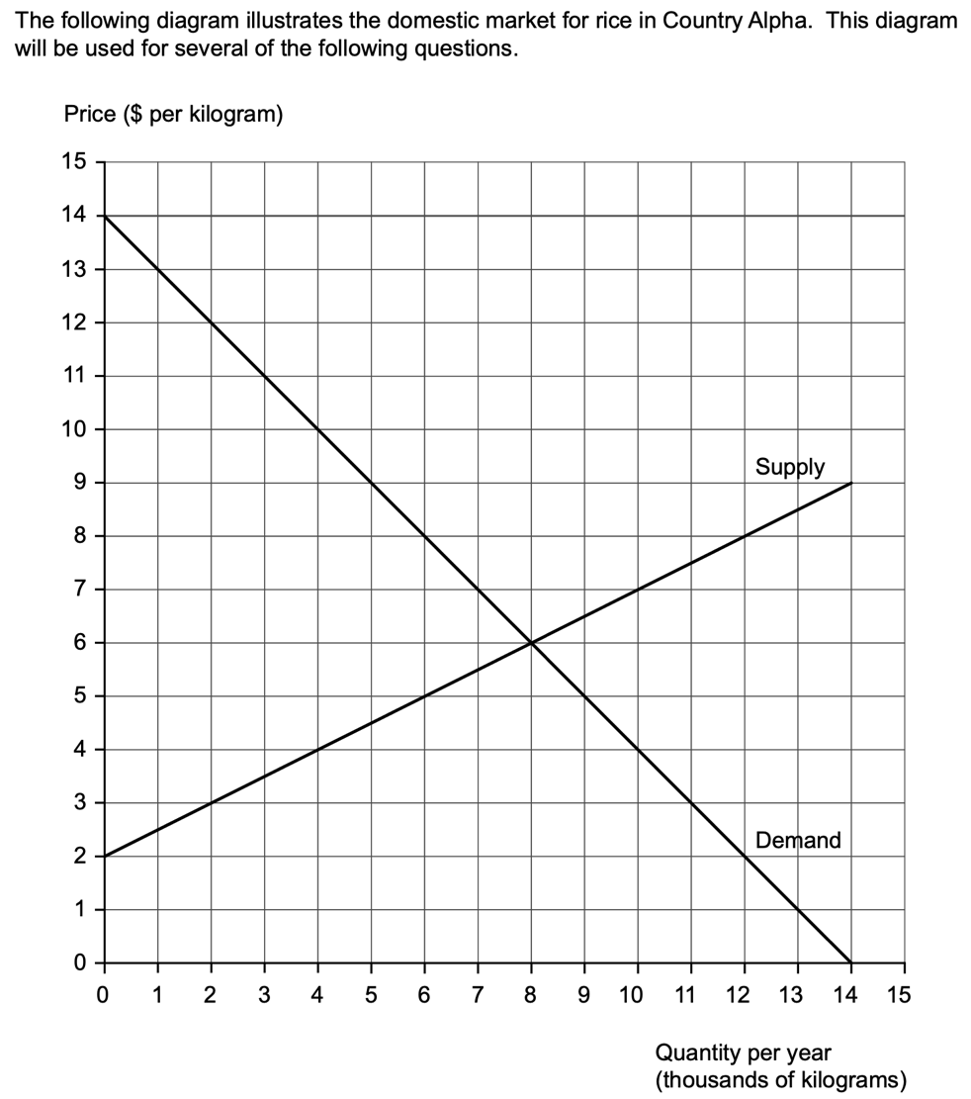

- Label the domestic demand and supply curve for country Alpha (1).
- Identify the equilibrium price and quantity before trade (1).
- Country Alpha opens to international trade, the world supply price for rice is $3, identify the new equilibrium quantity demanded and domestic supply (1).
- The government introduces a $2 tariff on imports to all rice. Draw the new world supply curve (1).
- Calculate the change in expenditure by consumers after the tariff (1).
- Calculate the change in imports after the introduction of the tariff (1).
- Calculate the change in producer revenue after the introduction of the Tariff (1).
- Calculate the change in consumer surplus after the tariff (1).
- Calculate the deadweight/welfare loss following the introduction of the tariff (1).
- Calculate the government revenue from the tariff (1).
- Discuss the consequences of tariffs on different stakeholders (8).

