Paper I | Prescribed Subject 4: Rights and Protests  South Africa: Protests and Action

People did not sit by and let apartheid happen. There were many acts of protest and civil disobedience to stand up to the government. The following events will be focused on in this section:
- The Defiance Campaign
- The Bantu Education Boycott
- The Congress of the People and Freedom Charter/The Treason Trial
- Bus Boycotts
- Sharpeville Massacre
- The Rivonia Trial
- International Movements and the UN

The Defiance Campaign
The African National Congress saw a revival in activity after during the WWII. The South African industry boomed and brought many Africans into the cities to take manufacturing jobs which led to the creation of new trade unions. Under the guidance of the Communist Party, many of the trade unions were also affiliated with the ANC. The ANC began to acknowledge to potential of the Black working class. In 1944 the ANC also created the ANC Youth League with Anton Lembede as its president. Leading members included Walter Sisulu, Oliver Tambo and Nelson Mandela. The Youth League rejected the cautious approach of former years and embraced a more assertive strategy. No longer would the ANC try to negotiate from a position of weakness. They could not depend on the goodwill of politicians but had to look to themselves for liberation. Nelson Mandela stated, “The ANC was not going to rely on a change of heart. It was going to exert pressure to compel the authorities to grant its demands.”
The ANC began to create links to squatters groups, community organizations, trade unions, and other opposition groups. They created a Radical Program of Action that called for mass trikes and other acts of defiance against the authorities. By 1948, the ANC was a different movement than it had been previously. It now stood in a stronger position of power to fight against the upcoming apartheid system. In 1949 the Youth League created a successful coup against the old leadership and officially adopted the Program of Action. This led to a spike in membership.
The ANC began to be regarded as a legitimate voice of Africans. They announced a series of One Day Strikes after the new apartheid laws were passed and a “May Day Stay at Home” event. About half of the Black workers in Johannesburg refused to go to work. This would also be a lesson in the repression the government would use against them, as armed police shot at protesters, killing 18. One Day Strikes called at short notice would be a weapon of choice for the ANC, however by 1952 it became obvious that strikes were not creating the results they wanted. It was clear that apartheid was different and much more extreme than the segregation of the past. The NP government was dismissive of African opinion and was determined to repress any opposition to their policies. The ANC risked losing credibility from the masses if they were incapable of providing an effective response. A more coordinated strategy was needed that culminated in the Defiance Campaign.

The Defiance Campaign marked a shift towards a more radical phase in the struggle against White minority rule, and encompassed the strategies of the Program of Action. The Defiance Campaign’s purpose was to put pressure on the government to force the repeal of apartheid laws. This was to be done by:
- Harness the political potential of mass support against apartheid laws by having ANC leaders & volunteers deliberately break the laws while onlookers provided support
- Nonviolent civil disobedience would sharply contrast with the violent repression they met from the government garnering international publicity as the world watched as many Africans were thrown in jail.
- South Africa’s prisons would be filled with nonviolent protesters, pushing the courts and prisons to the breaking point
- Other racial groups would get involved in the struggle against apartheid through a coordinating the Defiance Campaign with the South African Indian Congress and activists from other communities.

The impetus for the Defiance Campaign came from the NP organized tercentenary commemoration of Jan van Riebeeck’s landing at the Cape in 1652 (the first time a White man came to South Africa). Afrikaners celebrated across the South Africa in nationalist triumphalism. The ANC responded by organizing mass rallies in a number of major cities on that day. The success of how many attended inspired the ANC to take advantage of the popular anger against apartheid. A joint action committee of activists from the ANC, Indian, Coloured and White communities called for a national campaign of civil disobedience. This led to the creation of the National Action Committee (NAC) which consisted of members from:
- ANC
- South African Indian Congress (SAIC)
- Franchise Action Council (FRAC) - a Coloured organization
A Nationals Volunteers Board was created to coordinate the protests and Nelson Mandela was appointed the “volunteer in chief” as well as the chairman for the NAC and NVB.
The Defiance Campaign was officially set to begin on June 26th. This was the second anniversary of the Day of Protest. The goal was to repeal six unjust laws that had been introduced:
- Pass Laws Act
- Group Areas Act
- Suppression of Communism Act
- Bantu Authorities Act
- Separate representation of Voters Act
- Stock Limitation Act (forced Africans to cull (limit the number) their cattle & was an attempt to bring in rural Africans)
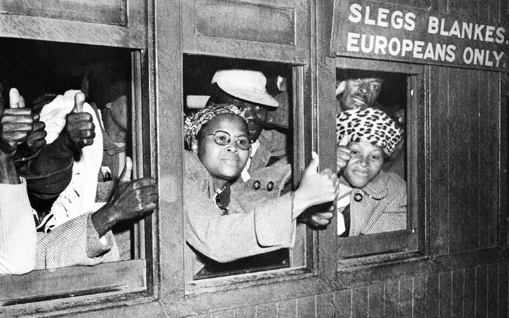
Acts of civil disobedience were to coincide with general strikes in the hopes that it would bring the apartheid state to its knees and force its leaders to negotiate with the ANC. It began with small groups of volunteers including Nelson Mandela, Walter Sisulu, Yusuf Dadoo, Moses Kotane, and JB Marks deliberately defying apartheid laws in full view of the police while onlookers cheered. The protests were good natured as freedom songs were sung and political slogans shouted (Mayibuye! Let it return! To which the crowds responded Afrika!). As protesters were arrested they gave their supporters the thumbs up sign that became a signature of the campaign. When sentenced they would chant, “Hey, Malan (leader) Open the jail doors, we want to enter.” Other acts of defiance included burning/damaging pass books, using segregated amenities and White- only entrances, illegally entering Whites-only suburbs without the required passes and remaining in Whites-only areas after curfew. The jail time for the first offence was usually a day or two, which led to many to repeat their offense and go back to jail. Volunteers who were closely involved in the organization would attend act of defiance as onlookers to avoid rearrest and longer prison sentences.
The Campaign soon spread to other cities and smaller towns. The public response was positive. Large numbers of Blacks and Indians were involved as volunteers and supporters of the defiers. Smaller support came from Coloured and White communities. ANC membership grew rapidly from 20,000 to 100,000. Women were a strong element in the success and growth of the movement. Many protesters were female and the ANC Women’s League was at the forefront of organizing acts of defiance. There was also a group of White women, called the Black Sash who supported the campaign with enthusiasm.
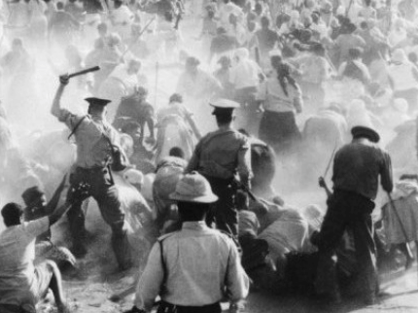
The Defiance Campaign peaked in July and August of 1952, totaling around 8,300 arrested. However, in October 1952 a riot broke out in the Eastern Cape and spread to Kimberley and Johannesburg. The risk that he ANC ran by using mass anger began to turn peaceful protests into violence. This defeated their purpose of civil disobedience and provided the government with an excuse to use force to crush them. And they did. In March 1953, the Criminal Amendment Act allowed courts to hand down longer sentences and whipping as punishment for “offences committed by way of protest”. They also issued banning orders against organizers using the Suppression of Communism Act. This prevented ANC leaders from meeting and coordinating future actions. Faced with harsher punishments and the rioting, the ANC wound down the Defiance Campaign.
Was the Defiance Campaign a success or failure?
The Defiance Campaign
Success | Failure
- It was the 1st time the ANC coordinated an extended national campaign against apartheid proving the leadership was disciplined and capable  - The mass action showed thousands were ready to be involved in the struggle as volunteers and supporters, which set the stage for a true mass movement.  - A broad coalition of interest groups worked together from communists, unions, Indian groups and women’s groups  - Very few opposed the campaign, and even more conservative members came out to support it  - The event gave the ANC national and international publicity that brought about world attention.  ….It can be argued the failures in the next column were necessary for the young ANC to learn important lessons from. The brutality of the government revealed the moral bankruptcy of apartheid to the international community and led to the creation in 1953 of the United Nations Commission on the Racial Situation in the Union of South Africa. | - The ANC failed to get the 6 laws repealed  - The government created an even stronger more repressive response to opposition (Criminal Law Amendment and Public Safety Act)  - Rural areas were hardly involved (except Ciskei) - Most support came from ANC supported cities  - The general strikes that would cripple the South African economy never happened  - Most who participated were middle class Black, poor and rural Blacks didn’t play a significant role showing there was much more work needed to create a truly mass movement  - White community mostly viewed it with hostility and as a revolutionary challenge to their interests (privileges) especially after the rioting  - English press was unsympathetic and some liberal Whites began to distance themselves from a campaign they began to see was radical and confrontational.  - In 1953 the NP won a sweeping election victory, showing they had not been weakened.

The Bantu Education Boycott

As was discussed in the previous handout (Nature & Characteristics of Discrimination) the Bantu Education systems that was set up under apartheid was extremely unequal and disadvantaged Black students. It had limited academic content and taught the bare basics in reading and math. Its goal was to prepare Black students for a life of servitude, not to enrich their minds and encourage critical thinking. While it focused on tribal identity, it wasn’t meant to foster a strong identity, but rather to keep Black Africans divided so that they could share a common experience and find unity. The government threatened to shut down any school that didn’t comply and cut funding to the missionary schools if they refused to follow orders. This led many missionary schools (who provided a better education in most instances) to shut down.
The ANC announced a permanent boycott of the new system, but they lacked the resources to provide a credible educational alternative. The boycott began in April 1995 with marginal success. Verwoerd (leader of South Africa) threatened to shut down any school that supported the boycott and permanently exclude any child who did not attend school (any child who participated in the boycott). This had the obvious effect of scaring parents so that they didn’t take part. However, the ANC response did scare Verwoerd enough to order the new syllabus to be rewritten to tone down the emphasis on tribalism. The ANC faced the choice of accepting a poor education or none at all. The only option was to end the boycott.

The Congress of the People (COP) and the Freedom Charter

The COP was an alliance of anti-apartheid movements that converged in 1955. Their purpose was to:
- Unite a single popular front of all South Africa’s racial groups in the fight against apartheid
- Expand the membership & social base of the ANC by direct involvement of poorer Africans in the COP and turn it into a truly mass movement
- Draft a Freedom Charter for the COP to outline their political goals
- Consolidate the ANC strategy of working together with other parties, including Coloureds, who had been mostly excluded from the Defiance Campaign.
The COP was first proposed by Professor ZK Matthews to ANC president Chief Luthuli. The COP would represents all races in South Africa. Millions of ordinary South Africans would contribute to the Freedom Charter. Professor Mathews proposed ideas at the Cape provincial congress and were adopted later that year. The plan for the COP was endorsed by the SAIC, the Coloured People’s Congress, the South African Communist Party, the South African Congress of Democrats (White left-wing activists) the South African Congress of Trade Unions to create Congress Alliance. Representatives agreed to establish a National Action Council (NAC) to organize the COP. The NAC would recruit “freedom volunteers” to bring the COP to the masses. The COPs objective was to reach as many South Africans as possible. They hoped this would transform the elitist image of the ANC.
The COP began as a series of meetings, most of which were on a small scale in factories, mining compounds, farms, and homesteads across the country. Their purpose was to raise awareness with volunteers stressing that all Black South Africans should be involved in the struggle by registering as ANC members and join in acts of protest. These meetings also recorded the grievances of the people and collected their signatures for the Million Signatures Campaign. Committees incorporated the suggestions of these millions into the official draft of the Freedom Charter.
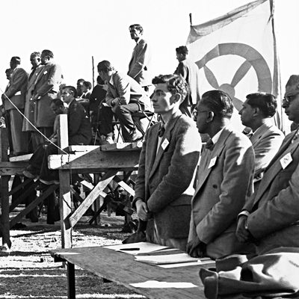
A mass meeting was scheduled for June 25th-26th at the football field in Kliptown, south of Johannesburg. Over 2,800 delegates from all over South Africa attended. Many ANC leaders were unable to go because of banning orders, however Nelson Mandela and Walter Sisulu discreetly watched from the sidelines even though they were banned. A statement from Chief Luthuli was read before the Freedom Charter was proclaimed. The Freedom Charter became an iconic document of the freedom struggle. It called for an end to apartheid, democratic elections for a non-racial government, and an equitable distribution of wealth/resources (hmmmm, wonder who put that last part in...Could it be the communists?).
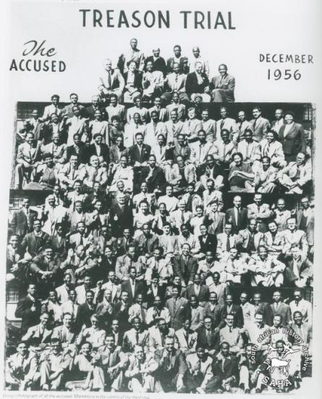
The Freedom Charter was unanimously adopted by the COP. The Kliptown rally however ended in chaos as armed police raided the meeting and took over the speaker’s platform. They arrested several delegates and many documents were seized. The support and success of the COP worried the government who planned to use the documents against the ANC leadership. In 1956, the ANC was preoccupied by legal proceedings in the Treason Trial. The government argued the COP was designed to supplant the Constitution of 1910 that created the Union of South Africa. Their Freedom Charter was the basis for a new constitution, which amounted to treason against the state. The Treason Trial took a toll on the ANC, but the evidence was weak and in 1961 all of the accused were acquitted.

The Bus Boycotts

The bus boycotts were a form of Black protest against South African even before apartheid. 1940 saw the first major boycott, followed by one in 1943 where Nelson Mandela marched 9 miles to the city center of Johannesburg with thousands of other protesters and 1944 saw yet another boycott. The causes of these boycotts were economic, not political. Nor were they planned but rather were a popular reaction to a raise in bus fares. These boycotts were related to the low wages of African Americans and the high unemployment in the townships.
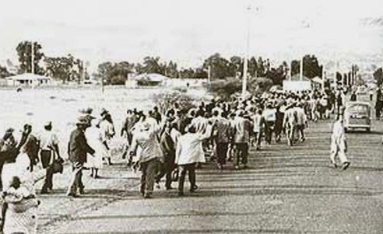
A committee of activists or community representatives usually formed after the boycott began on behalf of the poor. The committees negotiated with the bus companies and coordinated the boycotts, which were well supported by the commuters. In 1944 20,000 boycotted the buses. Unlike other protests, these economic boycotts were often successful. The Johannesburg Chamber of Commerce would typically intervene and persuade the bus companies to rescind their fare increases. This success indicated the power of economics and influenced the various “strikes” organized by the ANC. They were limited though because the ANC couldn’t control when the protests would occur, it was dependent on the decisions of the bus companies.
The most famous was the Alexandra Bus Boycott in January 1957, triggered by the bus company PUTCO when they raised their fares from four to five pence. Hundreds of thousands were involved in this boycott and it found widespread, and often, sympathetic coverage in the White media. The boycotts coincided with a rise on political tensions in the township and nationally. The forced evictions in Sophiatown had spread all over townships across South Africa by 1957. The Minister of Native Affairs had said he wanted to wipe Alexandra off the map, and a series of forced removals ensued. In 1956 the government issued compulsory passes to women that erupted in spontaneous protests.
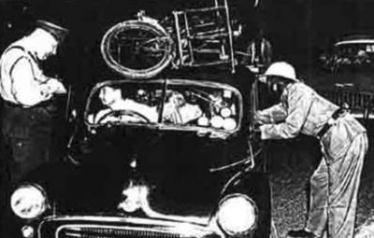
The PUTCO announcement of a penny raise in fares sparked an immediate response from commuters. Before the increase, their annual expense on bus fares amounted to more than a month’s salary. They literally could not afford to pay any more. On January 7th, thousands came out to begin the long trek into the city. The mood was high and people sang freedom songs and cries of “Azikhwelwa!” which is Zulu for “We will not ride!” The boycott spread to Sophiatown and the East Rand, as well as townships in Pretoria. Many joined the boycott even though their routes were not affected by the raise. Other cities initiated their own boycotts in solidarity with Alexandra. Over 70,000 people walked daily for 12 weeks in Alexandra, while thousands others were involved elsewhere, many supporting the weak and elderly.
The police would regularly stop marches and demand to see passes. Often they would puncture bicycle tires. The marchers persisted, even during dangerous thunderstorms. The Alexandra’s People’s Transport Action Committee (APTAC) coordinated the actions of the boycotters and presented their demands to PUTCO & the government. The ANC was represented with Oliver Tambo and Alfred Nzo as leaders. Initially it was nonpolitical, but as the boycott progressed, they became increasingly confident. The Johannesburg Chamber of Commerce felt obligated to intervene. A deal was reached and PUTCO reverted back to the old fare as the government subsidized their costs. Commuters celebrated a rare victory over the authorities.
The government viewed the boycott as a major threat, since it was not initiated or controlled by the ANC or any other political party. The bus boycotts were a spontaneous uprising of thousands of Africans who felt they had little to lose by protesting and could seriously threaten the basis of the apartheid regime. While the Defiance Campaign had been crushed by cracking down on the leadership of the ANC, the boycotts were only stopped when the bus company met protesters demands. Another issue was that the boycotters had won the sympathy of many Whites. Liberal English papers carried daily stories on the marches and the plight of the Africans. Large numbers of Whites from Johannesburg wealthy northern suburbs drove their cars to Alexandra to offer free rides into the city. This display of White fraternity with the Africans for the first time went beyond limited left-wing circles and was viewed as very dangerous by the government.
The bus boycott was a double-edged sword for the ANC. On the one hand it showed the government had little effect against a popular mass movement. If the NAC could harness this public anger, there was no limit to what they could achieve. The problem was that the ANC found it difficult to control and direct a mass movement it had not created. This was exemplified in 1960 when the factional party, the Pan Africanist Congress (PAC), broke away from the ANC. the PAC found it could take advantage of public anger by launching a rival campaign against the pass laws.

The Sharpeville Massacre & Decision to adopt Armed Struggle
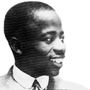
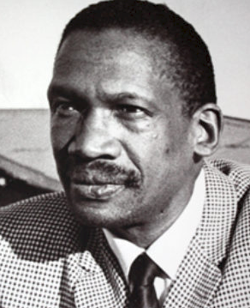
The origins of the massacre trace back to the ANC split of the Pan Africanist Congress in 1959. The Africanist slogan “Africa for Africans” showed that their best hope for liberation was through political self-reliance with a cultural focus on African beliefs and traditions. This ran counter to the traditional non-racialism of the ANC movement. The Africanists believed ALL of South Africa’s land and wealth should be returned to its original Black owners. This movement was led by Anton Lembede, who was the first president of the ANC Youth League, but who died in 1947 of heart failure. His followers, Robert Sobukwe and Potlako Leballo, continued his philosophy of Black liberation. They became disillusioned with the ANC’s connection to the White communists and other non-African groups.
1Robert Sobukwe
2Anton Lembede
Sobukwe and Leballo argued that the ANC’s insistence on non-violence lacked the dynamism and militancy to create real change. The Treason Trial (1956-1961) effectively removed leaders like Mandela and Sisulu from running the organization. This allowed the Africanists the opportunity to challenge from within. In 1958, they openly challenged the “stay at home” ANC strike. Ironically, this gave them support in the White press who said Sobukwe and Leballo represented the “respectable face” of Black politics. Things became heated when the Africanists attempted to break up a conference headed by Oliver Tambo in Soweto. When they failed to achieve their objective, they officially broke away from the ANC and created the Pan Africanist Congress (PAC), led by Sobukwe.
The PACs strategy was to hijack some of the ANC campaigns. In December 1959, the ANC announced their plan to launch a series of mass popular protests against the Pass Laws that would lead up to a great bonfire of passes. In June 1960, the PAC responded by setting a date for their own anti-pass protest for March 21st... Just a few days BEFORE the planned ANC protests. As the date approached, the government became nervous since the political temperature was rising. The PAC planned to involve thousands of protesters who would congregate without their pass books at police stations across the country to present themselves for arrest...sounds like the ANC strategy of nonviolence. The police responded by fortifying their stations and put all police on armed alert. PAC stressed that their demonstrations would be nonviolent and Sobukwe urged protestors NOT to provoke the police in any way.
On March 21st 1960, around 5,000 demonstrators met in a field outside the main police station in Sharpeville. The crowd sang freedom songs and chanted political slogans. Large numbers moved towards the fenced compound demanding to be allowed to enter to surrender themselves for arrest. What happened next is debated depending on what side you are on. The police claim there was an incident between an armed protester and a policeman. Whatever happened, the crowd “surged” forward to get a better look and, according to the police, began throwing rocks at the policemen. Eyewitnesses from protesters say no such provocation happened. A panicked officer, believing the station would be overrun, began firing, which caused a chain reaction of other officers and the protesters were overwhelmed with gunfire that lasted for 2 minutes. Dead bodies were strewn across the field...the vast majority were found facing away from the station and shot in the back. They were gunned down fleeing the station.
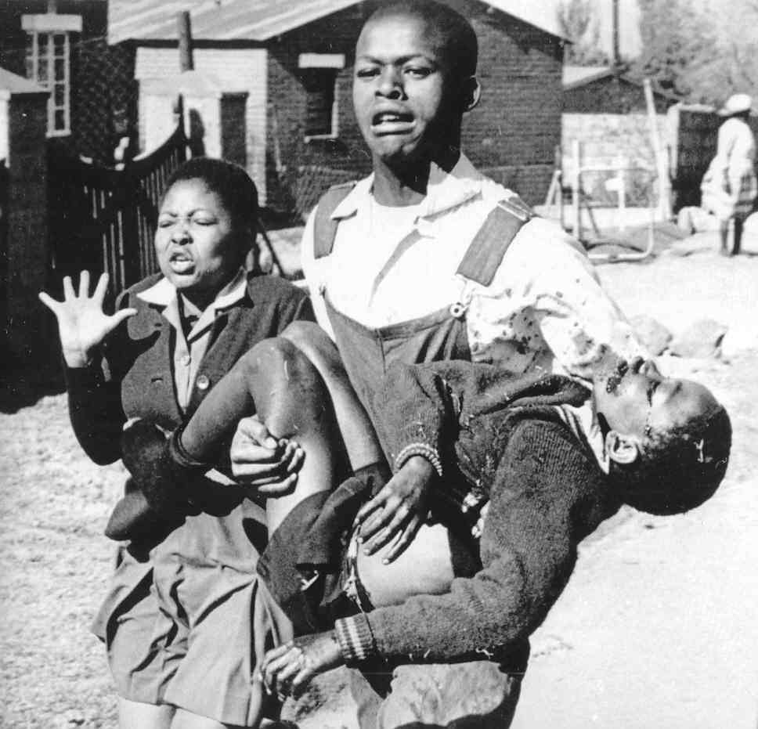
Most Non-white South Africans were outraged by the incident, horrified not only by the massacre but by the response of the government. Prime Minister Verwoerd seemed indifferent and callous (uncaring) about what happened when he addressed a crowd of nationalist supporters after the event. He assured them that the majority of South Africans were peaceful and supported his government's policies of separate development. He claimed the protesters had been coerced into demonstrating by the ANC and PAC. Other clashes between police and protesters occurred at Langa (near Cape Town), and other places created even more fatalities. At Evaton, 20,000 protesters were forced to flee by low-flying aircraft.
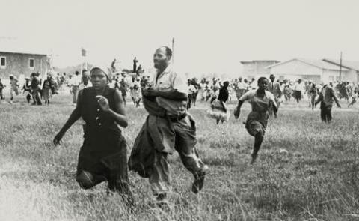
Verwoerd’s response was to call a State of Emergency on March 30th, 1960. Thousands of ANC and PAC leaders were arrested and all political meetings were outlawed. The Unlawful Organizations Act officially banned the ANC and PAC as illegal organizations. They were now out of options if they wanted to continue proposing meaningful resistance. They couldn’t act out in the open, they were forced to go underground. Non-violence was less and less an option, which only left armed struggle and sabotage. Nelson Mandela became a fugitive on the run.
The Sharpeville Massacre was a turning point in the strategy to deal with apartheid. It was the moment where moderate leaders of the ANC, like Chief Luthuli, saw apartheid as unrepentant and unrelenting. The government had scorned their peaceful nonviolent protests and responded with brutality. The nonviolent strategy failed because the government was willing to use everything it could against them, now, including armed force against unarmed protesters. The banning of the ANC that forced them underground killed the possibility for negotiations and peaceful resolutions. The ANC also had a national rival in the PAC which divided support. The PAC also quickly created an armed division after Sharpeville, the Poqo. If the ANC didn’t respond with their own armed wing, they would be outflanked by a rival group that had gotten massive support in a short period of time.
Before Sharpeville there had been a debate within the ANC between the more moderates and the younger, more radical members. These younger members (Mandela, Sisulu, Tambo and Nzo) had connections with the SACP and were thinking of creating an armed wing for the ANC. In 1953, Mandela had formulated a contingency plan in case the government was banned. The “M Plan” recommended the ANC dissolve its central organization and create smaller clandestine cells before launching a full-scale guerrilla insurgency against apartheid.
Sharpeville was also significant in how it impacted international opinion. After Sharpeville, many countries began to turn away from South Africa and it marked the beginning of the international campaign against apartheid. Britain’s Prime Minister, MacMillan gave his “Wind of Change” speech that issued a warning to South Africa that the political aspirations of the Black South Africans would eventually have to be met. After Sharpeville, South Africa’s international isolation began after Sharpeville. For the first time, economic sanctions were applied. These were not as effective as they could have been because South Africa's largest trading partners: Britain and the United States, refused to agree to a trade embargo. It also led to South Africa leaving the British Commonwealth in 1961.

Armed Resistance and the Rivonia Trial (imprisonment of ANC leadership)

In June 1961, the ANC established a military wing called the Umkhonto we Sizwe, which translates to “Spear of the Nation” and was shortened to MK. They conducted a sabotage campaign that targeted infrastructure: government buildings, railways, power lines in an attempt to force the government to negotiate with the ANC. They would try to avoid targets that inflicted human casualties. The acts of sabotage were combined with guerilla tactics to overthrow the government.
MK began operations in December 1961, by declaring a manifesto of their reasons for action and with bombs set off in Durban, Johannesburg and Port Elizabeth. Over the next year and a half, the MK attacked over 200 targets around South Africa. They were directed by a high command based in Liliesleaf Farm in Rivonia, just outside Johannesburg. The leadership included members of the South African Communist Party (SACP) and Congress of Democrats as well as ANC leaders. The MK was technically a separate organization from the ANC.
Nelson Mandela remained underground and avoided arrest for 8 months travelling across Africa to organize military recruits for the MK. When he returned to South Africa he was finally arrested and charged with organizing strikes and leaving the country without permission. He was given a Five year prison sentence with hard labor at Robben Island off the coast of Cape Town.
As was previously mentioned, the PAC had their own armed wing, the Poqo, meaning “pure” in Xhosa. The Poqo launched attacks in September of 1961, targeting chiefs and headsmen whom they accused of working with the government. Several of them were assassinated. The Poqo also targeted suspected informers, policemen and some random white civilians. Historian Tom Lodge claims the Poqo were the first political movement in South Africa to adopt a strategy that involved killing people and was probably the largest clandestine organization of the 1960’s. Their headquarters were in Lethoso ad they planned for a nationwide uprising in April 1963. It was led by Leballo, as Sobukwe was in jail for inciting people to break the pass laws. The government created the ‘Sobukwe Clause’ in the General Laws Amendment Act to keep him on Robben Island for longer than his sentence.
MK and Poqo were not the only armed resistance movements. There was also the African Resistance Movement (ARM) that adopted armed struggle. They were much smaller and consisted mostly of white radicals and intellectuals. They were based in Cape Town and Johannesburg. They bombed the Johannesburg Railway Station in 1964 that killed a passenger and injured others. A school teacher, Frederick Harris, was arrested for this incident and was executed. Besides ARM, Harris was also involved in the South African Non-racial Olympics Committee. ARM quickly collapsed when their other members were either arrested or left the country.
The government ramped up their repression and attempts to crush the resistance with spies and police informers. The Sabotage Act of 1962 gave them the power to restrict the liberty of oppositionists. The definition of sabotage was very loose, and allowed them to put people under house arrest for over 24 hours. The minimum sentence was five years and the maximum was the death penalty. It also banned other organizations besides the ANC and PAC. The General Law Amendment Act of 1963 allowed for arrest and detention without a trial. The police could arrest anyone on suspected charges of sabotage without a warrant and hold them for 90 days without legal counsel. It could also be renewed after the 90 days, making detention indefinite. In September 1963, a political prisoner, Looksmart Khulile Ngudle died in police detention while being interrogated. Over the years more people died under suspicious circumstances. Official causes were labeled as: suicide, slipped in the shower, fell out of a window or fell down the stairs.
The Poqo plan for April 1963 was discovered and more than 3,000 Poqo members were arrested and detained. This severely impacted PAC leadership and put an end to Poqo’s attempted overthrow of the government. Historian John Pampallis claimed this crackdown was a devastating blow to the PAC, one that they never fully recovered from. The government spies were also successful in taking down the MK. In July 1963, the police launched a raid against the Liliesleaf Farm and arrested nearly all of the MK high command. They confiscated documents that gave them information on other members as well. One of the documents outlined Operation Mayibuye, which called for guerilla warfare. The government used this against the MK leadership in the Rivonia Trial. Many believe the police had an inside informant.
The Rivonia Trial occurred from October 1963 to June 1964. Mandela was brought in from Robben Island to join the other MK leaders. The main charge against them was “recruiting people for training in the preparation and use of explosives and in guerilla warfare for the purpose of violent revolution and committing acts of sabotage.” They were also charged with conspiring to aid foreign military units to further the aims of communism and received money from sympathizers abroad. The prosecution demanded they be given the death penalty. The Rivonia accused were charged with conspiracy and sabotage rather than treason because in a trial of treason, the prosecution had to prove its case beyond a reasonable doubt, but in cases of sabotage, it was on the defense to prove their innocence.
Mandela and his associates agreed to admit to the charge of sabotage, but denied that any lives had been put at risk. Their strategy was to politicize the trial by arguing their struggle was morally legitimate for freedom and democracy against the domination and oppression of apartheid. They said the harsh response of the government left them no choice but to resort to armed resistance. Their decision to politicize the trial was risky. Mandela could have argued he was in prison during the MK operations, and therefore innocent, but he choose to stand by his colleagues, affirming that he was also an MK leader and took personal responsibility. Since they considered the trial to be political, all of the accused agreed not to appeal the death penalty if that sentence was handed down.
In Mandela’s opening statement he proclaimed:

Above all, we want equal political rights, because without them our disabilities will be permanent. I know this sounds revolutionary to the whites in this country, because the majority of voters will be Africans. This makes the white man fear democracy. But this fear cannot be allowed to stand in the way of the only solution which will guarantee racial harmony and freedom for all. It is not true that the enfranchisement of all will result in racial domination. Political division, based on color, is entirely artificial and, when it disappears, so will the domination of one color group by another. The ANC has spent half a century fighting against racism. When it triumphs it will not change that policy.

This then is what the ANC is fighting. Their struggle is a truly national one. It is a struggle of the African people, inspired by their own suffering and their own experience. It is a struggle for the right to live. During my lifetime I have dedicated myself to this struggle of the African people. I have fought against white domination, and I have fought against black domination. I have cherished the ideal of a democratic and free society in which all persons live together in harmony and with equal opportunities. It is an ideal which I hope to live for and to achieve. But if needs be, it is an ideal for which I am prepared to die.

This speech solidified Mandela’s iconic status and inspired anti-apartheid activists around the world to redouble their efforts to spare the lives of the defendants and release all political prisoners. Hundreds of journalists, photographers and diplomats from around the world attended the trial. On June 9th the UN Security Council passed a resolution calling on the South African government to end the trial and offer amnesty to the accused (The US, France, Britain and Brazil abstained from the UN vote). On June 11th all of the accused were found guilty, but to the surprise of everyone, the judge sentenced them to life imprisonment, not the death penalty.
The Rivonia Trial marked an end in armed struggle against apartheid. The government had successful broken the ANC/MK and PAC/Poqo. All of the leaders were either in prison, banished or exiled. For over a decade the townships would be defiant, but quiet until the 1976 Soweto Uprising. Large numbers of White South Africans would continue to support the NP Party in elections. Oliver Tambo became the de facto leader of the ANC in exile (Zambia). Mandela became an idol for South Africans and new political groups emerged: South African Student Organization (Biko’s group) and the Black Consciousness Movement. The government doubled down on their repression of opposition with a huge increase in military spending and of their security forces. Military conscription was mandatory for young White men of up to 2 years. However, resistance movements continued inside and outside South Africa.

International Protests against Apartheid

The 1952 Defiance Movement brought world attention to apartheid, but an international movement didn’t begin until 1959 with the Boycott Committees in Britain by South African exiles. They promoted boycotting South African goods and turned into the Anti-Apartheid Movement (AAM). Chief Luthuli’s statement calling for sanctions was a key factor in creating the AAM. They received support from the British Labour and Liberal Parties and trade unions, but the ruling Conservative Party (headed by MacMillan) was critical of sanctions. 15,000 people marched in Trafalgar Square in London. Their initial goal was to create awareness of what was going on. After Sharpeville, their goal was to push for a change of government. When ANC and PAC were banned, the AAM ramped up their efforts.
In 1964 the AAM organized an International Conference on Economic Sanctions against South Africa. Delegates came from forty nations. After the Rivonia Trial, the AAM established the World Campaign for the release of South African Political Prisoners with an international petition that got 194,000 signatures. AAM also worked with the South African Non-Racial Olympic Committee to get SA excluded from the 1964 Tokyo Olympics and expelled from the Olympics all together. The AAM worked to gain the support of the British public and many joined the boycott effort. Demonstrations were organized outside of banks/businesses that supported South Africa. Their protests expressed concerns over the continued supply of weapons to the SA military as well as assistance to SA to set up their own weapons industries.
In 1963, the UN Security Council Resolution 181 called for all UN member states to voluntarily stop the sale of weapons and ammunition to South Africa. It was the first time the UN had created a resolution against apartheid. It was a first step, but because it was voluntary, could not be enforced because the situation in SA was not deemed a threat to international peace. . A victory came in 1977, when the US announced they would support an arms embargo against SA under the Carter administration. One of carter’s main themes was supporting human rights, and he was put under public pressure to take action against SA.

