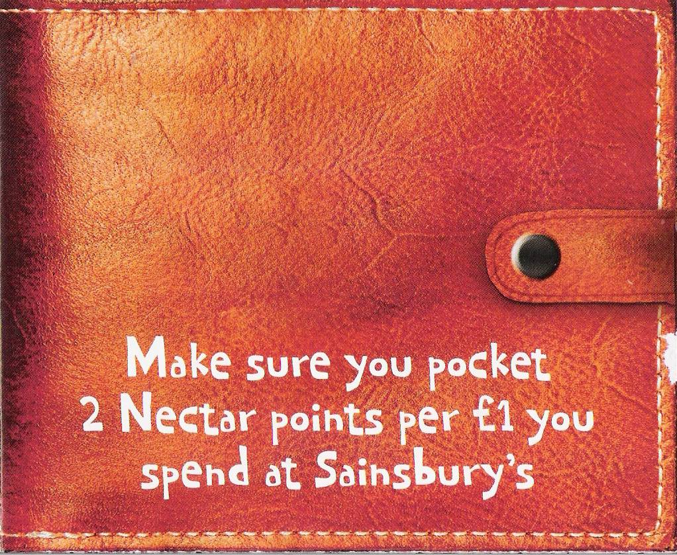  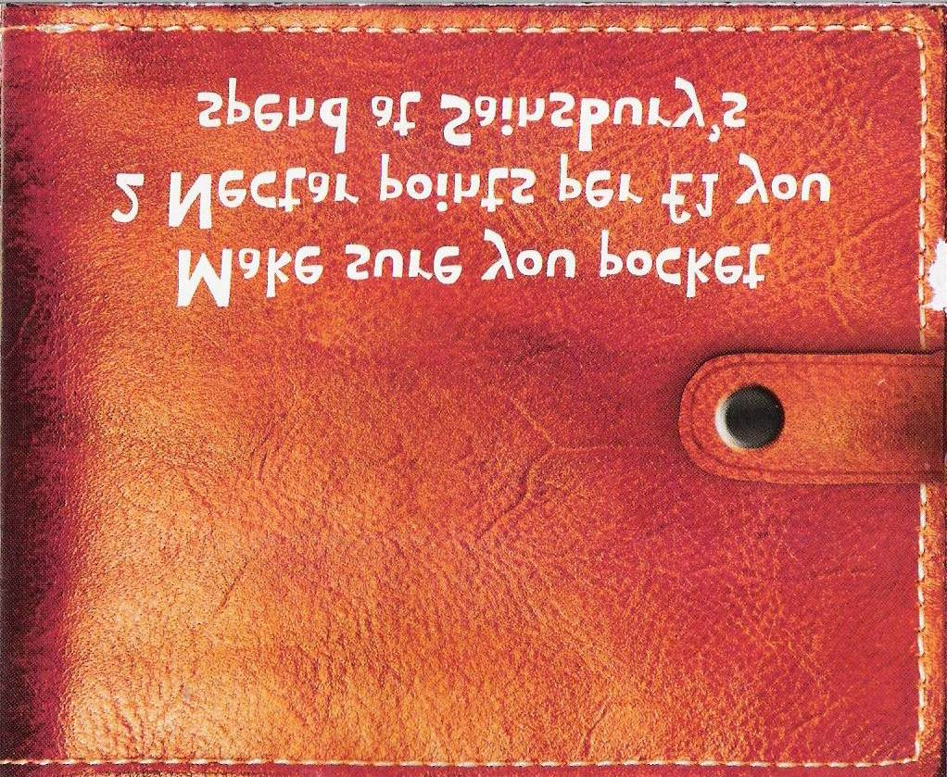  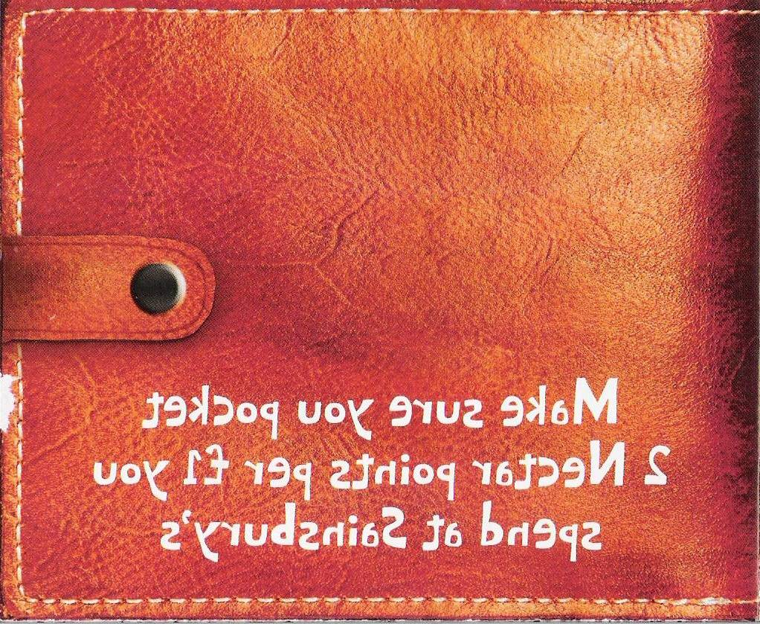  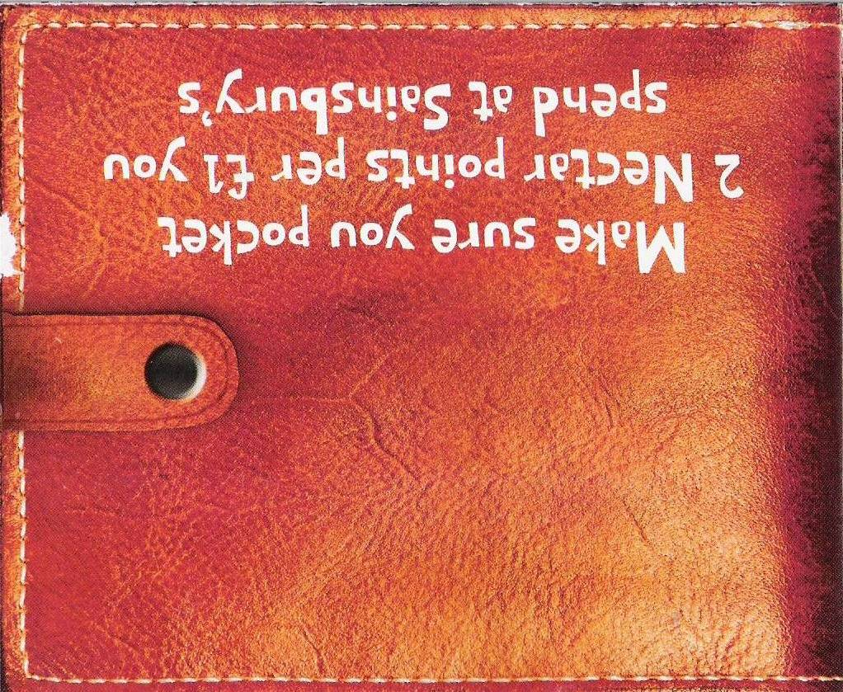 | Protester’s toolkit

I chose the ___________________________ because  __________________________________________  __________________________________________  __________________________________________  __________________________________________  __________________________________________ | I chose the ___________________________ because  __________________________________________  __________________________________________  __________________________________________  __________________________________________  __________________________________________
I chose the ___________________________ because  __________________________________________  __________________________________________  __________________________________________  __________________________________________  __________________________________________ | I chose the ___________________________ because  __________________________________________  __________________________________________  __________________________________________  __________________________________________  __________________________________________

I chose the ___________________________ because

__________________________________________

__________________________________________

__________________________________________

__________________________________________

I chose the ___________________________ because

__________________________________________

__________________________________________

__________________________________________

__________________________________________

