Pen and Paper

You can use these to write letters to the Prime Minister and MPs. You can tell them all the reasons that women deserve the vote. You can collect signatures and send the government petitions. This will let them know you are serious and responsible.
Printing Press

You will be able to make your own newspaper. You can sell it on the streets and try to convince shops to sell it. You can have articles all about your processions and meetings. You can have fundraising competitions and letters. This will spread your message to
people all over the
country.

Stones

You can use these to smash the windows of 10 Downing Street and other high profile buildings. This will grab people’s attention and make newspaper headlines.

Megaphone & Speech Writing Book

You will be able to organise speeches and meetings all across the country. You can address large groups of people and persuade them to support
your cause. This is legal
and you won’t get
into trouble.
Placards

These will come in handy for mass meetings and protest marches. They will show the public your beliefs and reasons for wanting the vote.
Matches

You could set on fire public buildings, such as racecourses (you would make sure there were no people or animals in the buildings). This will cause chaos and will certainly bring publicity to your cause.


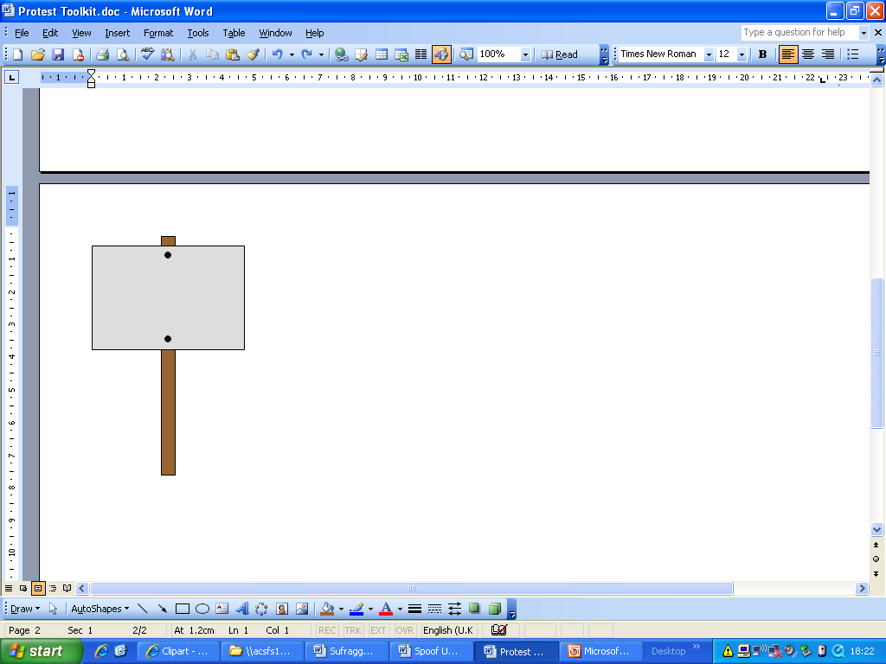
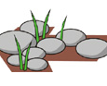

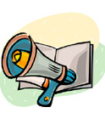



Bombs

They could be placed near important buildings, such as the Bank of England in London. This will attract the attention of the newspapers. The government will be terrorised into giving you the vote.
Acid

This could cause a lot of hassle for the men who won’t give you the vote! You could burn their golf greens with the acid and cause chaos. No-one will be hurt but you will certainly make your point and cause some trouble!

Axe

Men seem to value objects more than women. You could slash paintings in expensive and important art galleries. This will make a point.

Wire Cutters

You could use these to cut telegraph and telephone wires. This will cause a nuisance for the government and they will know it’s you who is responsible!
Chains

These will enable you to chain yourself to a railing outside Downing Street. This action will gain you publicity and give you more time to protest before the police take you away. This will show MPs that they can’t ignore you!
Courage

If you have chosen to take illegal action, you must be prepared to go to jail for breaking the law. You must be ready to go on a hunger strike until the government gives you the vote to gain sympathy from the public. This will be proof that you want the vote enough to be
willing to go to prison and
to die for it.








