**Price elasticity of demand**

* **The objectives of today’s lesson are as follows.**

1. To understand what is meant by the term **price elasticity of demand**.
2. To enable you to **calculate** the price elasticity of demand for different products.
3. To understand the link between **price elasticity and revenue**.

#### The Law of Demand



Before we discuss price elasticity of demand it is necessary to clear up a common area of confusion for students namely the difference between the law of demand and price elasticity of demand.

**The law of demand states:** __________________________________________________________________________________________________________________________

#### Price elasticity of demand

Price elasticity of demand on the other hand or P.E.D. measures the __________________________________________________________________________________________________________________________

##### **Task One**

Consider the list of products below. You have to state the extent to which demand would fall in response to a **10% increase in price**. You can describe the fall in demand as. (Estimate as best you can)

**very small , <5%,**

**small, 5%.**

**Proportionate, 10%**

**Large 15-20%**

**Very Large 20%**

|  |  |
| --- | --- |
| **Product** | **Extent of fall in demand/reason** |
|  |  |
|  |  |
|  |  |
|  |  |
|  |  |
|  |  |
|  |  |
|  |  |
|  |  |
|  |  |
|  |  |

* Generally speaking a 10% increase in price of what **type** of good would lead to less than proportionate (i.e. small or very small) fall in demand?

___________________________________________________________

* A 10% increase in price of what **type** of good would lead to a more than proportionate (i.e. large or very large) fall in demand?

________________________________________________________

The reverse situation would be true if there were a 10% decrease in the price of a product

* Demand for a product/service is described as _______________________if an increase or decrease in price results in a **more than proportionate** change in demand.
* Demand for a product/service is described as _______________________if an increase or decrease in price results in a **less than proportionate** change in demand.

1. Price elasticity of demand is calculated using the following formula

###### **Percentage change in quantity demanded**

**Percentage change in price.**

OR

###### **Change in quantity demanded / Original quantity demanded × 100**

**Change in price / Original price × 100**

For the following percentage changes in demand as a result of a the stated % change in price calculate the price elasticity of demand.

##### **Task Two**

|  |  |  |
| --- | --- | --- |
| **Change in price (%)** | **Change in quantity demanded (%)** | **Price elasticity of demand** |
| **20** | **40** |  |
| **10** | **5** |  |
| **15** | **15** |  |
| **30** | **15** |  |

##### **Task Three**

* **The price of the Consoles increases from £50 to £60. Demand falls from 100,000 units to 60,000 units.**

1. Calculate the price elasticity of demand for the Consoles.
2. Is the demand for Consoles price elastic or price inelastic?
3. What has happened to revenue as a result of the increase in price?

* **Bread in the supermarket falls in price from 40p a loaf to 35p a loaf. Quantity Demanded for bread increases from 200,000 units to 210,000 units.**

a) Calculate the price elasticity of demand for Bread.

1. Is the demand for bread price elastic or inelastic?

c) What has happened to revenue as a result of the fall in price?

* **Repeat the above steps for petrol when it increases in price from 80p to 90p and quantity demanded decreases from 500,000 units to 480,000.**
* **Bars of chocolate falls in price from 35p to 30p. Quantity demanded increases from 100m units to 150m units.**

##### **Task Four**

* You need to be able to understand what happens to total revenue when a price change leads to a subsequent change in demand. Using the information from the last four examples fill in the table below.

* **In the box write what happens to total revenue**

|  |  |  |
| --- | --- | --- |
|  | There is an **increase** in price | There is a **decrease** in the price |
| Demand for the product is **price elastic** |  |  |
| Demand for the product is **price inelastic** |  |  |

##### **Task Five**

Match the following descriptions to the correct diagram below.

* Price elastic demand
* Price inelastic demand
* Perfectly price elastic demand
* Perfectly price inelastic demand
* Unitary price elasticity of demand

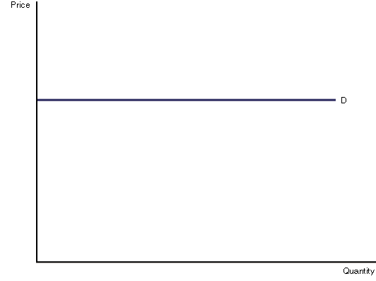

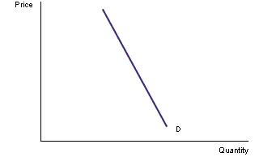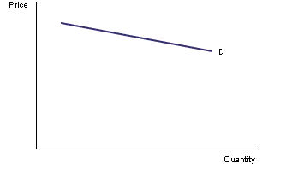

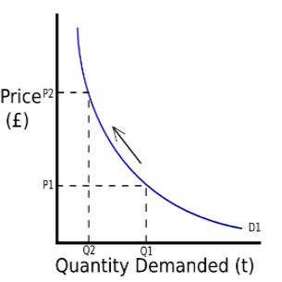

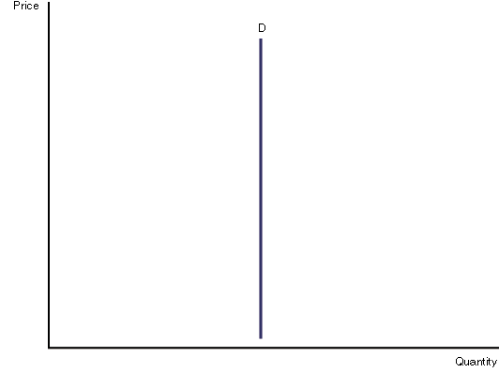

**Price Elasticity of Demand – Lesson 2**

* **Review of how to calculate Price Elasticity of Demand.**
* **Representing revenue changes on a demand curve for products with different elasticities.**
* **Looking at the factors that affect the price elasticity of demand for a product.**
* **Examining how price elasticity changes over the length of the demand curve.**

##### **Task One**

* Answer the question below.

|  |  |  |  |  |  |
| --- | --- | --- | --- | --- | --- |
|  | **Original Values** | |  | **New Values** | |
|  | Qd | Price ($) |  | Qd | Price ($) |
| a) | 200 | 10 |  | 240 | 6 |
| b) | 40 | 16 |  | 50 | 14 |
| c) | 24 | 6 |  | 32 | 0 |
| d) | 300 | 24 |  | 400 | 20 |
| e) | 90 | 12 |  | 90 | 16 |
| f) | 64 | 48 |  | 80 | 4 |

* Calculate the price elasticity of demand for the data in the table above.

_________________________________________________________________________________________________________________________________________________________________________________________________________________________________________________________________________________________________________________________________________________________________________________________________________________________________________________________

##### **Task Two**

Indicate on the diagram below the changes in revenue following an **increase in price.**

**QQuantity Demanded**

### Price



1. Overall change in revenue following a price increase? **(elastic/inelastic)**

_______________________________________________________

b)

### Price

**QQuantity Demanded**

c) Overall change in revenue following a price increase **(elastic/inelastic)**?

_____________________________________________________________

##### **Task Three**

Indicate what will happen to revenue following a **fall in price**.

d)

### Price

**QQuantity Demanded**

e) Overall change in revenue following **a price fall**. (elastic/inelastic)

_____________________________________________________________

f)

### Price



**QQuantity Demanded**

g) What is the **overall change** in revenue? (elastic/inelastic)

_____________________________________________________________

##### **Task Four**

* We now need to consider the factors that effect whether demand for a product will be elastic or inelastic.

|  |  |
| --- | --- |
| **Factor** | **Explanation** |
|  |  |
|  |  |
|  |  |
|  |  |
|  |  |

##### Task Five

* Calculate the price elasticity of demand using the diagram below if there is a fall in price from $12 to $8.

