THE CONSEQUENCES OF CLIMATE CHANGE – PRESENTATION NOTES
- The hydrosphere, including water stored in ice and oceans, changing sea levels

Sea level rise and changing precipitation patterns
- Increase in global temperatures has an impact on the proportion of water stored around the hydrosphere. Ice stores have decreased and ocean stores have increased. The rising temperatures have led to →
- Thermal expansion of the oceans: water absorbs heat and expands
- Melting of snow and ice:
- the glaciers of Mount Kilimanjaro in East Africa and the Andes in South are retreating.
- ice sheets in Greenland are shrinking and snow cover is decreasing
- shipping routes are opening up and improving global communications

- Sea level rises are significant. Between 1901 and 2013 they rose by about 19 cm. By 2100 they are expected to rise by 70 m. Rising sea levels will have significant impacts. Increased risk of flooding. This is high in low-lying coastal like Maldives. Coastal flooding could lead to
- Damage to infrastructure, homes and industry → loss of livelihood
- Risk to human life → death from drowning
- Contamination of freshwater resources by salt water → including saline intrusion of groundwater resources: this would render fresh water too salty for domestic, agricultural and industrial uses.
- Damage to inland ecosystems → threatening wildlife
- Degradation of coastal ecosystem such as wetlands, estuaries, mangroves and beaches

Rising global temperatures not only raise sea levels but they also change precipitation patterns. This is likely to affect the quantity and quality of fresh water available. The availability of water could be influenced by the following:
- Reduction in precipitation in semi-arid and arid regions will reduce available water resources → higher temperatures → increase evaporation rates → frequency and intensity of drought conditions is expected to increase
- Reduction in glacier or snow water storage → reduced water resources downstream during spring and summer. Loss of glacial melt in the Andes Mountains is expected to have effects in Peru. The reduction in river flow → affect both water resources and production of hydroelectric power.

Carbon stores
In addition to the four major sphere there are a number of global cycles that maintain balance and make life on Earth possible. The carbon cycle is very important when considering the changes in carbon storage in the hydrosphere, biosphere and geosphere.
In the ocean
Oceans absorbs 93 % of the atmospheric carbon and are the second largest sink in the carbon cycle. The ocean gains carbon dioxide from the following sources
- Carbon dioxide is gained from the atmosphere as it dissolves at the air-water interference and is converted into carbonates.
- Other parts of the hydrosphere contribute carbon dioxide as rivers flow into the ocean laden with dissolved organic carbon.
- Biosphere also contributes carbon dioxide: plants convert carbon dioxide into organic carbon through photosynthesis, which then moves through food chains or into deep ocean sediments as organisms die and sink to the bottom. The biosphere also converts dissolved carbon into calcium carbonate for shells and other hard bony structures in sea creatures.
- Oceanic absorption of carbon dioxide goes some way to counteracting the human-induced rise in atmospheric carbon dioxide. However, human actions are interfering with this mechanisms.
- The dissolution of atmospheric carbon dioxide into the oceans is temperature-dependent. It is most rapid in the polar regions where the water is cooler. So, warming of the oceans reduces the speed at which this exchange is taking place.
- Warm water holds less gas so warmer oceans means that less carbon dioxide can be stored in the oceanic sink.
- Acid deposition and other pollutants are changing the chemical composition of the oceans. This damages the fragile ecosystems that cycle the carbon, limiting the oceans' ability to absorb atmospheric carbon.
- Higher ocean temperatures are interfering with the thermohaline circulation, thus reducing the amount of carbon that is transferred into deep ocean sediments. This then reduces oceanic carbon absorption into surface layers.
In the ice
Large areas of sea ice are melting, with significant impacts on the balance in the carbon sinks. Rising temperatures mean less summer sea ice and thinner ice in the winter

- Carbon stored in ice, oceans and the biosphere

Global carbon stores
Ice, Oceans and Biosphere

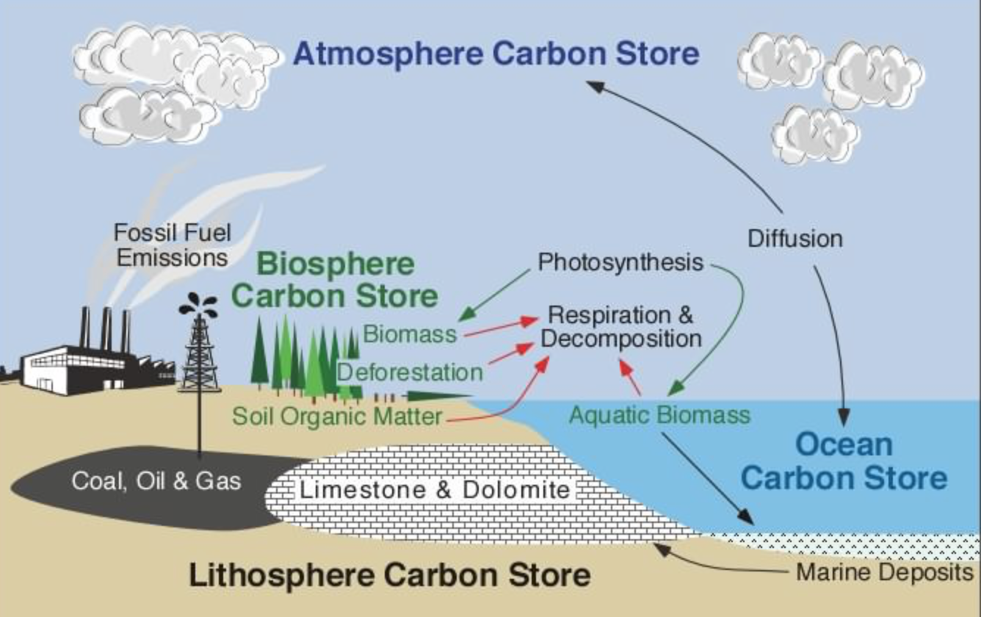

“A carbon store is a reservoir that stores carbon-containing chemical compounds for an indefinite period. They remove carbon dioxide from the atmosphere in a process called Carbon sequestration.”
Carbon Cycle
- Global cycles that maintain, balance and keep life on Earth possible.
- Major change in carbon sink happens in the geosphere.
- The geosphere stores the majority of the Earth carbon: 80% is in limestone and other calcium carbonate-based rocks. The rest is in fossil fuels.
- Carbons stays locked up in rocks for millions of years under natural conditions.
- Humans extract fossil fuels to support our lifestyles and its combustion releases vast amount of carbon. global cycles that maintain balance and keep life on Earth possible.

OCEANS

The oceans absorb 93% of the atmospheric carbon, and are the second largest sink in the carbon cycle.
- Carbon dioxide is gained from the atmosphere as it dissolves at the air-water interface and is converted into carbonates
- other parts of the hydrosphere contribute carbon dioxide as rivers flow into the ocean laden with dissolved organic carbon
- The biosphere also contributes carbon dioxide: plant convert carbon dioxide into organic carbon through photosynthesis, which then moves through food chains or into deep ocean sediments as organisms die and sink to the bottom.
- The biosphere also converts dissolved carbon into calcium carbonate for shells and other bony structures in sea creatures.
- Human actions are interfering with this mechanism.
- The dissolution of atmospheric carbon dioxide into the oceans is temperature dependent. Also warm water holds less gas so warmer oceans means that less carbon dioxide can be stored in the oceanic sink.
- Acid deposition and other pollutants are changing the chemical composition of the oceans. This damages the fragile ecosystems that cycle the carbon, limiting the oceans ability to absorb atmospheric carbon.
- Higher ocean temperatures are interfering with the thermohaline circulation, thus reducing the amount of carbon that is transferred into the deep ocean sediments. This then reduces oceanic carbon absorption into surface layers.

Ice
- Large areas of sea ice are melting - impacting the carbon sinks.
- Higher temperatures mean less summer sea ice and thinner ice in the winter.
- The chemical processes that involved in the formation of sea ice have a significant impact on the carbon cycle.
- Frost flowers contain very high concentration of calcium carbonate thus removing large amounts of carbon dioxide from the atmosphere.
- Periglacial areas are characterized by seasonally low temperatures and permafrost - permanently frozen soil.
- Permafrost contains large deposits of carbon accumulated over thousands of years.
- The low temperature reduces the rate of decomposition of organic plant matter. The low rate of decomposition in relation to plant productivity has allowed the large accumulation of carbon to develop.

Glaciers having big carbon impact
- Organic carbon is found in glaciers when they melt. Having these melted it could change the whole food web.
- Glaciers and ice sheets contain about 70% of the Earth’s fresh water and ongoing melting is a major contributor to sea level rise.
- Glaciers also store organic carbon derived from both primary production on the glaciers and deposition of materials such as soot or other fossil fuel combustion by products.
- 10% of the world is covered in glacial ice. With the glacial melt, this is one of the main reasons why the sea levels are rising.
Hindu Kush Himalayan
- The source of many of Asia’s major river systems, providing water for drinking, irrigation, industry and other uses for about 1.5 billion people.

- Glaciers in Switzerland are predicted to recede at an accelerated rate.
- This process would lead to a massive landscape and changes in water balance, glacial lake outbursts, mudslides and debris slides.
https://phys.org/news/2015-01-glaciers-big-carbon-impact.html
BIOSPHERE
- Carbon enters the biosphere when plants extract carbon dioxide from the atmosphere and use it for photosynthesis.
- The cabron is then combined with other compounds and elements to form organic carbon in plant material dead and alive, as one of the carbon cycle’s biggest sinks.
- As the organic carbon is atmosphere as carbon dioxide Some of the carbon in the cycle is stores an inorganic calcium carbonate
- Forests are the largest of the biosphere’s carbon sinks, with up to 80% of the above-ground carbon and around 30% of the below-ground carbon held in forests.
- Some of the 45% of this carbon is stored in just two forest areas: the Russian Taiga and Amazonia in South America
- Amount of carbon in biosphere shows strong diurnal and seasonal fluctuations that correspond to the cycles of photosynthesis. More apparent in northern hemisphere where there is a greater amount of land.
- Human activity is altering the carbon balance in the biosphere sinks both directly and indirectly.
- Deforestation causes loss of biodiversity, reduces ecosystem resilience, and decreases the amount of carbon dioxide that is removed from the atmosphere by photosynthesis.
- This direct effect is often exacerbated when the vegetation that is left after the trees are removed is burned or left to rot, thus releasing carbon dioxide directly into the atmosphere.
It is estimated that over 12 million hectares of forest and woodland are lost each year, resulting in 1.5 billion tonnes of carbon dioxide being added to the atmosphere.

- Weather: incidence and severity of extreme events such as drought, hurricanes, etc.

WEATHER -
- The number of heat waves has been increasing in recent years. This trend has continued in 2011 and 2012, with the number of intense heat waves being almost triple the long-term average.
- An example of recent drought occurred in 2011, when many locations in Texas and Oklahoma experienced more than 100 days over 100°F. Both states set new records for the hottest summer since record keeping began in 1895.
- Heavy downpours are increasing nationally, especially over the last three to five decades.
- Increasingly, humanity is also adding to weather-related factors, as human-induced warming increases heavy downpours, causes more extensive storm surges due to sea level rise, and leads to more rapid spring snowmelt.
- There has been a substantial increase in most measures of Atlantic hurricane activity since the early 1980s.
- Hurricane development, however, is influenced by more than just sea surface temperature. How hurricanes develop also depends on how the local atmosphere responds to changes in local sea surface temperatures, and this atmospheric response depends critically on the cause of the change., For example, the atmosphere responds differently when local sea surface temperatures increase due to a local decrease of particulate pollution that allows more sunlight through to warm the ocean

- Spatial changes in biomes, habitats and animal migration patterns
Changing distribution of biomes and other impacts on the biosphere and its non human inhabitants

- Biome: A ecosystem that is characterised by a distinct plant or animals that are maintained under constant climatic conditions
- Types of biomes: Marine, Desert, Forest, Grassland, Tundra and mountainous
- Less forests
- More desert
- Lake chad has decreased to ⅕ its size in 1963
- 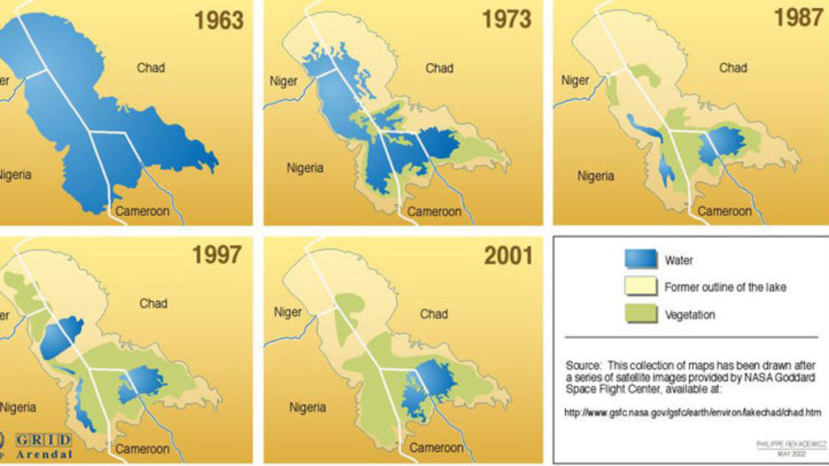
- Terrestrial
  - Forces species into higher latitudes or altitudes as they seek cooler temperatures
  - Expands the geographical range of some species, threatening others
  - Species usually living in the boreal forest now live in the tundra
  - Polar bears forced to hunt on land as ice melts, and grizzly bear forced to emerge from hibernation earlier as temperatures rise, creating the pizzly bear
  - Animal Species already living in the coldest areas of the world have nowhere to go
  - Plants undertake passive migration through seed dispersal. Species that can’t adapt quickly enough become extinct.
  - Longer summers mean that pests have more time to breed and spread
  - Short winters mean insect larvae and eggs are not killed
  - Causes more wildfires, leading to desertification
- Aquatic
  - Warm-water species are thriving, while cold-water species are dying out
    - Salmon and trout are estimated to lose over 47% of their habitat by 2080
    - Great Barrier reef to drop to below 10% coverage. At this point t

  - Acidification of ocean as CO2 concentration increases
    - Coral bleaching
    - Marine organisms (including coral) cannot reproduce and grow at an optimal rate
    - Skeletal organisms cannot produce calcium carbonate shells
    - Coral coverage in the Great Barrier Reef to drop to below 10%, at which point it may never recover again
  - Saltwater overflows into freshwater ecosystems, leading to loss of habitat for freshwater organisms
  - Biome Shifts can also contribute in a positive way. The most classic example is that due to rising temperatures, the UK will have a more suitable climate to grow crops such as Wine and tomatoes. However due to this shift, places such as Ethiopia are getting hotter, causing yearly droughts and famines.
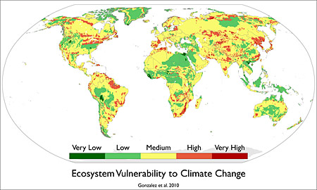
- Changes in migration patterns
  - Cod deserting tropic for colder North Sea
  - Mosquitoes spreading more
  - Changes in migration patterns have long term effects, for example, if the the African Gnus were to travel north, Lions would have to adapt to the change and move with them or hunt other animals
  - Polar bears have to travel further to hunt seal as melting arctic ice means that there is less land for polar bears to travel on

- Changes to agriculture, including crop yields, limits of cultivation, soil
erosion

6. Human health, migration and transport

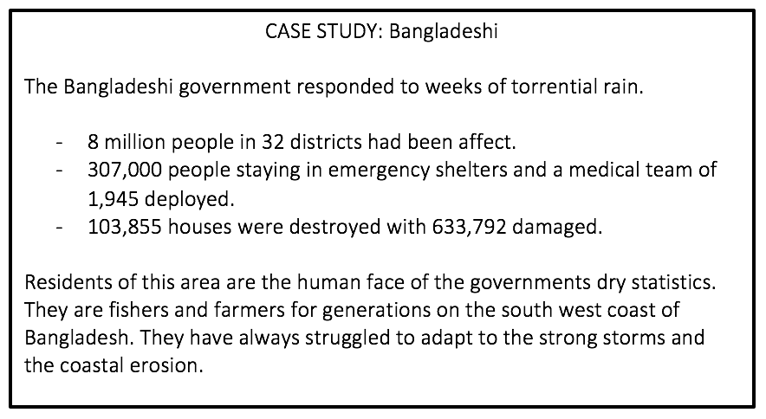
This case study shows the negative consequences of how climate change is affecting the wellness of other communities. Their trade and way of earning money has been stunted due to the effects of climate change and flooding and other natural disasters as a result.
A common discrepancy would be that the people that are most affected by the consequences of climate change are those that are contributing the least. This is due to the fact that they are usually less developed countries with different ways of love, resulting in a smaller carbon footprint.

Impacts of Climate Change on Human Health:

Factor: | Impact:
Severe Weather | Injuries and fatalities.  Damages to facilities and resources for communities.
Air Pollution | Asthma and Cardiovascular diseases.  Lowers quality of life as air is not pleasant to breath.
Allergies | Respiratory diseases.  Causes breathing issues especially in young people.
Water - borne diseases | Cholera.  Results in fatalities and a lack of drinkable water.
Environmental Refugees | Forced migration causes civil conflicts, affecting both the host country and the country that they are migrating from.
Mental Health | Anxiety and despair from losing home and loved ones.  Post Traumatic Stress Disorder from what they have lived through.
Water and Food Supply | Malnutrition - affects the development of young children.  Diarrhea and harmful algal blooms.

Here are some links to external websites and resources on the theme:

https://www.theguardian.com/global-development/2018/jan/04/bangladesh-climate-refugees-john-vidal-photo-essay

http://www.climatechangenews.com/2017/08/14/will-become-bangladeshs-climate-migrants/

