The Principal Story
Principles of Leadership

Name: __________________________________________________________

Directions: Watch the clips from the film The Principal Story. Make careful observations about the leadership skills of the featured principals. Record the qualities and skills you notice in the left column below and note supporting evidence to the right.

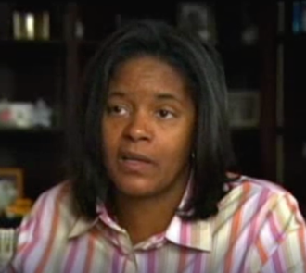
Tresa Dunbar - Principal
Tresa Dunbar is shown in her second year as principal at Henry H. Nash Elementary School, which prior to Dunbar had six principals over a five-year period and typically ranked at the bottom in statewide testing. Previously Dunbar served as an assistant principal, a teacher, a social studies department chair and an evaluation specialist, and she has extensive experience designing and facilitating professional development experiences for teachers. She has a Ph.D. in curriculum development with endorsements in language arts, reading and social studies.

Leadership Qualities and Skills | Supporting Evidence

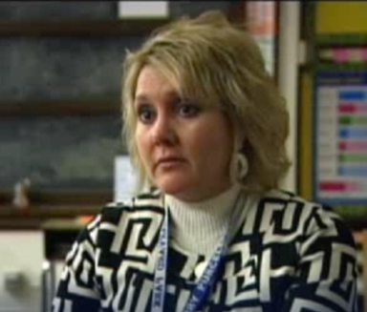
Kerry Purcell - Principal
Kerry Purcell is shown in her sixth year at Harvard Park Elementary School. Earlier in her career, she taught kindergarten for 12 years and served in various leadership capacities at the school, district and state level. Purcell has a master’s degree in educational administration. During her tenure as principal, test scores increased by approximately 45 percent in reading and 50 percent in math. Purcell currently works for Focus on Results, where she provides professional development and coaching support to help educational leaders use data to make sound instructional, fiscal and human resource decisions.

Leadership Qualities and Skills | Supporting Evidence

