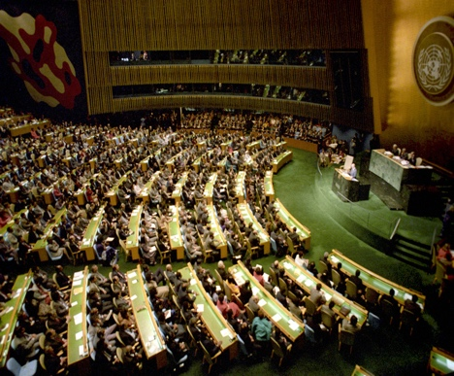
MUN Position Paper Checklist
*The word ‘delegation’– denotes your country delegation or persona you have been assigned at the conference.

Countries biographical info
☐ location, population, economy, government
☐ GDP/Capita
☐ Brief history since 1945
☐ The geography of your delegation country

Committee topic
☐ Describe your committee assignment/assignments?
☐ How the committee topic affects the delegation socially or economically?
☐ How the committee topic affects the delegation politically or militarily?
☐ What does your delegation aim to achieve through the committee? (Top 3 ideas)
☐ Can you recall 3 pieces of evidence e.g. studied, statistics etc. to support your view on the topic?
☐ References in MLA or acceptable format

Caucusing/developing alliances
☐ Which countries share similar views?
☐ Which countries have different views?
☐ Is the international community broadly supportive or opposed to your country’s views on the issue/s?
☐ How does the international community divide on the issue/topic? Is it religious, political, regional/continental etc?

Resolutions
☐ Can you suggest ideas for inclusion in a resolution? (3 ideas)
☐ What challenges do you see in passing a resolution you support? Opposition, economic constraints, political constraints etc
☐

