Population Revision Booklet

IGCSE Geography

POPULATION REVISION LIST
Describe and give reasons for the rapid increase in the world's population.
Identify the major influences on population density and population distribution. Reference should be made to physical, economic and human factors.
Examine a case study of a country/region that is sparsely populated (Case Study: Canadian Northlands)
Examine a case study of a country/region that is densely populated (Case study: North-east United States)
Define over and under population
Explain the causes of over and under population
Provide case studies of an over populated and under populated country (Case studies: Over-population = Bangladesh, under-population = Canada)
Understand the main cause of change in population size
Explain varying reasons for high and low birth and death rates
Explain the impact of HIV/AIDs in a country (Case study: Botswana)
Describe and explain the demographic transition model
Give reasons for contrasting rates of natural population change
Identify features of population pyramids for countries at different stages of development
Explain implications of countries with different population structures.
Examine case study for a population with a high dependent population (Case studies: Japan (elderly dependents) and Gambia (young dependents)
Explain why population structures are changing
Examine issues of a country with a high rate of natural population growth (Case study: Gambia)
Examine issues of a country with a low rate of natural population growth or population decline (Case study: Japan)
Link population pyramids to different stages of the demographic transition model
Explain problems of rapid population growth
Evaluate a population policy to reduce population growth (Case study: China One Child Policy)
Evaluate a population policy to increase population growth (Case study: Japan)
Describe and suggest reasons for population migrations.
Differentiate reasons for different migrations such as internal movements i.e. rural-urban migration as well as to international migrations both voluntary and involuntary.
Examine reasons for international migration in a particular country (Case Study of International Migration: Mexico to USA)

Theme 1 - Population Revision Notes
Population distribution means the pattern of where people live. World population distribution is uneven. Places which are sparsely populated contain few people. Places which are densely populated contain many people. Sparsely populated places tend to be difficult places to live. These are usually places with hostile environments e.g. Antarctica, Sahara. Places which are densely populated are habitable environments e.g. Europe.
Population Density
Population density is a measurement of the number of people in an area. It is an average number. Population density is calculated by dividing the number of people by area. Population density is usually shown as the number of people per square kilometre.
The map below is a choropleth (shading) map and illustrates population density. The darker the colour the greater the population density.
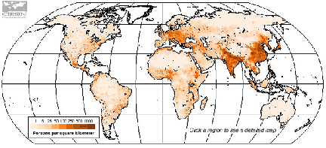
The map above shows that world population distribution is uneven. Some areas have a high population density while others have a low population density. Areas of high population density tend to be located between 20° and 60°N. This area contains a large land area and a relatively temperate climate.

Factors Affecting Population Density
There are a range of human and natural factors that affect population density. The tables below illustrate this.
Physical Factors | High Density | Low Density
Relief  (shape and height of land) | Low land which is flat e.g. Ganges Valley in India | High land that is mountainous e.g. Himalayas
Resources | Areas rich in resources (e.g. coal, oil, wood, fishing etc.) tend to densely populated e.g. Western Europe | Areas with few resources tend to be sparsely populated e.g. The Sahel
Climate | Areas with temperate climates tend to be densely populated as there is enough rain and heat to grow crops e.g. UK | Areas with extreme climates of hot and cold tend to be sparsely populated e.g. the Sahara Desert

Human Factors | High Density | Low Density
Political | Countries with stable governments tend to have a high population density e.g. Singapore | Unstable countries tend to have lower population densities as people migrate e.g. Afghanistan.
Social | Groups of people want to live close to each other for security e.g. USA | Other groups of people prefer to be isolated e.g. Scandinavians
Economic | Good job opportunities encourage high population densities, particularly in large cities in MEDCs and LEDCs around the world. | Limited job opportunities cause some areas to be sparsely populated e.g. Amazon Rainforest
Case study of a sparsely populated area: The Canadian Northlands
Location:
The Canadian Northlands are an area of North America that lie beyond 55 degrees north
•The largest settlement in the Canadian Northlands is Yellowknife in the Northwest Territories, population 19,000
•The area has a population density of less than 1 person per square kilometer

Reasons why the area is sparsely populated:
•A major reason why so few people live in this area is due to the climate.
•Temperatures are extremely cold and inhospitable in winter, with the mean average January temperature being -20 degrees C.
•Summers are short and the climate in much of the northlands is beyond the limits of agriculture.
•The inability to grow food on the land is a key factor in explaining low population density.
- Much of the Northlands are affected by permafrost. This means that the ground is permanently frozen for long periods of the year. When the ice does melt in some the land becomes waterlogged. This makes life in the region very difficult e.g. it makes it restricts building and crop growth.
- The environmental conditions mean that there are great difficulties for human development in the region.
- For example, transport and communications are hampered by the climatic conditions.
- Railway and road routes are extremely limited and the use of water transport is dictated by the seasons.
- For many communities, air transport is the only link they have to the outside world.

Case Study of a densely populated area: The North-East United States

- The greatest concentration of population in the USA is in the North-East.
- The region stretches from Inland from Boston and Washington to Chicago and St Louis.
- The area from Boston to Washington is known as BOWASH. This continuous urban area is known as a megalopolis, it also includes the cities of New York and Philadelphia.
- New York City is a global city because it is one of the great financial cities of the world. It is the most densely populated city in the USA.
- The global importance of New York means that there is a wealth of job opportunities in the area, leading to population growth.
- The north-eastern states are along the Atlantic Coast, this enables trade which provides job opportunities and boosts population growth. Port of New York is the busiest port in the United States of America.
- The north-east has the most highly developed transport networks In North America, this enables people to move around easily making it more appealing for businesses to develop and for people to settle in the area.
- The climate and soils in the north-eastern USA are generally fertile. This enables the development of agriculture to support human populations.

Over-population, under-population and optimum population

Key definitions
OVER-POPULATION
- Is when there are not enough resources for the inhabitants in an area. Inevitably this leads to famine, water and electricity shortages, increased unemployment.
- Bangladesh, Ethiopia, and parts of China, Brazil and India are said to be overpopulated as they have insufficient food, minerals an energy resources to sustain their populations.
- All suffer from localised famines, natural hazards (drought/flood) and are characterised by low incomes, poverty, poor living conditions & high levels of emigration.

UNDER-POPULATION
- Is when there are more resources than inhabitants in an area. Surplus in food and water results in wastes.
- Societal systems such as schools and hospitals will then not have enough demand to run at a sustainable level, so the cost per capita for the service will increase.
- Additionally, there will be less "working population" this has a negative impact on a countries economy and will lead to an increase in taxation.
- Canada and Australia are good examples of countries that are underpopulated. Both have surplus amounts of food, energy and mineral resources that are exported. Their populations have high incomes, good living conditions and high levels of technology an immigration.
- Standards of living would probably rise further if populations increased, as greater volumes of resources would be produced and exploited!

OPTIMUM POPULATION
- Is when there are enough resources for the number of inhabitants (population demand for goods is equal to the supply).
- The optimum population will also be influenced by developments in technology, demographic structure changes, as trade opportunities develop/falter, and as new raw materials are discovered to replace old ones which are exhausted or whose values change over time.

CARRYING CAPACITY:
- The amount of people an area can support

Case Study of an over-populated country: Bangladesh
Lack of resources, poor infrastructure and under-developed technology coupled with the high population have been responsible for decreasing the carrying capacity of the region.

Problems of overpopulation:
- Overpopulation in Bangladesh results in overcrowded areas with traffic congestion as there are too many vehicles on the roads, especially in cities such as Dhaka. Vehicle emissions, industrial discharge and burning of fossil fuels have resulted in air pollution, while the ground water has been polluted due to arsenic. Furthermore, shortage of food lead to over-cultivation on the flood plains of the Ganges river, causing lower yields and soil exhaustion.
- Another major problem is the widespread deforestation for firewood on the slopes of the Himalayas.
- The capital of Bangladesh, Dhaka, also suffers from severe housing shortages due to mass urbanisation.

Case study of an under-populated country: Canada
Canada is regarded as an underpopulated country as the carrying capacity is much higher than the current population. The 35 million people in Canada cannot fully exploit the available resources and technology.

Problems of under-population in Canada:
- Labour shortage: 32% of Canadian employers are encountering difficulties in hiring workers due to a lack of applicants.
- Services (e.g. schools, hospitals and transport) close down as there are not enough customers.
- Less innovation and development (lee brain power)
- Difficulties in defending the country
Canada has tried to promote immigration to maintain the fairly high standard of living, but in the previous decades less people are migrating to Canada, than during the 1950’s and 1960’s.
Solutions:
- Relaxing immigrant policies and visa requirements to encourage migration
- Pro-natal government support to increase the birth rate e.g. subsidies and parental leave programs.
- Allow pensioners to continue working

Underpopulation in Australia
Australia has a population of 20 million and is a similar size to the USA. However the USA has 300 million people living in it. Many areas of Australia are empty and it could support a higher population. Successive governments have tried to increase its population, to develop the country economically and to protect it from foreign influence.
What problems has underpopulation caused in Australia?
- Shortage of workers which has led to lower optimum productivity.
- Conflicts caused in major cities such as Sydney by need to attract foreign workers.
- Not possible to exploit all resources and large areas of outback undeveloped/underutilised.
- Less people paying tax. 43% of the labour force will be due to retire in next 20 years. Taxes will have to be raised to fund retirement.
- Schools and hospitals may close because there are not enough people to support them.
- Public transport links might close because of less customers. It is unlikely that new transport systems will develop as there is not enough people to support them. This increases peoples reliance on cars.
- There may be less innovation and development.
- Hard to defend country.

Population Change
The world's population is growing very rapidly. In 1820 the world's population reached 1 billion. In 1990 it reached 6 billion people.
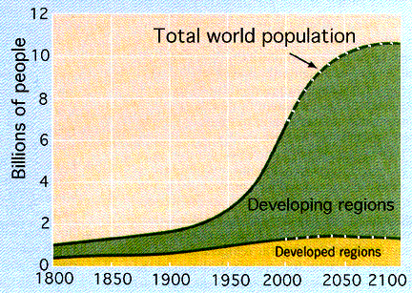
This rapid growth in population has been called a population explosion. This is an exponential growth of the world’s population that has taken place over the past 200 years.
The major reason for population changes, whether in an individual country or for the whole world, is the change in birth and death rates.
The birth rate is the number of live babies born in a year for every 1000 people in the total population. Death rates are number of people dying per 1000 people. When birth rates are higher than death rates the population of an area will increase.

Over the past 150 years improvements in health care and sanitation around the world have led to a drop in the death rate, especially Infant Mortality rates (the number of babies dying before their first birthday per 1000 live births.). While birth rates have dropped in MEDCs, birth rates are still high in LEDCs. Therefore, the number of people in the world has grown rapidly.
Life Expectancy
Life expectancy is the average age a person can expect to live to in a particular area. Life expectancy can be used as an indicator of the overall 'health' of a country. From this figure you can determine many features of a country e.g. standard of living. As a general rule the higher the life expectancy the healthier (or developed) a country is.
The Demographic Transition Model
The Demographic Transition Model attempts to show how population changes as a country develop. Natural Increase or Decrease: the difference between the birth rate and the death rate. Additional effects of migration are not included.
The model is divided into four stages.
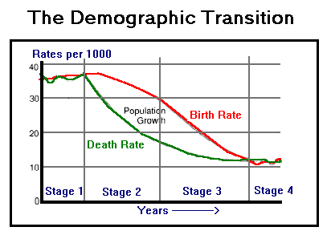
Stage 1
Birth rate and death rate are high - low natural increase - low total population
Prior to the Industrial Revolution, countries in Western Europe had a high Birth Rate and Death Rate. Births were high because more children meant more workers on the farm and with the high death rate, families needed more children to ensure survival of the family. Death rates were high due to disease and a lack of hygiene. The high BR and DR were somewhat stable and meant slow growth of a population. Occasional epidemics would dramatically increase the DR for a few years (represented by the "waves" in Stage I of the model.

Stage 2
Birth rate is high - death rate is falling - high natural increase (population growth)
In the mid-18th century, the death rate in Western European countries dropped due to improvement in sanitation and medicine. Out of tradition and practice, the birth rate remained high. This dropping death rate but stable birth rate in the beginning of Stage II contributed to skyrocketing population growth rates. Over time, children became an added expense and were less able to contribute to the wealth of a family. For this reason, along with advances in birth control, the BR was reduced through the 20th century in developed countries. Populations still grew rapidly but this growth began to slow down.
Many less developed countries are currently in Stage II of the model. For example, Kenya's high BR of 32 per 1000 but low DR of 14 per 1000 contribute to a high rate of growth (as in mid-Stage II).

Stage 3
Falling birth rate - low death rate - high natural increase (population growth)
In the late 20th century, the BR and DR in developed countries both levelled off at a low rate. In some cases the BR is slightly higher than the DR (as in the U.S. 14 versus 9) while in other countries the BR is less than the DR (as in Germany, 9 versus 11). Immigration from less developed countries now accounts for much of the population growth in developed countries that are in Stage III of the transition. Countries like China, South Korea, Singapore, and Cuba are rapidly approaching Stage III.

Stage 4
Birth rate and death rate is low - low natural increase - high total population
At this stage there is little fluctuation, and there is low population increase. Many MEDCs are at this stage. Japan, USA and UK are at this stage

Stage 5
The original theory had 4 stages but today some countries have gone to a next stage which is the 5th stage. At this stage the birth rate has fallen below the death rate. In countries like Sweden and Germany more people are dying than been born and the population is falling i.e. a negative natural increase

The Demographic Transition Model does not take into account migration

Population Structure / Population Pyramids/ Age-sex pyramid
The population structure for a country shows the number of males and females within different age groups in the population. Age-sex pyramids display the percentage or actual amount of a population broken down by gender and age.
Population pyramids of LEDCs (Less Economically Developed Countries) typically have a wide base and a narrow top. This represents a high birth rate and high death rate. Population pyramids of MEDCs (More Economically Developed Countries) typically have a roughly equal distribution of population throughout the age groups. The top obviously gets narrower as a result of deaths.
The most important demographic characteristic of a population is its age-sex structure. Age-sex pyramids (also known as population pyramids) graphically display this information to improve understanding and ease comparison.

There are three key types of population pyramids:

Rapid Growth
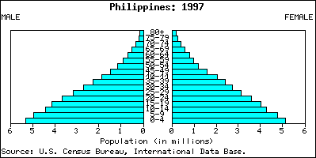
This pyramid of the Philippines (LEDC) shows a triangle-shaped pyramid and reflects a high growth rate of about 2.1 percent annually.

Slow Growth
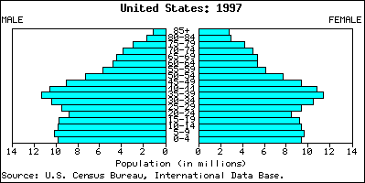
In the United States, the population is growing at a rate of about 1.7 percent annually. This growth rate is reflected in the more square-like structure of the pyramid. Note the lump in the pyramid between the ages of about 35 to 50. This large segment of the population is the post-World War II "baby boom." As this population ages and climbs up the pyramid, there will be a much greater demand for medical and other geriatric services.
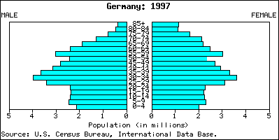
Germany is experiencing a period of negative growth (-0.1%). As negative growth in a country continues, the population is reduced. A population can shrink due to a low birth rate and a stable death rate. Increased emigration may also be a contributor to a declining population.
Population Problems in LEDCs
The population problem facing LEDCs is rapid population growth. Countries such as Nigeria, Bangladesh and China already have high population even limiting couples to have one child could still mean large population for them for many years to come. By having lots of children, they are creating a high dependency ratio. LEDCs tend to have lower Literacy Rates (the proportion of the total population able to read and write), this lack to education can mean women are not taught about contraception and are unlikely to have career aspirations.

Case study of youthful population structure: Gambia (or a country with rapid economic growth)
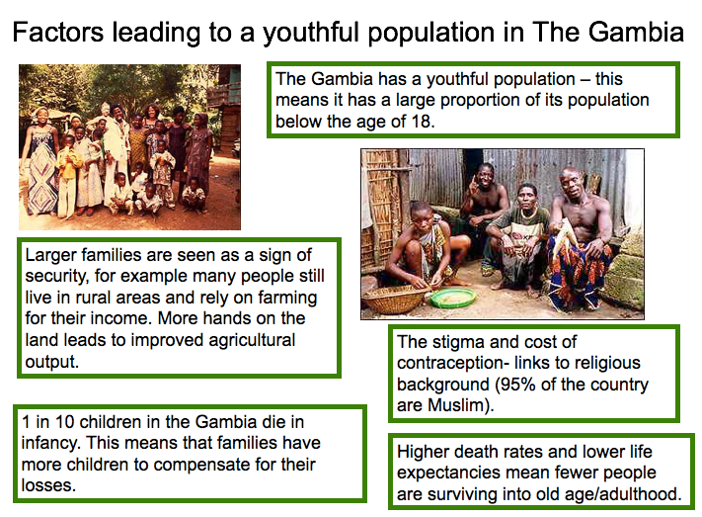
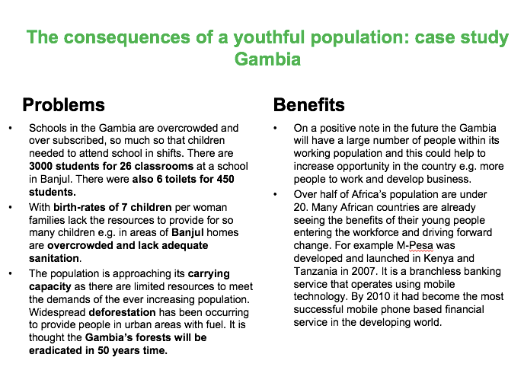
Population Problems in MEDCs
Ageing Population: In the population structure of many MEDCs there is often a high proportion of elderly people who have survived due to advances in nutrition and medical care. This creates problems since these people do not work and have to be provided with pensions, medical care, social support, sheltered housing etc. from the taxes paid by a proportionally smaller number of workers. In addition, an increasing number of young people are employed as care workers for the elderly. This removes them from more productive jobs within the economy and harms a country's competitiveness.

The number of people of non-working age compared to those of working age is called the Dependency Ratio. If this is high, that means there are more people not of working age (under 16 or over 65) than those of working age. A high dependency ratio can be difficult for a country’s government to manage.

Case study of an ageing population structure: Japan (or country with population decline)

Why does Japan have an ageing population?
- Japan has an ageing population, meaning that it has a large proportion of its population over the age of 65. Japan’s population is like this due to a combination of long life expectancies and a very low birth rate.
- Japan has one of the lowest birth rates in the world, with a fertility rate of just 1.4 children per woman. This is below the replacement rate for the country, meaning that Japan’s population will decline in the future. Japan has very low birth rates, due to a cultural preference for only having one child. However, Japan’s birth rate was higher in the past (especially during the post WW2 baby boom). These people are now reaching old age, however, there are fewer young people being added to the population to support them.
- Japan has the longest life expectancy in the world, with its citizens living to an average age of 83 years. This is because it is one of the wealthiest countries in the world and so it has an excellent healthcare system. The typical diet in Japan is also healthy, including lots of fish, fruit and vegetables – such a diet helps keep people healthy for longer.

What are the consequences of Japan’s ageing population?
Having an ageing population brings both positive and negative consequences for the country.

Positive Consequences:
- Many of Japan’s elderly do not retire at the age of 65, many continue in the workforce for much longer than this. This means that elderly people are still contributing to society e.g. through their work and the taxes they pay. They are therefore not dependent on others.
- When elderly people do retire they often add a lot to society in different ways, for example through unpaid work such as volunteering or caring for grand-children while their parents are working.

Negative Consequences:
- Japan has a high dependency ration, this means it has a lot of dependent people (those who are not working) relative to its economically active population. Since the taxes of the working population pay for the services of the ageing population (e.g. pensions, healthcare etc), having a lot of people to support can be problematic as there may not be adequate government money to pay for these services. The consequence can be that the government raises taxes for the working population to pay for the increased need for services. This is typically unpopular with the working population as it leaves them with less disposable income.
- Caring for elderly people in society often results on a burden for their relatives, who often need to act as carers for them. Because Japan’s life expectancy is so long, this often involves elderly people caring for even more elderly relatives. This can be stressful and very time consuming for those people for need to act as carers.
- Japan has a shortage of nurses and professional care workers because so many are needed to care for the ageing population. This causes the country to need to look for migrant labour to fill the shortage. However, immigration is unpopular in Japanese society and it is often difficult for immigrants to settle in to the country, especially due to the language barrier as Japanese is a very difficult language to learn.
- Pensions in Japan are low and 20% of elderly Japanese live below the poverty line. This can lead to a poor quality of life and there are growing numbers of elderly homeless people in Japan.
- It has been noted that 1/3 of the suicides in Japan are from the over 65 population. This can be the result of unhappiness and loneliness that can occur when people are widowed or when they have little contact with others.

How can Japan’s ageing population be managed?
Solutions:
- Increase birth rates (but, social attitudes and trends difficult to change)
- Reforms e.g. increasing child benefits, providing tax allowances for families, making child care more accessible
- Encourage immigration (to solve labor shortages—but, difficult for country to accept foreigners)
- Offer part time jobs for elderly population (less demanding)
- Increase retirement age so they can contribute to economy

Pro-natalist policy in Japan (a policy that encourages birth rate)
- The Government has introduced new laws like the 'Child Care' and 'Family Care Leave' Laws. In which parents can receive: -8 Weeks paid leave from work -Shorter Working hours -A maximum of 24 hours over-time a month
- Economic Incentives e.g. Yamatsuri, a town of 7,000 just north of Tokyo, offers parents $4,600 for the birth of a child and $460 a year for 10 years.
- Businesses have been urged to give their employees more time off to procreate.
- Shops offer discounts to larger families.
- -Child allowance is paid to families by the government.
- Despite government efforts and various incentives put in place the scheme was not a success. This is because the fertility rate only rose by 0.14% from 2005 to 2013.

The impact of HIV/AIDS on population structure

HIV/AIDS: Case Study Botswana

- Why is there an issue?
- Botswana has the 2nd highest rate of HIV infection in the world (35-38% of the population are infected, this compares to just 0.4-0.9% of the population in North America).
- What causes such high infection rates?
- Only 18% of people in Botswana are married, some men are polygamous – meaning many people have multiple sexual partners.
- Until the government awareness campaigns there was much ignorance considering HIV/AIDs.
- Lack of doctors/nurses
- Poverty led to some young women becoming prostitutes, increasing the spread of the virus.
- What are the issues/which groups of people are impacted?
- It is a social stigma to be diagnosed with the disease as people have been shunned by their communities. This means people avoid getting testing. If people don’t know they have the disease they are more likely to pass it on to others.
- Life expectancy has fallen dramatically as a result of the high rates of infection. The life expectancy in Botswana was 58 years in 2011, having fallen from 65 in 1991.
- The most affected group is those in the age range 15-40. This is the most productive sector of the population and so Botswana is facing a labour shortage as so many of the working population are dying/too sick to work. It is thought 1/3 of Botwana’s workforce is infected with the disease.
- Children have become orphans as their parents have passed away.
- Some children are living with the disease as they contracted it in-utero
- What are the solutions?
- Pregnant women have given anti-retroviral drugs since 2002. This has made a huge impact on infant mortality rates (there were 56 child deaths per 1000 in 2001 and 11.1 deaths per 1000 in 2011).
- Companies, such as Debswana (the National Mining company of Botswana) provide free healthcare and access to anti-retroviral drugs for all of their employees and their wives. They also run classes about safe-sex for their employees – including the use of condoms.
- The government carry out awareness campaigns on TV, Radio and Billboards.
- Routine testing for the virus is carried out and awareness campaigns are used to promote the effectiveness of anti-retroviral treatment.
- Condoms are distributed for free and the number of people receiving anti-retroviral treatment has steadily increased.
- How may this issue be changing the population structure?
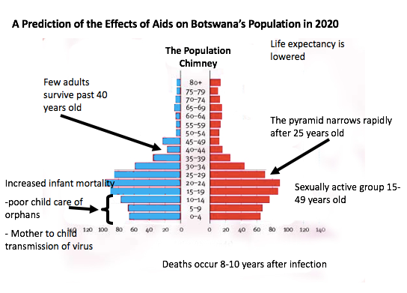

Managing population growth

An anti-natalist policy is a policy that aims to decrease birth rates.
An example of an anti-natalist policy is China’s One Child policy (1979-2015)

DECREASING BIRTHS – CHINA
During the 1960s and 70s China faced widespread famine as its population exploded out of control. In a controversial attempt to control the size of its population the Chinese government introduced the one-child policy in 1981. For almost 20 years no couple was allowed more than one child and those that did were severely penalised. After 1996 the policy was relaxed a little, particularly in rural areas where couples are allowed to have a second child if their first was a girl. The policy became a 2-child policy in October 2015.

During the One Child Policy, the Chinese government tried to control family size by offering incentives (rewards for following the policy) and disincentives (punishments for not following the policy.

Incentives and disincentives:
Incentives used to discourage childbirth –
- Cash payments – couples who sign up for the one child policy certificate would receive additional money which would mean that parents can provide their child with a better standard of living.
- Free healthcare for child – beneficial as less money would have to be spent on the healthcare of a sick child, therefore this money can be saved or spent on other needs.
- Free education for child – eases pressure on family to financially support their child with education. Allows for more disposable income.

Disincentives used to discourage childbirth –
- Fines – discourage people from not obeying the rules as fines can be large of up to 10-20% of annual salary, meaning that the standard of living for these families would decrease.
- Job loss – if parents were not able to earn a living, then important necessities like shelter and food would have to be compromised. This would mean that the family doesn’t have enough resources to accomplish their daily needs.
- Rice rations – when food handout are given in rural areas during times of shortages, governments won’t give equal amounts per head to families with more children. This will discourage people from having more children because the family may not have enough resources meet daily needs.
- Nanny police – These are older women in the community who spy on other community members and report people disobeying the policy to the authorities. China’s government is communist, so regime leaders are highly respected. Disobeying them would be taken very seriously and people would be afraid as being revealed as traitors to government ideals.

Impact of the policy:
- The birth rate in China has fallen since 1979, the Communist party credits the policy with preventing 400m births, thus contributing to China’s dramatic economic takeoff since the 1980s.
- However, there are many negative impacts of the policy:
- Many human rights campaigners have rallied against the policy for years saying that the Chinese government should not be able to dictate how many children people have.
- Due to a traditional preference for boys, large numbers of female babies have ended up homeless or in orphanages, and in some cases killed. In 2000, it was reported that 90 per cent of foetuses aborted in China were female.
- As a result, the gender balance of the Chinese population has become distorted. Today it is thought that men outnumber women by more than 60 million.

THE FUTURE:
While China's population is now rising more slowly, it still has a very large total population (1.3 billion in 2008) and China faces new problems, including:

- The falling birth rate - leading to a rise in the relative number of elderly people.
- Fewer people of working age to support the growing number of elderly dependents - in the future China could have an ageing population.
China Is trying to combat these negative impacts by relaxing the policy. Since 2015, the country has operated a 2-child policy to try to ensure that there are sufficient young people being added to the population. However, experts say that the relaxation of family planning rules is unlikely to have a lasting demographic impact, particularly in urban areas where couples were now reluctant to have two children because of the high cost.
Some people also believe the changes to the population policy haven’t gone far enough. Human rights campaigners would like to see an end to any government stipulations over the number of children families can have.
Migration
What is Migration?
Migration is the movement of people from one place to another.
What are the main types of migration?
Migration can be:
- Internal – Movement within a country Or International Moving from one country to another
- Voluntary Moving by choice Or Forced Having to move - reasons could include: war, famine, natural disaster, political asylum
- Permanent- with no intention of going back shortly Or Temporary/seasonal Moving for a short period of time
- Rural to urban Moving from the countryside to the city Or Urban to rural Moving from the city to the countryside
Push and Pull factors
Migration can occur as result of push and pull factors.
Push factors are those which force a person to move. This can include drought, famine, lack of jobs, over population and civil war.
Pull factors are those which encourage a person to move. These include a chance of a better job, better education, a better standard of living, availability of food, peace and wealth
Migration has a lot of advantages and disadvantages
 | Advantages | Disadvantages
To the host country | 1. source of labour- skilled and unskilled  2. Cultural exchange | 1. Strain on resources-housing, hospitals and education  2. Increase of unemployment  3. May cause racial tension, violence and discrimination
For the losing country | 1. May reduce burden on the country  2. Migrants send money to support families and friends  3. Help to sustain the local and national economy | 1. Loss of labour especially the skilled ones  2. Can cause diplomatic tensions if migrants are not treated properly
For the migrant and family | 1. May earn more money and improve standard of living  2. May meet new people and broaden cultural understanding. | High cost of living  May result in family separation

Case Study of International Migration: Mexico to USA

Location
Migration from Mexico to the United States Of America primarily involves the movement of Mexicans from Mexico to the southern states of America which border Mexico. In order to gain access to America, Mexicans must cross the “Unites States-Mexico Border”, a border which spans four US states & six Mexican states. In America, it starts in California and ends in Texas (east to west). Due to their proximity to the border & the high availability of work in these states, the majority of Mexicans move to California followed by Texas. California currently houses 11,423,000 immigrants with Texas holding 7,951,000.
Many Mexicans from rural communities migrate to America, the majority being males who move to America and then send money back to their families in Mexico. Many of these immigrants enter the country illegally, which often requires them to cross a large desert that separates Mexico and America and the Rio Grande. These journeys are dangerous and many immigrants have died, or nearly died, trying to cross into America through these routes.

Reasons for Migration

Push Factors
- There are incredibly high crime rates in Mexico, especially in the capital. Homicide rates come in at around 10-14 per 100,000 people (world average 10.9 per 100,000) and drug related crimes are a major concern. It is thought that in the past five years, 47,500 people have been killed in crimes relating to drugs. Many Mexicans will move out of fear for their lives and hope that America is a more stable place to live, with lower crime rates.
- Unemployment and poverty is a major problem in Mexico and has risen exponentially in recent years. In 2000, unemployment rates in Mexico were at 2.2, however, in 2009, they rose by 34.43%.. A large portion of the Mexican population are farmers, living in rural areas where extreme temperatures and poor quality land make it difficult to actually farm. This is causing many Mexican families to struggle, with 47% of the population living under the poverty line. With these high unemployment and poverty rates, people are forced to move to America, where they have better prospects, in order to be able to support their families and maintain a reasonable standard of living.
- The climate and natural hazards in Mexico could force people to move to America. Mexico is a very arid area which suffers from water shortages even in the more developed areas of Mexico. The country also suffers from natural disasters including volcanoes, earthquakes, hurricanes & tsunamis. Recent natural disasters could force people to migrate if their homes have been destroyed or made uninhabitable. People who live in danger zones could also migrate out of fear for their lives.

Pull Factors
- There is a noticeable difference in the quality of life between America & Mexico. Poverty, as mentioned above, is a major issue in Mexico, with 6% of the population lacking access to “improved” drinking water. Mexico’s infrastructure is severely undeveloped when compared to America’s. Despite being the 11thrichest country in the World, Mexico also has the 10th highest poverty. With America offering significantly better living standards and services, such as health care, people are enticed to move to America for a better life.
- Existing migrant communities in states such as Texas and California help to pull people towards migration. Existing communities make it easier for people to settle once moved and family members & friends who have already moved can encourage others to move. People are also enticed to move in order to be with their families. Cousins and brothers will often move in with their relatives after they have lived in America for a while in order to be with their family.
- 86.1% of the Mexican population can read & write versus 99% of the population in America. In addition, the majority of students in Mexico finish school at the age of 14, versus 16 in America. These statistics show that there are significantly better academic opportunities in America than in Mexico, which can entice Mexicans to migrate for an improved education, either for themselves or, more likely, their future children, in order to give them more opportunities in the world and allow them to gain higher paying jobs.

Impacts

Social
- Assimilation of Mexicans into American communities has been problematic. Many Mexicans can’t speak fluent English and studies show that their ability to speak English doesn’t improve drastically whilst they live in the US. This is largely due to them living in closed communities of other Mexican immigrants which reduces their need to assimilate with America. This can, in turn, create tension between migrants and locals which can, in extreme cases, lead to segregation, crime and violence.
- The introduction of Mexican cultural traditions to America, especially in states with large numbers of migrants, have helped to improve cultural aspects of those states. Mexican themed food has become incredibly popular in America with burrito and taco fast food shops opening up across the country. The new food & music has helped to improve the cultural diversity of America significantly.
- With such a large number of Mexican migrants not speaking English fluently, it is now common for Spanish to be taught in American schools, widening the skill set of the younger population and improving the potential career opportunities that students may have. This also (slightly) helps ease social tensions caused by people speaking different languages which locals don’t understand.
- With so many young people leaving Mexico, its developing an increasingly dependant population as the majority of people left are the elderly who can not work. Furthermore, the lack of young fertile couples is reducing the birth rate in Mexico, further increasing the dependency ratio as there is no workforce to pay taxes to support the elderly.
- The majority of migrants leaving Mexico are males leaving a population with a high number of females. This is problematic as they are unable to find partners, get married and, in a mostly catholic country, have children (out of wedlock). This is, as mentioned above, reducing the birth rate and increasing the dependency ratio.

Economic
- Mexican migrants often take low paying, menial jobs, which, while low paying, offer higher wages than what they’d earn in Mexico. This was, at first, advantageous, as many Americans did not want these low paying jobs but companies needed people to fill these jobs. Now, as unemployment rises in America, Americans want these menial jobs but many migrants already have taken the jobs. This can lead to increased social tension as Americans believe that their jobs are being taken.
- Migrants work at incredibly low wages. Americans who are desperate for work are now often expected to work at these incredibly low wages too, which they can’t afford to do, leading to increased poverty in America. Many companies are now also replacing American labour with cheaper migrant labour, also increasing unemployment rates are people are forced out of their jobs.
- While legal Mexican migrants are working & paying taxes, they often send money they earn back to their families in Mexico, rather than spending it in America, which can affect the country’s economy as there is less money being spent on products which are taxed in America. Conversely, the increased amount of money being sent back to Mexico is helping its economy greatly as people now have money to spend on goods and services.
- As people move out of Mexico, pressure on land, social services and jobs is being relieved. Unemployment will fall and health services will no longer be over capacity as the population is reduced. The problem, however, arises when the young and skilled workforce leaves, resulting in a shortage of potential workers to fill these newly freed jobs and to work in these social services. A shortage of medically trained people, for example, could counteract the relieved health system.
- Mexico’s population is very dependent on food grown in Mexico. Unfortunately, the majority of migrants come from rural areas, leaving a shortage of farmers and therefore the potential for food shortages in Mexico as the economically active people from rural areas leave.
Model Answer exam questions - IGCSE Geography: Topic Population

Describing questions

TIP: If it is a describe question and there is data to use, make sure you use it!

Q: Using historic and future global population growth describe the overall pattern of global population growth (4 marks).

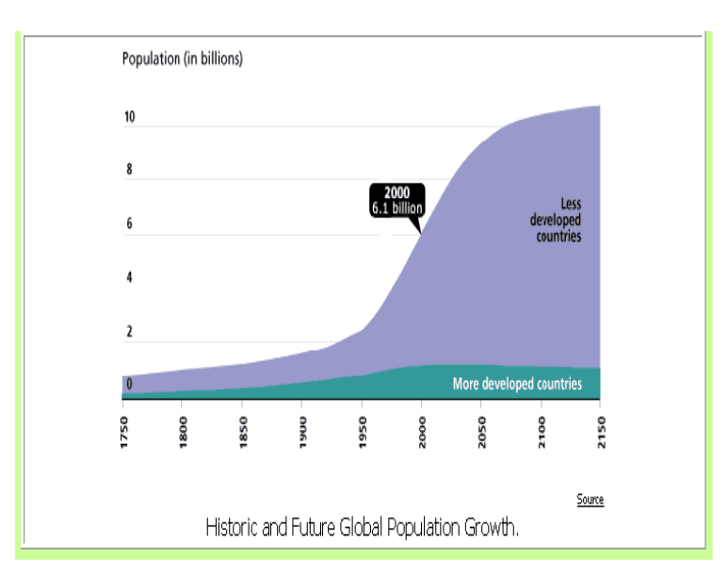

A: The overall pattern shows an increase in global population between 1750 and projected figures for 2150. Population was under 1 billion in 1750 and is projected to rise to over 10 million by 2150. Global population has increased rapidly from the 1950s onwards, particularly in LEDCs.

Q: Using historic and future global population growth describe the contribution made by LEDCs to global population growth.

A: LEDCs are responsible for contributing the most people to the world’s population. There has been a rapid rise in population growth in these countries since the 1950s and this has led to a population explosion. By 2150 it is projected that approximately 90% of the world’s population will be inhabitants of LEDCs.

Explaining questions – give reasons for the things you notice

TIP: For a 7 mark question, make sure you can include a case study (with specific facts and figures about the area)

Q: For a named country explain why natural population growth is taking place (7 marks)
A: The Gambia is a country in west Africa. It is a developing country, with high birth rates and falling death rates. It is at stage 2 of the demographic transition model. Whilst healthcare has improved, enabling death rates to fall, Gambia’s birth rate remains high.
There are religious, cultural and economic reasons why birth rates continue to be high in the Gambia. One reason is that due to the religious beliefs held many in the country. 95% of people in the Gambia are Muslim and Islamic religious teachers have often taught that contraception should not be used. As a result, it is a cultural taboo in society to use contraception or discuss family planning.
An economic reason for high birth rates is that many people in the Gambia still live in the countryside and rely on farming for their income. It has often been thought that more hands on the land means better agricultural production and so children help their families to cultivate the crops.
These factors contribute to a rapid increase in Gambia’s population as birth rates are still very high, with 7 children been born on average per woman, whilst death rates have been declining.

Another 7 mark question:
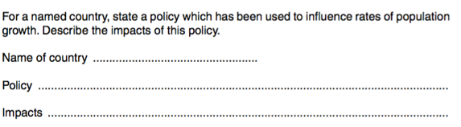

A: Name of the country: China

Policy: One Child Policy

Impacts:

The communist government of China, introduced the One Child policy in 1979; it was finally relaxed in 2015. After more than 30 years of the policy, it is now a 2 child policy. The birth rate in China has consequently fallen since 1979; the Communist party credits the policy with preventing 400m births, thus contributing to China’s dramatic economic takeoff since the 1980s.
However, there are many negative impacts of the policy. For example, many human rights campaigners have rallied against the policy for years saying that the Chinese government should not be able to dictate how many children people have. Indeed, it is believed by many that the current 2 child policy does not go far enough in protecting people’s rights and freedoms.
Due to a traditional preference for boys, large numbers of female babies have ended up homeless or in orphanages, and in some cases killed. In 2000, it was reported that 90 per cent of foetuses aborted in China were female. As a result, the gender balance of the Chinese population has become distorted. Today it is thought that men outnumber women by more than 60 million.
Today, China faces new problems; including a rise in the relative number of elderly people, compared to the young. This means that in the future China may have an ageing population.

Q: Describe the problems caused by an ageing population (7).

A: Japan is a country that has an ageing population, meaning it has a large proportion of its population in the over 65 age group. This situation has presented Japan with several problems.
One problem is that it often costs a lot of money to care for elderly people, especially as they reach the older age groups, as people can become increasingly frail and many require specialized care. This means that more government money needs to be spent on services such as healthcare and state-run retirement homes, leaving less money for other societal needs.
Caring for elderly people in society often results on a burden for their relatives, who often need to act as carers for them. Because Japan’s life expectancy is so long (average life expectancy is 83 years), this often involves elderly people caring for even more elderly relatives. This can be stressful and very time consuming for these carers.
Japan has a shortage of nurses and professional care workers, because so many are needed to care for the ageing population. This causes the country to need to look for migrant labour to fill the shortage. However, immigration is unpopular in Japanese society and it is often difficult for immigrants to settle in to the country; especially due to the language barrier as Japanese is a very difficult language to learn.
A final problem is that pensions in Japan are low, as a result 20% of elderly Japanese live below the poverty line. This can lead to a poor quality of life and there are an increasing number homeless people amongst Japan’s ageing population. Sadly 1/3 of Japan’s suicides are from Japan’s over 65 population.

Exam board mark-scheme:

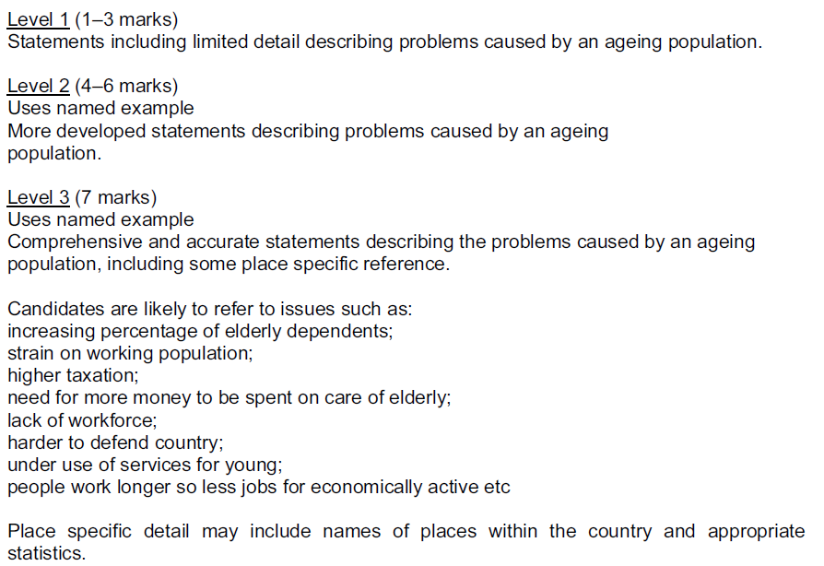

Model HIV 7 mark answer written by the year 11 geography revision class on 9th March
The size and structure of the population in a country may change as a result of HIV/AIDS. For a country, you have studied, describe the impacts of HIV/AIDS on the population and economy. (7)

Botswana is a country in Southern Africa. 20% of the population are suffering from HIV and aids. Because of the HIV outbreak, the life expectancy has dropped from 65 to 45. Many children suffer from the disease as it is passed in womb from mother to baby. Many children also are orphans due to death of parents from the disease = high dependency ratio. As the economically active population are dying, this has impacted economic productivity. For example, one of Botswana’s main exports are diamonds and they have had a loss of miners.

Examples of 7 mark questions

2007: Overpopulation occurs when there are too many people living in an area for the resources which are available. What problems are caused by overpopulation? You should refer to a country or area which you have studied. [7]
2007: International migration is the movement of people from one country to another. Choose any example of international migration and name the countries between which people moved. Explain why many people made the decision to migrate. You should refer both to pull and to push factors. [7]
2008: Choose any example of international migration which you have studied and name the countries between which people moved. Explain why many people made the decision to migrate. You should refer both to pull and to push factors. [7]
2009: For a named area which you have studied, explain why it has a low population density. [7]
2010: The size and structure of the population in a country may change as a result of HIV/AIDS. For a country which you have studied, describe the impacts of HIV/AIDS on the population and economy. [7]
2010: For a named country which you have studied, describe the policies which have been used by the government to influence rates of natural population growth. [7]
2010: For a country which you have studied, explain why the government is worried about its rapid population growth. [7]
2010: Choose an example of rural to urban migration in an LEDC which you have studied. Name the areas between which people moved and explain why many people migrated. You should refer both to pull and to push factors. [7]
2011: For a named country which you have studied, describe and explain the distribution of its population. [7]
2011: For a named country which you have studied, describe the problems caused by overpopulation. [7]
2011: Name an example of a country which has attracted large numbers of international migrants. Explain the pull factors which have attracted people to your chosen country. [7]
2012: For an example of international migration which you have studied, name the countries between which people moved. Explain why many people made the decision to migrate. You should refer both to pull and to push factors. [7]
2012: For a named country which you have studied, explain why the birth rate is high. [7]
2012: For a named country which you have studied, describe the problems caused by an increase in the percentage of the population over the age of 65. [7]
2012: For a named country which you have studied, describe the problems caused by under-population. [7]
2012: For a named country which you have studied, describe the problems caused by an ageing population. [7]
2013: For a named country, state a policy which has been used to influence rates of population growth. Describe the impacts of this policy. [7]
2013: Choose any example of international migration which you have studied and name the countries between which people moved. Explain why many people made the decision to migrate. You should refer both to pull and to push factors. [7]
2013: For a named country which you have studied, describe the distribution of its population and draw a labelled sketch map to show this distribution. [7]
2013: Choose any example of international migration which you have studied and name the countries between which people moved. Explain why many people made the decision to migrate. You should refer both to pull and to push factors. [7]
2013: Choose an example of an international migration which you have studied and name the countries between which people moved. By reference to both pull and push factors, explain why many people made the decision to migrate. [7]
2013: For a named country which you have studied, explain why the rate of natural population growth is low. [7]
2013: For a named example of a country you have studied, describe the policy or policies used by the government to reduce birth rates. [7]
2016: For a named country you have studied, describe and explain the problems caused by under- population. [7]
2017: For a named country you have studied, explain why rapid natural population growth is taking place. [7]
2017: For a named country you have studied, explain why the natural population growth rate is low. [7]

