Environmental Risks – Polluting Industries
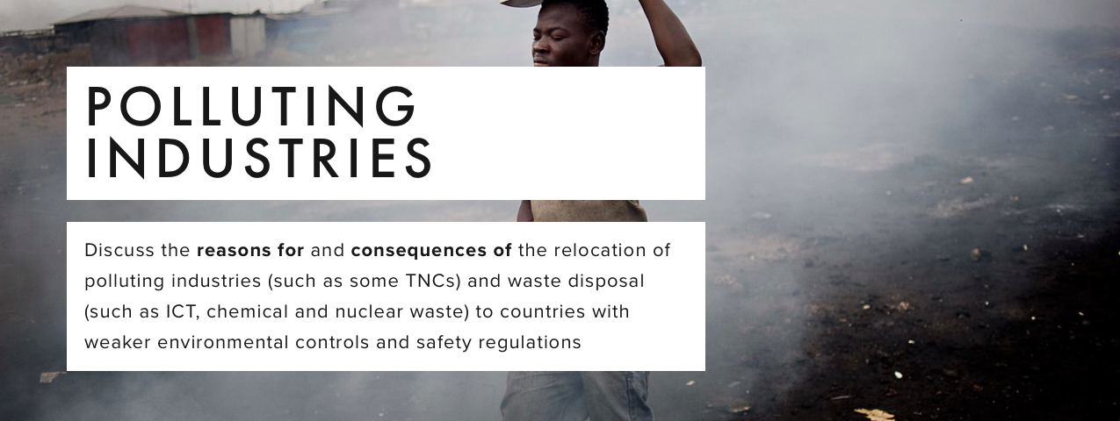

- What is meant by ‘the global shift in industry’?
- What are the reasons for the global shift?
- What is meant by a negative externality?
- Why do many polluting industries decide to locate in developing countries?
- Explain the theory shown in the Kuznet curve
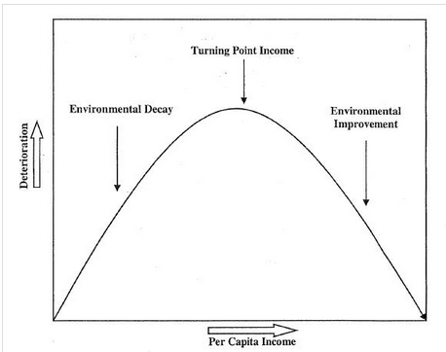

Case study – textiles in Bangladesh
- Make notes on the negative (and positive?) externalities that occur in Bangladesh due to the relocation of manufacturing industries here.
- How can the negative impacts be reduced?
- Who should pay for the negative externalities?
- Use ‘water pollution in Bangladesh’ and make notes on the causes and issues of water pollution
- Explain in about 500 words whether further pollution controls in Bangladesh would bring benefits or problems
Case study – e-waste in Ghana (you should be able to use your previous notes for this)
- Why is e-waste a problem?
- What areas are affected in Ghana?
- Why is so much e-waste located here?
Carbon footprints
- What is meant by the ‘carbon footprint of food’?
- Describe the food miles of a Christmas dinner
Agribusiness
- What is agribusiness?
- How does it result in environmental risks?
- Why are Green beans (and flowers) for the UK being grown in Kenya?
- What are the consequences of this?

Exam question: “Global interactions result in some form of environmental damage being experienced everywhere.” Discuss this statement.

