News story  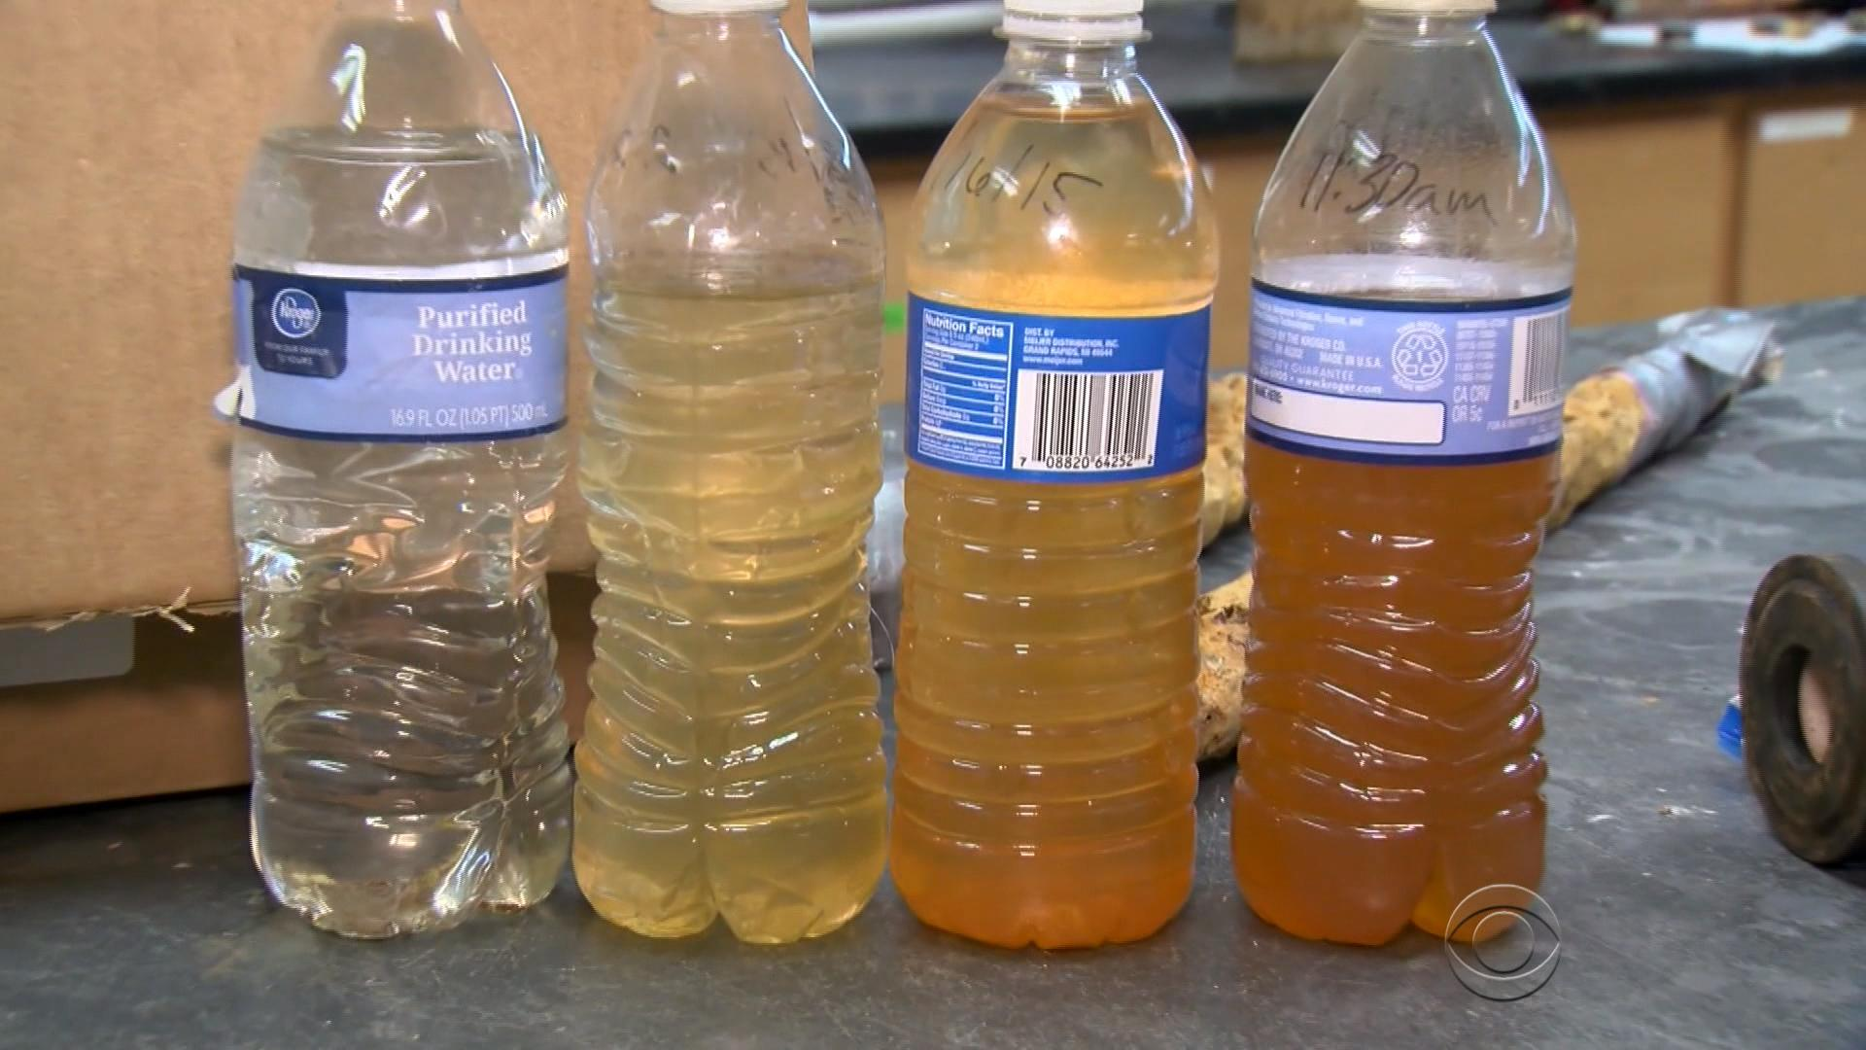  Flint once thrived as the home of the nation's largest General Motors plant. The city's economic decline began during the 1980s, when GM downsized. In 2011, the state of Michigan took over Flint's finances after an audit projected a $25 million deficit.  In order to reduce the water fund shortfall, the city announced that a new pipeline would be built to deliver water from Lake Huron to Flint. In 2014, while the pipeline was under construction, the city turned to the Flint River as a water source. Soon after the switch, residents reported changes to the water's color, smell and taste. Tests in 2015 by the Environmental Protection Agency (EPA) and Virginia Tech indicated dangerous levels of lead in the water at residents' homes. Lead consumption can affect the heart, kidneys and nerves. Health effects of lead exposure in children include impaired cognition, behavioral disorders, hearing problems and delayed puberty. | Diagram
C  L  A  Stakeholders  Pros and cons  Priorities | Conclusion – Why is this policy preferred over others?

News story  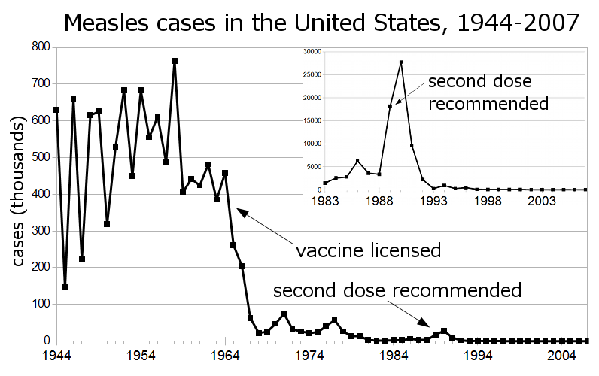  From January 1 to December 5, 2019, the USA reported 1276 confirmed measles cases spanning 31 states, among them 124 were hospitalized and 61 have serious complication like pneumonia and encephalitis, compared with 372 reported cases in 2018, 120 in 2017, 86 in 2016, 188 in 2015, and 667 in 2014 [1]. This is the greatest number of cases reported in the USA since 1992 while measles was declared officially eliminated in the US in 2000 [1]. More than 75% of the cases this year are linked to recent outbreaks in New York. | Diagram
C  L  A  Stakeholders  Pros and cons  Priorities | Conclusion – Why is this policy preferred over others?

News story  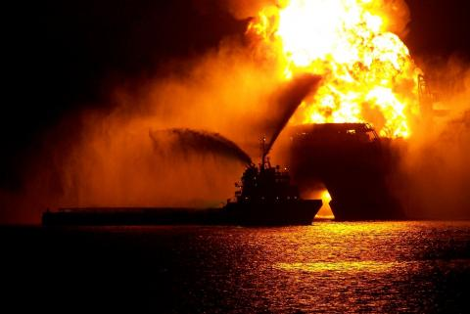  The blowout and oil spill on the Deepwater Horizon in the Gulf of Mexico was caused by a flawed well plan that did not include enough cement between the 7-inch production casing and the 9 7/8-inch protection casing. The presumed blowout preventer (BOP) failure is an important but secondary issue.  Judge Barbier said BP should shoulder 67% of the blame for the 2010 spill, with drilling rig owner Transocean responsible for 30% and cement firm Halliburton responsible for 3%. He ruled that BP will be "subject to enhanced civil penalties" due to its "gross negligence" and "wilful misconduct". BP was ordered to pay $5.5 billion to settle civil damages claims made by the U.S. as a result of the Deepwater Horizon oil spill. The amount will be paid over the course of 16 years. | Diagram
C  L  A  Stakeholders  Pros and cons  Priorities | Conclusion – Why is this policy preferred over others?

News story  Cases of lung illness and deaths from vaping have tapered off since peaking in September, health officials said on Thursday, but the outbreak also reached a grim new milestone: The youngest death, of a 15-year-old, was reported by Dallas County Health and Human Services.  The teenager had “a chronic underlying medical condition,” Texas officials said in a statement on Dec. 31, but they did not identify the condition, the patient’s gender or what products the patient had been vaping. | Diagram
C  L  A  Stakeholders  Pros and cons  Priorities | Conclusion – Why is this policy preferred over others?

News story  At the beginning of May, American space exploration agency NASA issued a press release announcing a newly established searchable public database of NASA’s expired patents. These patents cover thousands of technologies which are already in the public domain, but NASA has made it much easier to examine its patents by operating its own portal. Also announced was the release of 56 formerly-patented technologies to the public domain so that they can be used by commercial enterprises prior to their expiration. | Diagram
C  L  A  Stakeholders  Pros and cons  Priorities | Conclusion – Why is this policy preferred over others?

