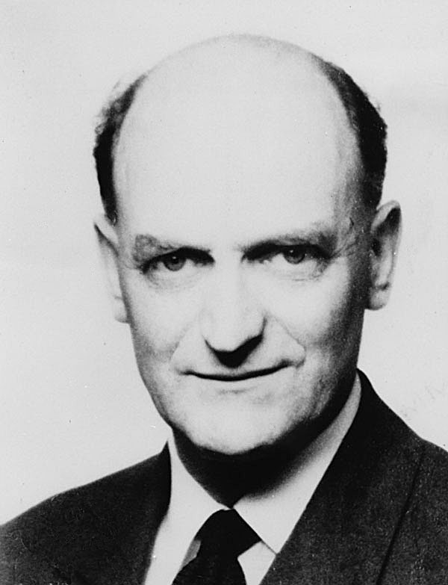
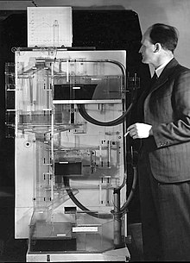

You May Remember The MONIAC
The NZ Economist A.W. Phillips

Some Broader Questions to Think About During This Topic
To what extent does the Phillips curve challenge the traditional trade-off between inflation and unemployment?
How does the Phillips curve concept influence government policies aimed at managing inflation and unemployment?
How does the Phillips curve relate to the concept of natural rate of unemployment? Can the natural rate of unemployment be manipulated through government policies?
What are the implications of a "flattening" or "disappearing" Phillips curve? How does it challenge our understanding of the relationship between inflation and unemployment?

The Phillips Curve
In today’s lesson we will be covering the Phillips curve and looking at :

- The original Phillips curve.
- How to derive a Phillips curve.
- Arguments related to the Phillips curve.

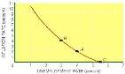
1. The original Phillips curve was based on data relating to the rate of change of money wages and the rate of unemployment.

What relationship do you imagine there would be between the rate of change of money wages and the rate of unemployment?

On the graph below plot the Phillips curve.

Rate of change of money wages

Unemployment rate %

- Other economists thought that this research gave a good insight into the relationship between inflation and unemployment.

How are changes in wages and changes in prices linked?

- Using the inflation and unemployment data below can you plot the relationship between the two variables?

Year | Unemployment (% of workforce) | Inflation (% change)
1974 | 2.0 | 17.0
1975 | 3.2 | 23.5
1976 | 4.8 | 15.7
1977 | 5.1 | 14.7
1978 | 5.0 | 9.5
1979 | 4.6 | 13.7
1980 | 5.6 | 16.3
1981 | 8.9 | 11.2
1982 | 10.3 | 8.7
1983 | 11.1 | 4.8
1984 | 11.1 | 5.0
1985 | 11.5 | 5.3
1986 | 11.5 | 4.0
1987 | 10.6 | 4.3
1988 | 8.7 | 5.0
1989 | 7.3 | 5.9
1990 | 7.0 | 5.5
1991 | 8.8 | 7.4
1992 | 10.1 | 4.7
1993 | 10.4 | 3.5
1994 | 9.6 | 2.5
1995 | 8.8 | 2.6
1996 | 8.4 | 2.7
1997 | 5.8 | 3.4

Inflation
%

Unemployment %

- Show the basic shape of the Phillips curve on the diagram below.

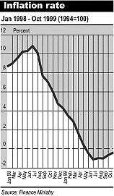
Inflation
%

Unemployment %

- If the government decides to increase government spending ( policy) in order to boost the economy what will happen in the economy? (Illustrate on the diagram above)

- The rate of inflation will now be at 4%. In the short-term workers suffer from a « Money Illusion ». They don`t realise that in real terms their wages have actually :-

- When they do realise their wages have fallen in real terms? What action might they take ?

- How big an increase in wages will the workers demand?

- What impact will this have on the rate of inflation?

- Illustrate this on the diagram on the next page.

Inflation
%

Unemployment %

- If the government tries to increase government spending one more time once the economy is at point C what will happen?

- To what rate of unemployment will the economy tend?

- What do we call this rate of unemployment?

- On the diagram below illustrate the Classical Phillips Curve.

Inflation
%

Unemployment %

- How would Classical economists advocate reducing the rate of unemployment?

- Illustrate this on the diagram below.

Inflatio n
%

Unemployment %

Stagflation

  - What do you understand by the term Stagflation?

  - Draw a diagram to show that one would normally associate rising prices with lower levels of unemployment.

Price Level

Real G.D.P.

  - What is an external supply-side shock and what shock occurred in the 1970s?

  - Draw a diagram to show what happened to the U.K./U.S. economy when there was a supply-side shock.

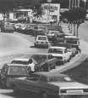
Price Level

Real G.D.P.

  - Why was there an increase in aggregate demand at the end of the 1970’s?

  - Would the economy remain at point C?

Classical economists

Price Level

Real G.D.P.
Keynesian Economists

Price Level

Real G.D.P.

  - On the Phillips Curve below illustrate the concept of ‘stagflation’.

Inflation
%

