Resource consumption week 1: The patterns of wealth
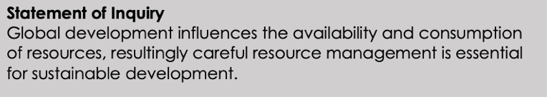

How: Map/ Data response….
Inquiry Question 1: Where in the world is the wealth?
Open up the map here: http://esriurl.com/enviroGeoinquiry13
Explore the map and use it to answer the following questions:
- Which regions of the world earn the highest annual salaries?
- What are some of the top earning countries? Are there any surprises?
Step: In the Details pane, click the ‘Show Contents Of Map’ button. Point to the Gross National Income By Country, 2014 layer, and click the Show Table button.
Step: In the table, click the Gross National Income Per Capita, PPP column header and sort descending.
- What countries have the top five highest gross national income (GNI) earnings in the table?
- What are the lowest GNI earning countries? (Hint: In the same column, sort ascending.)

Inquiry Question 2: What are the negative effects of high or low wages?
- What environmental issues have you heard about that one of the high-earning countries named in question 3 faces?
- What environmental issues have you heard about in the low-earning countries?

Inquiry Question 3: Who leaves the lights on?
Step: Click the checkbox to the left of the layer named, Energy Use By Country, 2010.
- Per capita, what countries consume the most energy?
- What are life expectancy and adult literacy like in low-energy-consuming countries?

Inquiry Question 4: What does human quality of life look like in different countries?
Info: The Human Development Index (HDI) combines several country statistics to monitor progress toward improving quality of human life- GNI, adult literacy and life expectancy.
Step: Turn off all selected layers, and turn on the Human Development Index By Country, 1980-2010 Time Series layer. Notice a new time slider bar appears at the bottom of the map.
- What areas of the world have made improvements?
- What do you think has contributed to this growth?

Inquiry Question 5: How do earnings and energy consumption vary with human development?
- How does GNI relate to HDI countries pre-2010?
- How does GNI relate in countries with high HDI after 2010?
- Does greater energy usage result in a greater increase in industrial production?
Guidance
