Year 8 baseline assessment
What is the pattern of population distribution and density in the USA?

What: To produce a choropleth map to show the pattern of population density/distribution in the US
Why: So that we can use geographical skills to analyse US population patterns
How:
- Handle data correctly
- Present the data in a geographically appropriate way
- Describe and explain data
- Analyse route to enquiry

The route to enquiry (the learning cycle)
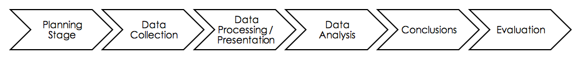

1: Planning stage:

What do you think the population distribution/density will be like in the USA?
Can you predict where the most densely and sparsely populated areas will be?

Geographical Enquiry Focus

Enquiry Question:

Hypotheses:

2: Data collection

Calculate the population densities for the 50 US states (using the worksheet).

3: Data processing/ presentation

Using the data collected produce a choropleth map. The map should have a key and a clear and descriptive title should be provided.

4: Data analysis/ conclusion

Describe data- what is the general trend? i.e. How is population spread out across the USA (distribution)? Which regions of the USA are more densely/sparsely populated?
Use specific examples from the map to back up your description. Also use figures (numerical data).
Are there any anomalies in your data (things that do not fit the overall pattern)?
Explain why you may have got the patterns you have found (may require additional research)

What conclusions can we draw from this?

5: Evaluation
How successful is a choropleth map in showing the pattern of population distribution in the USA?
Does your data tell the whole story?

Key words glossary:

- Population distribution: The way people are spread across the earth’s surface e.g. nucleated, random, dispersed.

- Population density: The number of people in a given area (e.g. the number of people per km squared)

- Sparsely populated: few people in a given area (less than 50 people per square km)

- Medium population density: a moderate amount of people in a given area (50-250 people per square km)

- Densely populated: a crowded area (more than 250 people per square km)

