**On the Silk Road with Sam Willis**

In a new BBC Four series Dr Sam Willis reveals how the Silk Road was the world's first global superhighway where people with new ideas, new cultures and new religions made exchanges that shaped humanity. Here, Willis tells *BBC History Magazine*’s TV editor, Jonathan Wright, about the series, about his experiences travelling to places that were once among the most connected and cosmopolitan in the world, and why we’ve got the Silk Road to thank for rhubarb crumble…..

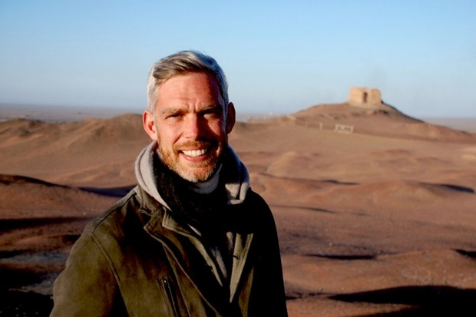

According to Willis, “The Silk Road cut across borders and broke down the borders in our minds”. It’s a quote that in itself does much to explain why Willis wanted to explore the route, which once linked China’s ancient capital Xian with Venice, and its history…

**Q: What was the spark for the series?**

**A:** I have always been interested in undertaking an enormous journey – one that would be almost too difficult to fathom – and to travel as a historian rather than as a tourist. I think that the Silk Road attracted me because of the scale of the challenge: 5,000 miles, so many cultures, so many countries, so many people, so many stories. I am also fascinated by the unknown; I like visiting places and studying parts of history that are entirely new to me.

**Q: You had a lot of ground to cover – how did you choose where to spend time?**

**A:** I realised early on that there were certain major building blocks that we could start with. I wanted to emphasise certain major themes: how the Silk Road transported not just goods but ideas, religion, culture, war and peace, and those themes dictated certain locations.

I also wanted to experience the full range of climate – from the hottest desert on earth (in Iran) to the snow-covered mountains of Tajikistan. My favourite place was an extraordinary desert in central China that was like the moon. It was full of grey stones about the size of golf balls.

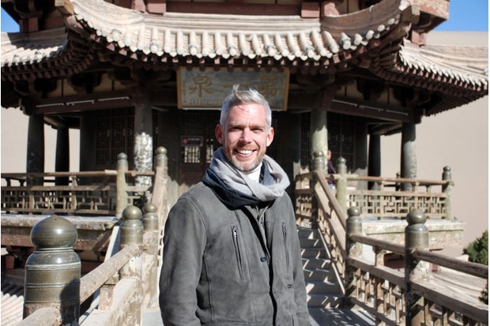

*Dr Sam Willis in China. (BBC/Alastair McCormick)*

**Q: Perhaps we don’t always realise how connected our forebears were. Did making the journey give you any insights into this?**

**A:** The one major theme that comes out of the programme and of my personal experience is one of connection – and the flip side of that is how isolated we Europeans seem to have been. The countries of central Asia were most aware of what was happening everywhere because of the constant influence of trade, and people coming from both east and west. Above all, the Iranians were and certainly still are most conscious – and proud – of this. They felt as if they were in the centre of the world.

**Q: What was it like visiting Iran?**

**A:** It is staggeringly beautiful and the people are so fascinated in their own history and place in the world. They were polite, kind, thoughtful, generous, interested, interesting, charming and funny. They found the idea of a western film crew quite bewildering. “Where are you from?” they would all ask in mild astonishment. The answer, Glasgow (the programme was commissioned out of BBC Arts in Scotland), then confused them even more. I would urge you all to go.

We were there on the day that the sanctions were lifted and there was a tangible sense of excitement and promise, and if I know one thing now it is that the Iranians are endlessly resourceful. They will now make that country even more magical than the bones of it already are.

**Q: How difficult was it to get all the necessary permissions to film?**

**A:** This was very difficult. Iran, Uzbekistan and China are three of the most difficult countries for any film crew to access but we stuck to our guns and the gamble paid off. There were one or two major hiccups, not least when we spent a week filming in Tajikistan and were waiting to receive our visas for Uzbekistan, which never arrived. We had no choice but to fly home, with a massive hole in our documentary and very low morale.

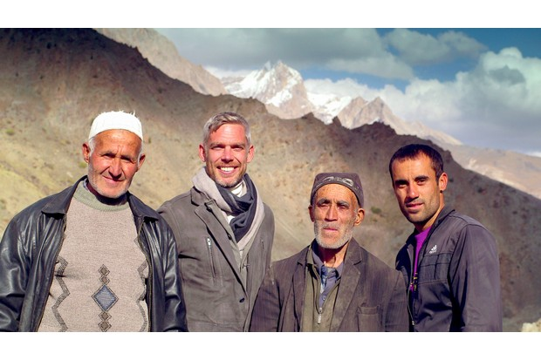

Fortunately, a number of weeks later the permissions came through and we made it to Uzbekistan, which meant that we could visit the iconic Silk Road cities of Samarkand, Bukhara and Khiva – places that changed the world as we know it.

**Q: Was there a favourite moment during filming?**

**A:** An extraordinary experience was visiting a very remote valley in Tajikistan, the Yaghnob Valley, which is populated by a tribe of people who are related to the Sogdians, who once dominated the Silk Road trade of central Asia but were dominated by countless invading armies and forced to hide in the mountains. These folk – and there are very few of them indeed – still speak Sogdian. To hear them speak is to hear history at least 2,000 years old. It sent a shiver up my spine because the language is dying.

**Q: What other themes does the shows throw up?**

**A:**I like one of the simplest of all examples of the power of the Silk Road. In Venice, on the corner of a house overlooking a canal, is a statue of a man carrying a bag of rhubarb on his back. He is a rhubarb merchant, but rhubarb comes from China. So, although the Silk Road helped spread such world-defining ideas as algebra, paper, printing and gunpowder, it also spread rhubarb: no Silk Road, my friends, no rhubarb crumble.

**Sam Willis’s three-part series**[***The Silk Road***](http://www.bbc.co.uk/programmes/p03qb130)**airs on BBC Four on Sunday 1 May at 9pm.**