Oklahoma tornado: Dozens killed
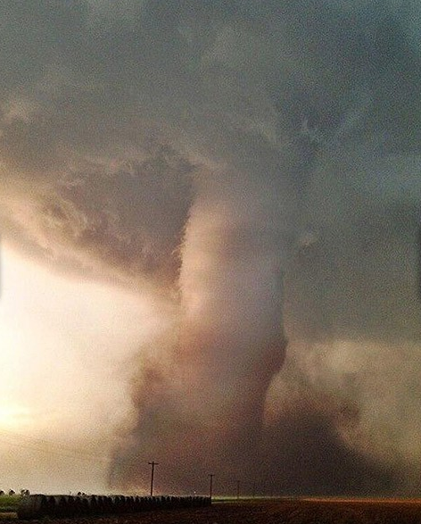
At least 91 people, including 20 children, are feared to have been killed by a huge tornado which tore through Oklahoma. Worst hit was Moore, south of the city, where homes were flattened and schools destroyed by winds of up to 200mph. About 120 people are being treated in hospitals.
President Barack Obama has declared a major disaster in Oklahoma. He also ordered federal authorities to join in the search efforts which have continued throughout the night.
A volunteer with a canine search-and-rescue group told me his team was getting ready to go in, but there is a lot of ground to cover and many people still missing.
Monday's twister hit Moore, a suburb of about 55,000 people, at 14:56 and remained on the ground for about 45 minutes.
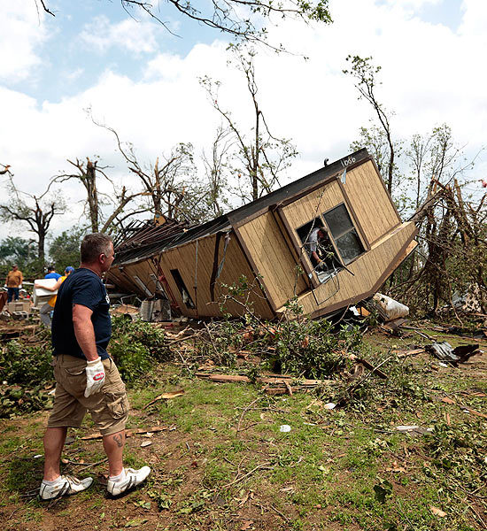
The official death toll is 51, but local authorities say the figure is expected to rise as another 40 bodies have been found. At least 20 children were among the dead, the Oklahoma chief medical examiner's office said.
Lt Gov Lamb said Moore had been prepared for a tornado, but not of this strength: "There was a warning in place, but when it veers and is as extensive as this one is - two miles wide - on the ground for 45 minutes, that is just wreaking havoc that it's hard to get out of the way of."
The storm destroyed several areas, leaving a tangle of ruined buildings, piles of broken wood, overturned and crushed cars, and fires in some places. Many houses are built on hard ground without basements, so residents did not have places to shelter.

Oklahoma tornado
- Use 4 different colours to highlight the article you have been given to answer these questions:
- Write the information in the correct boxes
- What are the facts of the tornado (date, time, people injured, people dead…)?

- What were the effects on people ?

- What were the effects on the environment ?

- Why was the damage so bad?

What do you think can be done to reduce the damage?

