IB DP Geography – Powerful Organisations and Groups

Name of organisation / group | The OECD | Logo / Brand  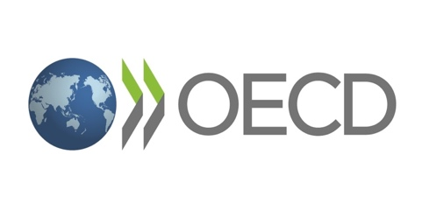
Year Established | September 30th, 1961
Brief History of the organisation / Group including any recent member changes.
The Organisation for European Economic Cooperation (OEEC) was established in 1948 to run the US-financed Marshall Plan for reconstruction of a continent ravaged by war. By making individual governments recognise the interdependence of their economies, it paved the way for a new era of cooperation that was to change the face of Europe. Encouraged by its success and the prospect of carrying its work forward on a global stage, Canada and the US joined OEEC members in signing the new OECD Convention on 14 December 1960. The Organisation for Economic Co-operation and Development (OECD) was officially born on 30 September 1961, when the Convention entered into force.
Other countries joined in, starting with Japan in 1964. Today, 36 OECD member countries worldwide regularly turn to one another to identify problems, discuss and analyse them, and promote policies to solve them. The track record is striking. The US has seen its national wealth almost triple in the five decades since the OECD was created, calculated in terms of gross domestic product per head of population. Other OECD countries have seen similar, and in some cases even more spectacular, progress.
So, too, have countries that a few decades ago were still only minor players on the world stage. Brazil, India and the People's Republic of China have emerged as new economic giants. The three of them, with Indonesia and South Africa, are Key Partners of the Organisation and contribute to its work in a sustained and comprehensive manner. Together with them, the OECD brings around its table 39 countries that account for 80% of world trade and investment, giving it a pivotal role in addressing the challenges facing the world economy.

Country of Base / Headquarters. | Paris, France
Recent News Story Notes | Example of how it is a co-operation or aims to influence policies and on what scale.
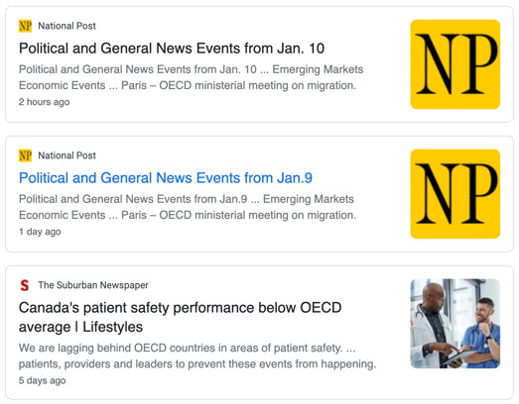 | The Organization for Economic Cooperation and Development (OECD) is a unique forum where the governments of 36 member states with market economies work with each other, as well as with more than 70 non-member economies to promote economic growth, prosperity, and sustainable development. They ‘promote policies that will improve the economic and social well-being of people around the world’  They also agreed to work together to tackle the challenge of ageing population.
Criticisms of the organisation / group activities | Key powers identified for criticism.
OECD economists failed utterly to predict the slowdown in the world economy which began in 2008 due to a huge oversight.  - International flows of trade grew steadily between 1990 to 2007 before collapsing the year later  - Annual cross border capital flows of USD 3 trillion is well below their 2007 peak of USD 8.5 trillion | “A rich man’s club”, include perceived narrowness of its membership; it excludes major market players like China, and critics point to an overarching like-mindedness of its members as hindering more effective outreach and engagement.
Map to show spatial spread of influence of the organisation / group | Memorable photo from recent event linked to the organisation / group
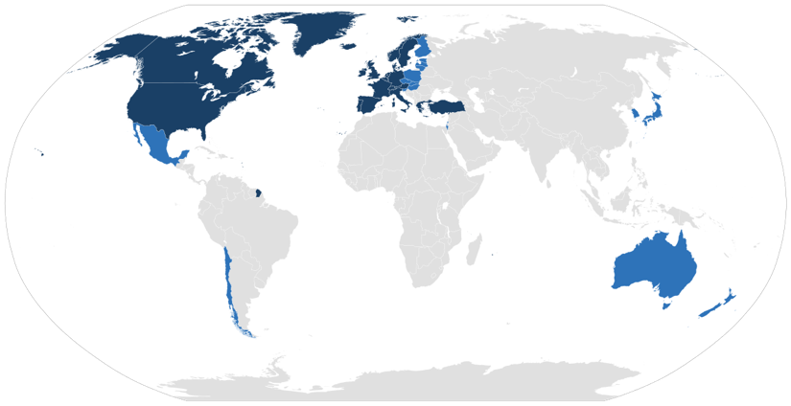 | 