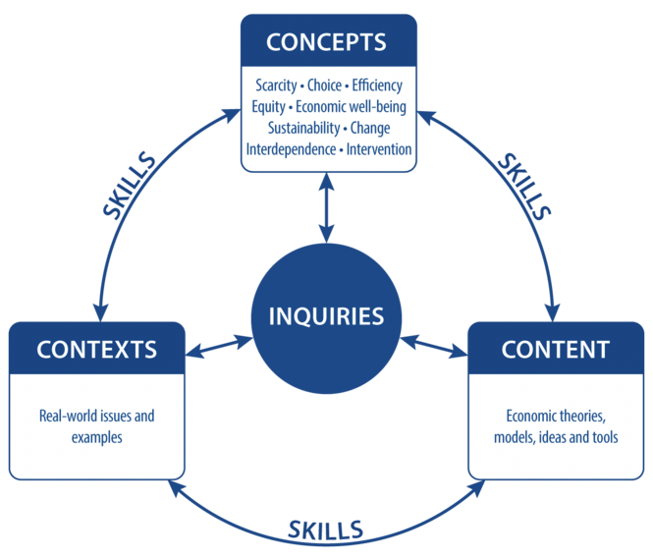

IB Inquiry Title:

How can we improve BISH?

IB Concepts:

Scarcity-Choice-Efficiency-equity-Economic well-being

Sustainability - Change-Interdependence-Intervention

* Choice

IB Content:

Economic theories, models, ideas and tools

* Cognitive biases
* Choice architecture
* Nudge theory

Contexts:

Real world issues and examples

* Responsible consumption and production
* Health and Safety
* Learning at BISH
* Environment at BISH

Outcome:

1. Justification for 5 improvements that could

be presented to SLT

2. Write a report for presentation

Concepts

Context

Inquiry

Content