Equity in the distribution of income

In this lesson we will focus on the following issues:-
Differentiate between equity and equality Define what is meant by income inequality.
Consider how income inequality can be measured using the Lorenz Curve. Examine reasons for income inequality.
Consider whether income inequality is desirable or undesirable.

CEO to Average Worker Compensation

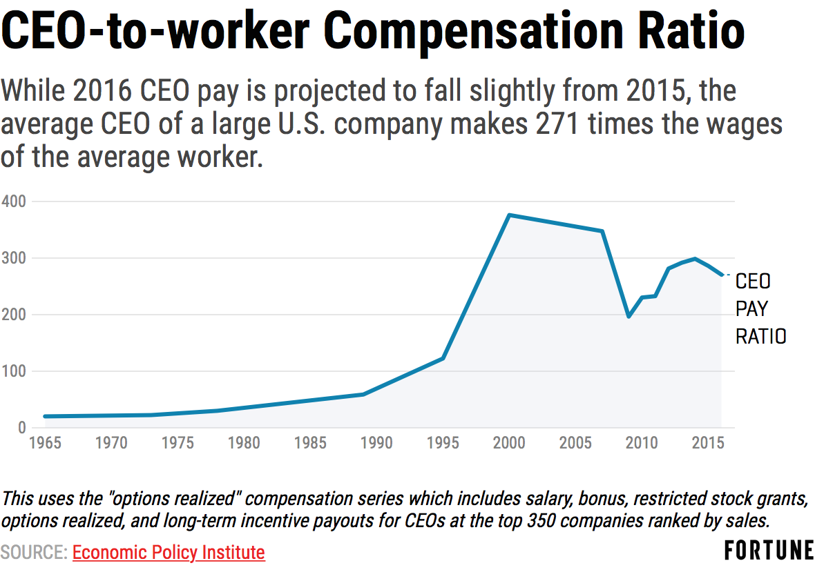

- What is the difference between an equitable distribution of income in a nation and an
equal distribution of income?

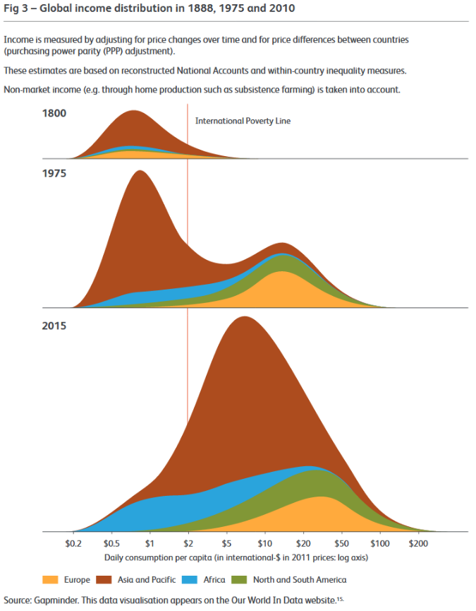

- What do you understand by the term ‘income inequality’?

- How do we measure income inequality?

The Parade of Dwarves – An illustration of income inequality

Imagine that the income distribution of the U.K. is represented by a parade of its whole population marching past an observer of average height. The whole parade takes one hour to pass and the income of each person is represented by their height. The parade starts with the smallest people (i.e. those with the lowest incomes) and at the end are giants (i.e. those with the highest incomes)

- Using employment earnings data from the U.K. can you estimate the following values?

  - The proportion of the workforce living on ‘mean wage’ or less

  - The proportion of the workforce earning twice the ‘mean wage’.

Income

Time (minutes)

- What do you notice about the parade of dwarves and what issues does it raise?

The Causes of Income Inequality

The Labour Market/Innate Ability
Imperfect Competition
Education
Gender, Race and Culture
Wealth

Lorenz Curve

In today’s lesson we will be focusing on the Lorenz Curve.
- Example of a Lorenz Curve.
- Plotting Lorenz Curves.
- Comparing Lorenz curves of Different Nations
- Calculating and Interpreting the Gini Coefficient

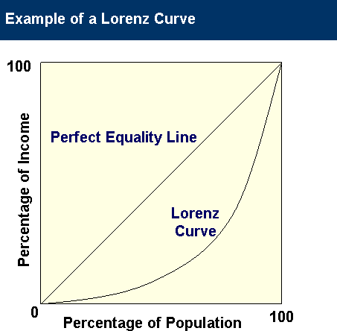
- Sketch onto the diagram the Lorenz Curve for a nation with an equal distribution of income and one for a nation with unequal distribution of income.

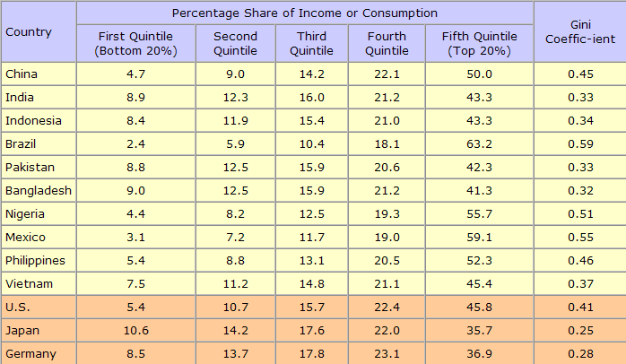

- Using the data from the previous page, plot two Lorenz Curves below. (Plot them on the two graphs provided)
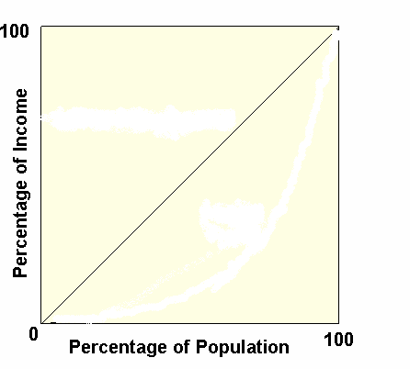
What do you notice ?

What do you notice ?

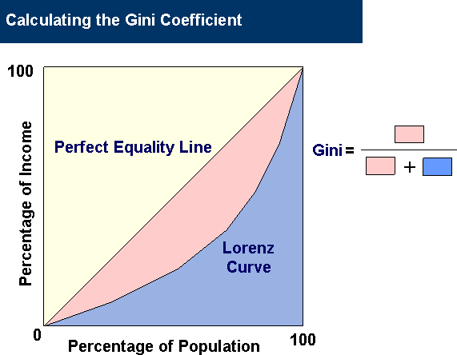

- Using the diagram above, explain what is meant by the Gini Coefficient.

- What does a high and low Gini Coefficient indicate?

Is income inequality desirable?

- What are the arguments in favour of income inequality?

Efficiency Economic Growth Brain Drain

- What are the arguments against income inequality?

Equity
Economic Cycle (Boom/Recession) Social Problems

Group Task – In groups of three or four you must put together an argument either in favour or against the following proposal. You will present this argument to the rest of the class next lesson.

The government believes that an increase in progressive taxation and subsequent reduction in income inequality is both desirable and essential.

Poverty

- Use the pictures below to explain the difference between absolute and relative poverty.

- How do we measure absolute and relative poverty?

Absolute poverty

Relative poverty

- In the table below identify some of the causes of poverty in a society.

Cause of Poverty: | Explanation:
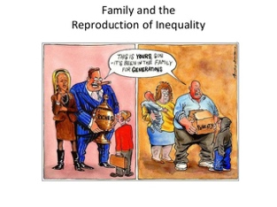
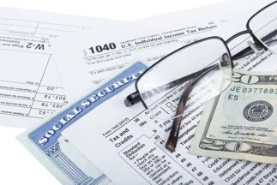

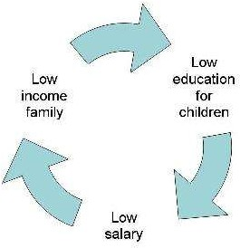
- Can you identify some of the consequences of poverty? (cause and effect)

Taxation

We will be looking at the following issues in the next two lessons.
Why governments levy taxes. Different types of tax
The difference between direct and indirect tax Progressive and regressive taxes.
The Laffer Curve.

  - What is a tax?

  - Can you think of as many different types of tax as possible?

•
•
•
•
•
•
•
•

  - Give examples of different taxes in the table below.
Type of Tax
- Tax on household income
- Tax on consumer spending
- Tax on company profits
- Tax on financial gain
- Tax on demerit goods
- Local Government tax

Example

  - The taxes above can be divided into two main categories. These are direct taxes and

indirect taxes.

DIRECT TAX

INDIRECT TAX

  - Some taxes would be regarded as progressive, some are regressive and some are proportional. In the table below see if you can define these three terms.

Type of Tax | Definition
Progressive
Regressive
Proportional

  - On the diagram below illustrate the relationship between the level of income and the proportion of income that is paid in tax for a progressive, regressive and proportional tax.

Proportion of income paid in tax

Level of income

Calculating the average and marginal tax rate HL ( Only)

Define what is meant by the average and marginal rate of tax

7)

Term Definition Equation
Average tax rate
Marginal tax rate

- On the diagram below illustrate how a typical (simplified) income tax system operates in terms of personal allowances and marginal/average rates of taxation.

Income ($US) | Tax rate (%)
0-9,000 (allowance) | 0
9,001 – 40,000 | 12
40,000 – 86,000 | 22
86,000-164,000 | 24
164,000-209,000 | 32
209,000-523,000 | 35
523,000+ | 37

  - – Sketch the above tax system onto the diagram below.

Marginal/ average tax rate

Level of income

  - – Calculate the i) total amount of tax paid and ii) the average tax rate for the following individuals.

Individual X earns 100,000 US$

Individual Y earns 35,000 US$

- How can a progressive tax be used to redistribute Income from rich to poor?

Personal allowance

Marginal tax rate

- What other measures can be taken by the government to reduce income inequality and promote equity in the following areas?

Health __________________________________________________________________

Education________________________________________________________________

Transport________________________________________________________________
Unemployment benefit______________________________________________________
Pension___________________________________________________________________
Vital Infrastructure_________________________________________________________

- What do you understand by the term ‘transfer payment’?

- We now need to think of the reasons why governments impose taxes on their citizens.

- Measures to promote equity might require the government to increase taxes such as income tax. We should consider the impact this might have on the economy.

If there is an increase in personal income tax. the New Classical view is that it will act as a disincentive to work..

This view is supported by an American Economist called Laffer. He claimed that high rates of income tax would lead to less revenue for the government because of their
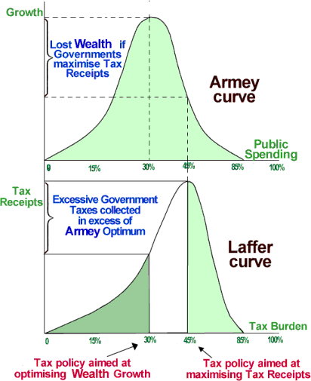
impact upon worker’s incentive to work.

Tax Yield

Tax Rate

- Can you explain what is happening at each point on the diagram?

- Draw Laffer Curves from a free-market and socialist perspective.

Tax Yield
Tax Yield

Tax Rate Tax Rate

- However there is an alternative view that if you use income and corporation tax to redistribute income there could be an improvement in the economy.

Illustrate below how there might be an increase in aggregate demand

Price Level

Real G.D.P.

Why might this occur? (Use the term MPC)

- Illustrate and explain how an increase in income tax or corporation tax might also lead to an improvement in the supply-side of the economy.

Price Level
Real G.D.P.

