Natural Hazard Evaluation
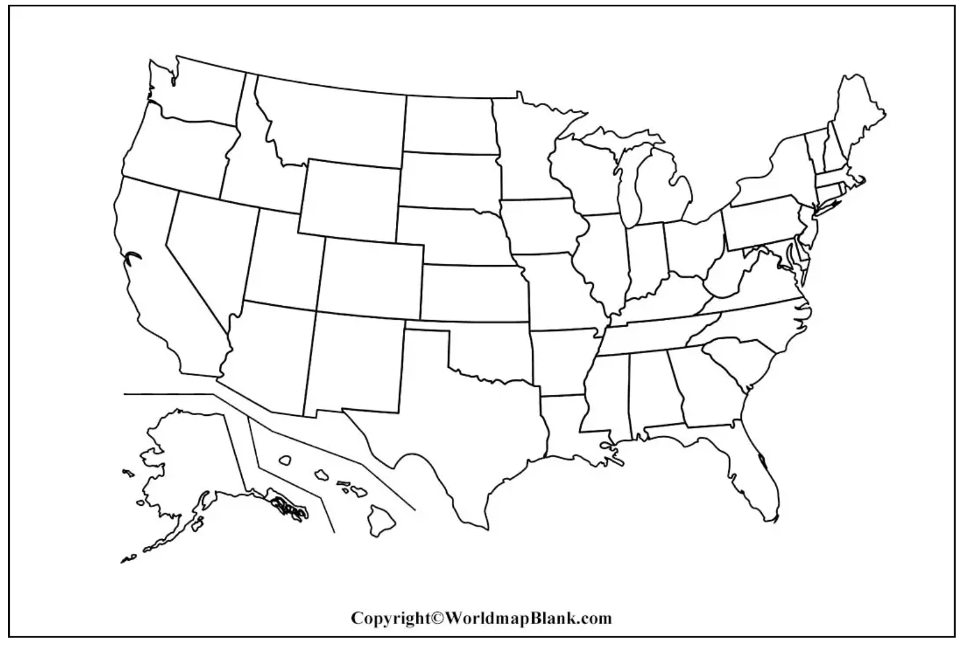
Type of Hazard: ____________________________

Threat | Regularity – How often does this hazard occur? e.g., hurricanes are annual threats, countries can be hit by repeated storms each causing greater damage because it has not been possible to recover from previous damage
 | Frequency – How frequent are large/severe hazards? The return interval of hazards of certain sizes. For example, earthquakes with a magnitude of over 8.0 happen on average once a year, but earthquakes of only 3 or 4 happen many times a day. If the hazard is a less frequent strong event, then it is going to have a bigger impact.
 | Magnitude – How strong is the hazard? This is the strength of a hazard. Most hazards are measured on a scale e.g., the Richter scale or the Saffir - Simpson Scale. Generally speaking, the stronger the hazard the more severe the hazard is.
 | Duration – How long does the hazard last? As a general rule the longer the hazard the more severe it is likely to be. For example, an earthquake that lasts 1 minute is likely to be more severe than one that last two seconds and a drought that lasts ten years is likely to be more severe than one that last three months.
 | Speed of onset - If the peak of the hazard arrives first or arrives quickly e.g. an earthquake, then the effects are likely to be worse than one that arrives slowly e.g. a drought.
Vulnerability | Predictability - Some hazards are easier to predict than others. For example, volcanoes normally give warning signs before they erupt and tropical storms can be tracked from development to landfall. However, others like earthquakes are much harder to predict. Generally speaking, hazards that hit with no warning are going to be more serious.
 | Areal Extent - If a hazard covers a large area e.g. a drought covering the whole of East Africa, then the severity of the hazard is likely to be more severe, than a flood hitting just one village.
Cost | Population Density – Population density: If a hazard covers an area of high population density, or a big city it is likely to impact a higher number of people than if it occurs in a low densely populated area.
 | Effects

