Native Americans in Texas
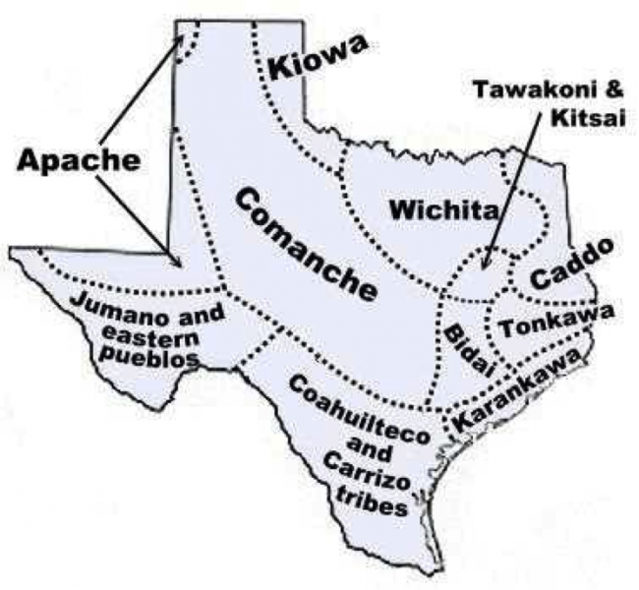

Use the Bullock Museum, Texas website to discover
the history of Native American Tribes in Texas.

Go to https://www.thestoryoftexas.com/discover/campfire-stories/native-americans

TEXAS TRIBES

The Texas story didn’t begin with the arrival of __________ explorers in the ____________. Hundreds of different groups of __________ peoples with a variety of languages, customs and ___________ lived on the land for at least _________ years before the arrival of ______________. For the American ____________, Texas had long been their world. The land, the life and even other ___________ peoples they encountered were already ____________. It was the explorers who were ________.
THE CADDO

In the Caddo language, TAYSHA means ___________. The Spanish spelled it _________. We call it __________. By the time European explorers arrived, some Caddo communities had settled along the ______ River and in ________ Texas from their homelands in ____________, Arkansas and _____________. There were as many as ________ separate Caddo groups linked by ___________ and customs, including the ____________ alliance, who settled in East Texas.

APACHES

Dominating almost all of ___________ Texas were the __________ and Mescalaro ________. The name Apache may have come from the Zuni word ___________ meaning __________. Apaches were among the first American Indians to ride _____________. This allowed them to live a ___________ life following the _____________ herds from place to place.

800 AD
Lipan Apache
1528
Jumano
1687
Coahuiltecans
1734
Atapaka

