Native American Tribes
North / East / South / West
North East / North West / South East / South West

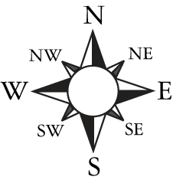

Use the map on page 14 to identify where
the Tribe was based within the Plains.

Tonkawa
Blackfoot
Missouria
Crow
Wichita
Sarcee
Kiowa Apache
Plains Cree
Comanche
East Sioux
Arapaho
Gros Ventre
Cheyenne
West Sioux
Quapaw
Plains Ojibwa
Osage

Native American Tribes
North / East / South / West
North East / North West / South East / South West

Use the map on page 14 to identify where
the Tribe was based within the Plains.

Tonkawa | South
Blackfoot | North West
Missouria | South East
Crow | West
Wichita | South
Sarcee | North
Kiowa Apache | South
Plains Cree | North
Comanche | South
East Sioux | East
Arapaho | West
Gros Ventre | North
Cheyenne | West
West Sioux | West
Quapaw | South East
Plains Ojibwa | North East
Osage | South East

