Native American Match Up

Use your device to identify which Native American is which.
Cut out the 9 pictures, stick them in & label them correctly.

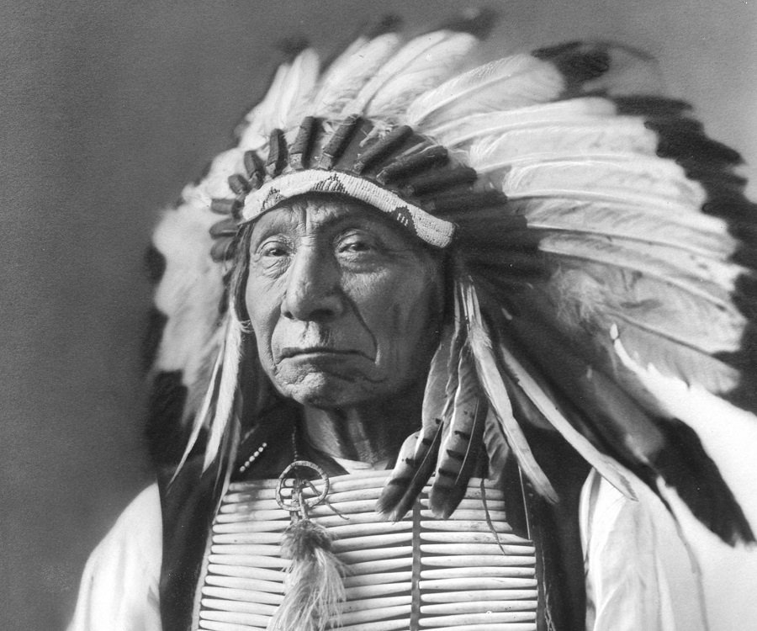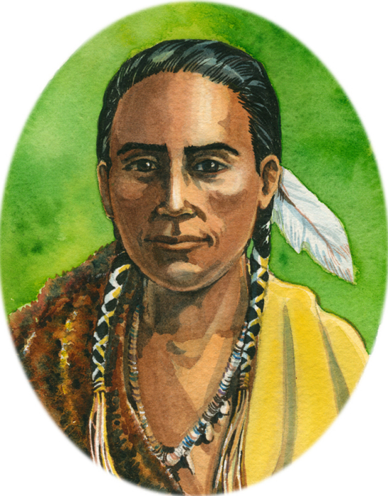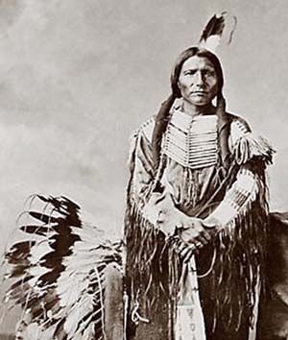

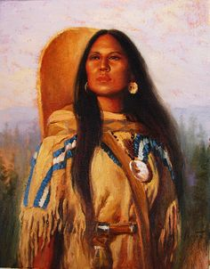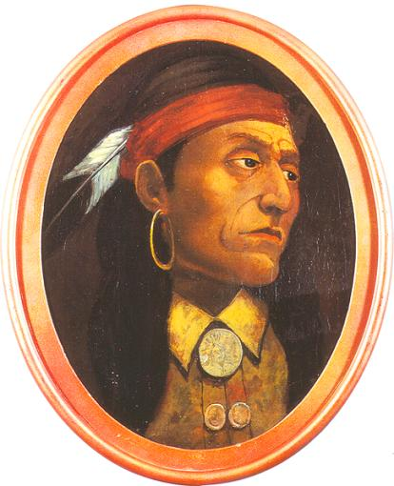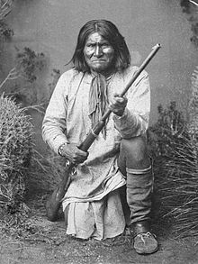

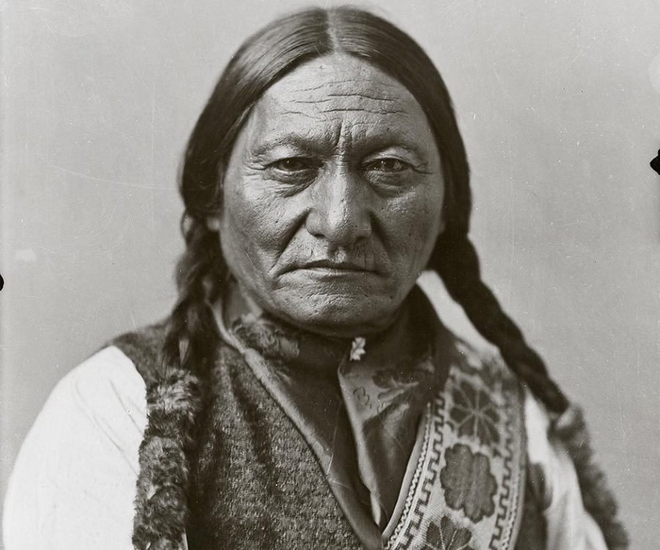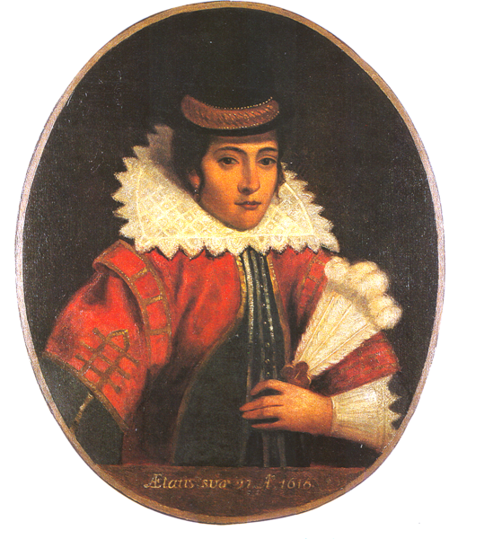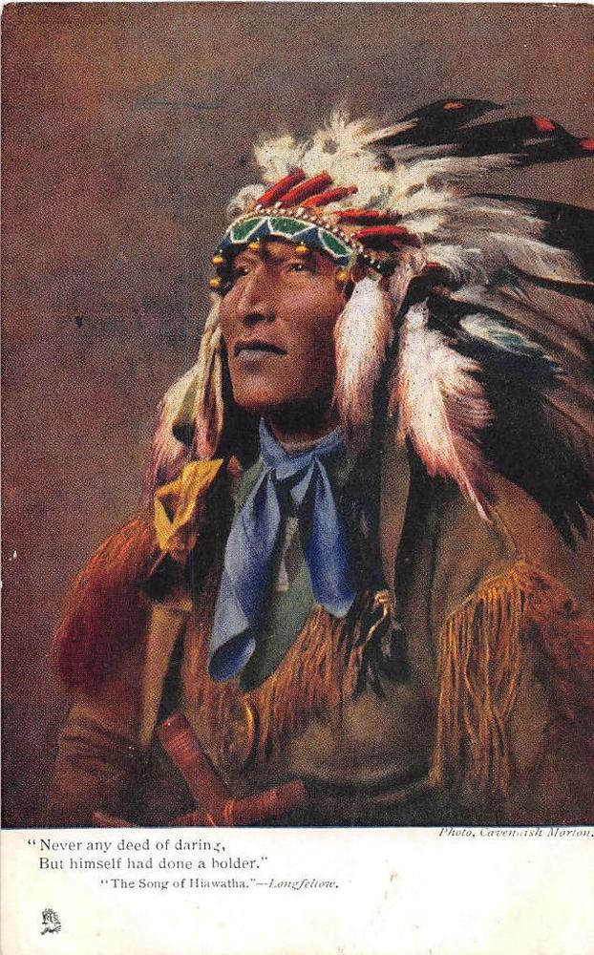

Sitting Bull, Red Cloud, Pocahontas, Crazy Horse, Hiawatha, Squanto, Geronimo, Pontiac, Sarajawea
Native American Match Up

Use your device to identify which Native American is which.
Cut out the 9 pictures, stick them in & label them correctly.

Red Cloud Squanto Crazy Horse

Sacajawea Pontiac Geronimo

Sitting Bull Pocahontas Hiawatha

