Native American Buffalo
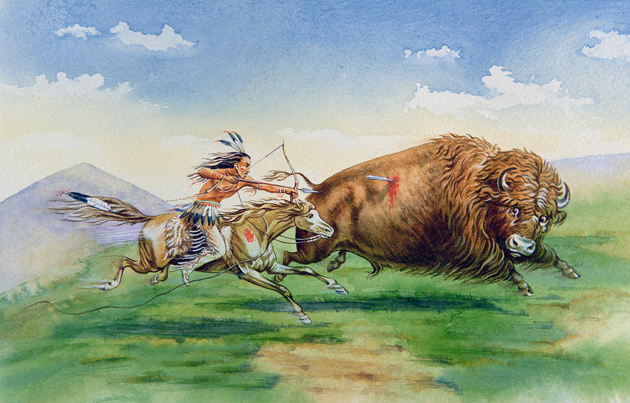

Use the diagram on page 16 to identify what uses
each part of the Buffalo had for Native Americans.

Hide | Clothes |  | Tipis |  | Moccasins
Hide | Parfleches |  | Harnesses |  | Shields
Shoulder Blades & Bones | Hoes | Knives |  | Sledge Runners
Flesh | Raw | Boiled |  | Roasted |  | Dried
Horns | Headress | Spoons |  | Cups |  | Flasks
Skulls | Religious Rituals
Hooves | Glue |  |  | Tools
Tongue | Hairbrushes |  |  | Food
Fur | Blankets |  | Saddles |  | Gloves
Hair | Pillows |  | Cushions |  | Saddles

Native American Buffalo

Use the diagram on page 16 to identify what uses
each part of the Buffalo had for Native Americans.

Hide
Hide
Shoulder Blades & Bones
Flesh
Horns
Skulls
Hooves
Tongue
Fur
Hair

