Native American Artifacts
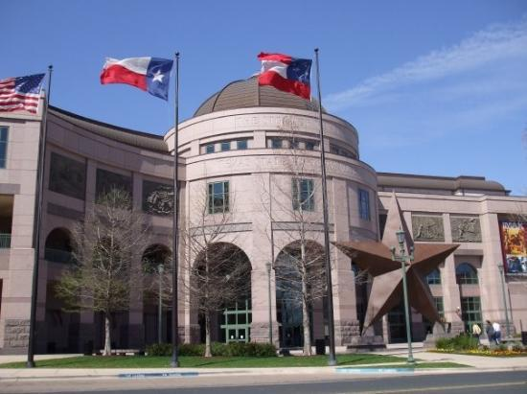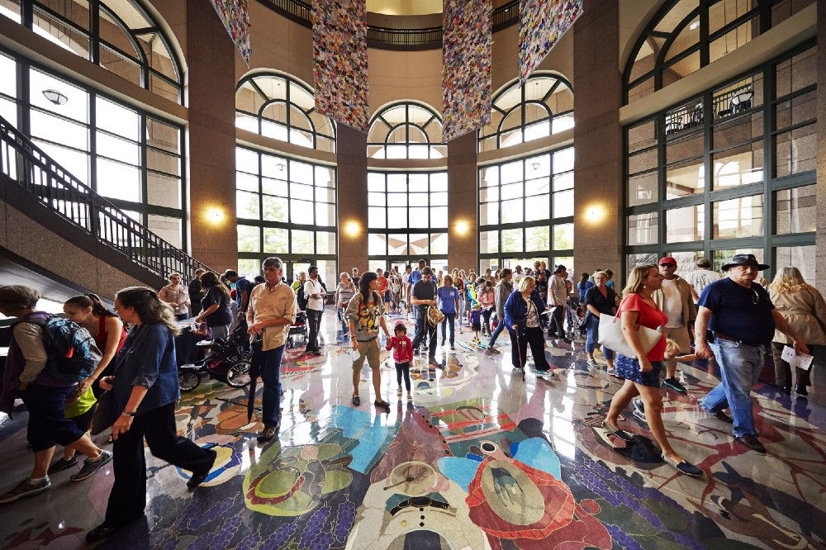

Use the Bullock Museum, Texas website to discover
Native American artifacts made by Texas Indians.

Go to www.thestoryoftexas.com

Select Discover Texas History online

Select Artifact Gallery

Use the Search by Keyword to find the following artifacts

- Find the American Indian Headdress

Who was it  given to? | Where in Texas was he raised by grandparents?

- Find the Missouri Warhawk

Who carried  this tomahawk? | What pattern is on  the ax blade?

- Find the Comanche Man’s & Woman’s Saddles

When did Comanche  boys learn to ride? | What materials are  both saddles made of?

- Find the Comanche-Made Necklace

Who was given this as a bond of friendship? | Who kidnapped the owner & his sister for 2 years?

- Find the Northern Plains Indian Beaded Vest

Who was this vest most likely made for? | What materials is  the vest made of?

- Find the Comanche Hunting Bow

What wood is the bow made of? | What animal fur is on the bow for good luck?

- Find the Comanche Water Jug

What 3 woods is the water jug made of? | What makes the jug waterproof?

Native American Artifacts

Use the Bullock Museum, Texas website to discover
Native American artifacts made by Texas Indians.

Go to www.thestoryoftexas.com

Select Discover Texas History online

Select Artifact Gallery

Use the Search by Keyword to find the following artifacts

- Find the American Indian Headdress

Who was it  given to? | Where in Texas was he raised by grandparents?
Willie Nelson | Abbott, Texas

- Find the Missouri Warhawk

Who carried  this tomahawk? | What pattern is on  the ax blade?
A Scout, Anga Quash | “Bleeding Heart”

- Find the Comanche Man’s & Woman’s Saddles

When did Comanche  boys learn to ride? | What materials are  both saddles made of?
Age Six | Wood + Doeskin Rawhide

- Find the Comanche-Made Necklace

Who was given this as a bond of friendship? | Who kidnapped the owner & his sister for 2 years?
“Dot” Babb | Comanche Indians

- Find the Northern Plains Indian Beaded Vest

Who was this vest most likely made for? | What materials is  the vest made of?
Tourists | Hide Vest & Beads

- Find the Comanche Hunting Bow

What wood is the bow made of? | What animal fur is on the bow for good luck?
Osage Orange Tree | Coyote Fur

- Find the Comanche Water Jug

What 3 woods is the water jug made of? | What makes the jug waterproof?
Sumac, Willow & Redbud | Pine Pitch

