Anon.
[Centre Number] – [Candidate Number]
Foreign home buyers face new tax in the Vancouver area
Source: BBC News
Date Written: 6th January 2017
Date of Article: 2nd August 2016
Word Count: 745
Section 1 – Microeconomics

The article discusses rising prices in Vancouver’s housing market resulting from a market failure within the foreign buyers housing market that has not allocated the most socially desirable quantity and combination of housing. This occurs because overseas buyers purchase property solely for financial gain rather than utilizing them. Negative side-effects on third parties who are not directly involved in the economic transaction (negative externalities of consumption) mean there has been overconsumption of housing past the social optimum leading to allocative inefficiency.

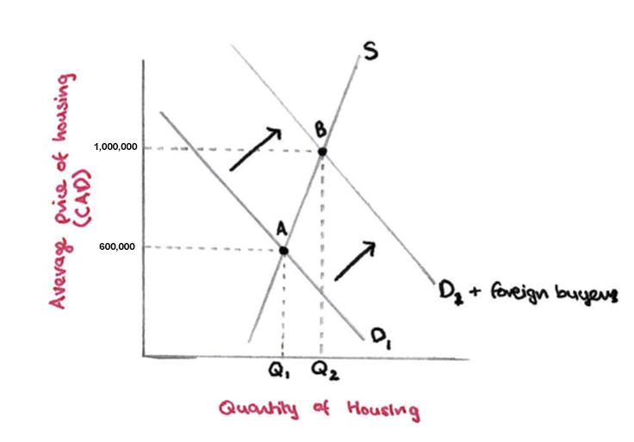

The problem is modelled above. Foreign investors increase the consumer population in the market - a non-price determinant of demand. Increased population means more people willing and able to purchase housing at each price, so shifts the demand curve rightward (D₁ to D₁+foreign buyers). This results in a new equilibrium point B at a higher price of 1000000 CAD. These are negative externalities caused by foreign consumption, as they are impacts on local buyers not involved in the transaction, making them struggle to afford the higher prices.
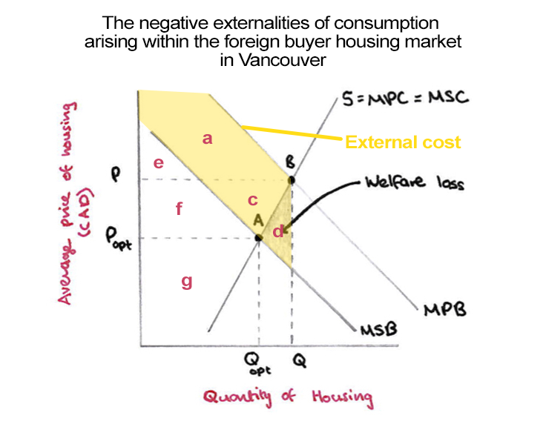

These external costs mean the marginal private benefit (MPB curve), the utility the consumer receives from consuming one additional unit, is greater than the marginal social benefit (MSB curve), the utility that society receives from this additional unit. The social surplus in the current market is the sum of the consumer and producer surplus minus the external cost - equal to areas e+f+g-d. In the ideal market with no external cost, social surplus is just the consumer plus the producer surplus (areas e+f+g). There is area d less of social surplus in the current market, so this is the surplus (welfare) lost due to the market failure. This includes affordable housing for ordinary Canadians, 11,000 potentially occupied houses and decreased homelessness and crime. Overconsumption and the welfare loss should be reduced to fix this.

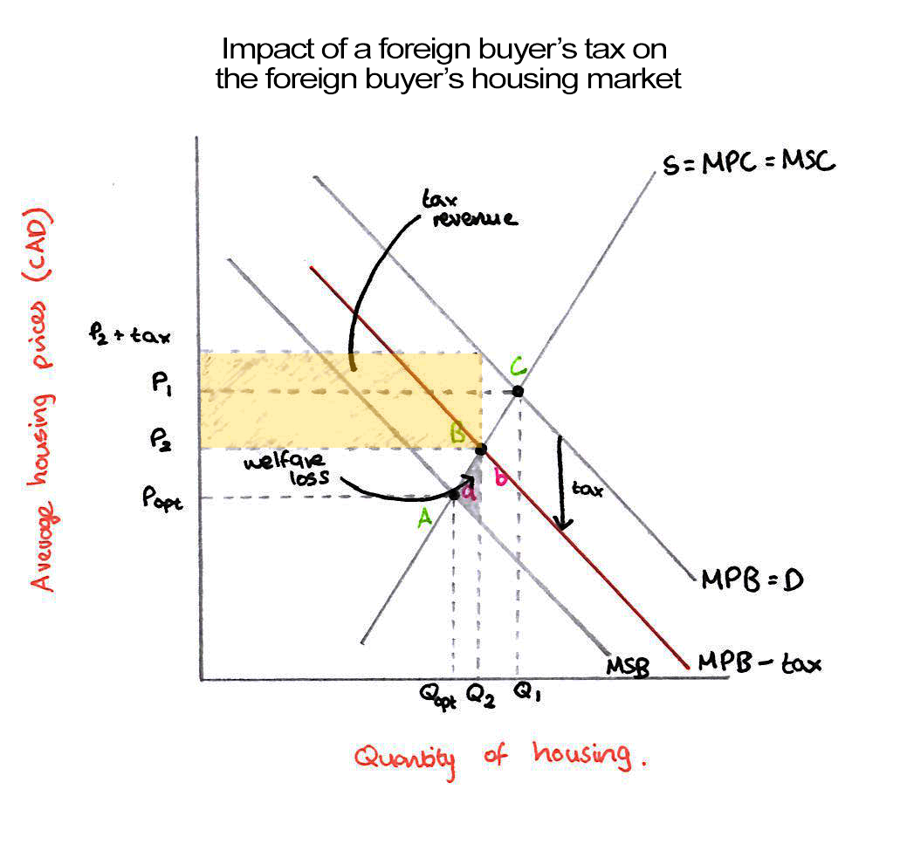

A direct tax can be levied on foreign consumers impacting the MPB (Demand) curve. A direct tax works better because the government is more equipped than firms to distinguish between foreign and domestic buyers. The tax raises prices for foreign buyers corresponding to a downward shift of the demand (MPB) curve to curve MPB-tax. At each quantity, the price is lower by the amount of the tax, so that the price after tax is the same as what each quantity of people were willing and able to pay without it. The shift in the curve brings the MPB-tax curve closer to the MSB curve, reducing welfare loss by area b and getting closer to a situation where the market failure has been fixed (where MSB=MPB).

Reduced foreign demand corrects the overconsumption, and the model assumes it should decrease the population of consumers in the whole housing market, lowering market prices. Locals should be better off because houses will be more affordable. This may not happen, however, as foreign investors are often wealthy and able to take on the tax burden. Foreign demand is likely to be elastic, however, due to the presence of substitutes (investments in other cities), meaning the quantity demanded should be responsive to price changes caused by the tax. This may impact other Canadian cities as investors move their business from Vancouver to substitute cities, causing the same problems there.

The government will require more employees to audit the tax, but they will also earn the tax revenue area shown on the diagram that can fund spending to increase the housing supply and further ease the problem. Foreign consumers suffer, seen by their reduced consumer surplus as they now get less for the same amount of money. This tax is most effective from the perspective of government’s priorities, looking out for its own people’s interests by focusing on foreign buyers more than locals. Alternative solutions like increasing the housing supply through public provision and subsidies would put too much burden on local people through tax revenue spending. The inelastic supply of housing due to construction times mean that taxation will be more effective than supply-side policies at tackling the problem quickly and cheaply.

Short term, the tax could destroy expectation in the market influencing foreign property owners to sell their properties, decreasing prices even further. Foreign purchases are a form of investment into the local economy, and so the tax may decrease local investment and growth in Vancouver. A better tax, perhaps, would be one on unoccupied properties. This would encourage more properties to be rented out, increasing supply and access to affordable housing, but wouldn’t discourage positive economic investment.
