ANON.
[candidate number]
The Cost of a Hot Economy in California: A Severe Housing Crisis
Source: The New York Times
Date of Article: July 17, 2017
Word count: 743
Section 1: Microeconomics

Microeconomics IIA
Source: nytimes.com
Article title: The Cost of a Hot Economy in California: A Severe Housing Crisis

https://www.nytimes.com/2017/07/17/us/california-housing-crisis.html

As California’s demand for housing has grown, the supply has not. The article argues that despite the strong economic growth of the past three decades, California’s local laws, housing ordinances, and local anti-growth movements have deterred housing development. This issue is fundamentally one of demand and supply, and the lack of supply to meet demand. In this case, demand is the quantity of a good (in this case housing) that consumers are willing and able to purchase at a given price in a given time period. Likewise, supply is the willingness and ability of producers to produce a quantity of a good or service at a given price in a given time period. This issue is a market failure.

While demand for housing is highly elastic ( it is highly responsive to changes in price), the supply of housing is highly inelastic - as housing development takes both a significant amount of time and initial capital investment to construct, as well as having to comply with local regulations. California’s housing market, is a market failure.. There is market inefficiency as the demand and supply of housing is not at the equilibrium level. Moreover, affordable housing is not being produced - and particularly in areas such as San Francisco and San Jose, housing is highly priced - and affordable housing neglected. Housing in this case could be seen as a merit good, as a lack of affordable housing/or even quality housing can lead to social issues such as crime, as well as health related issues.

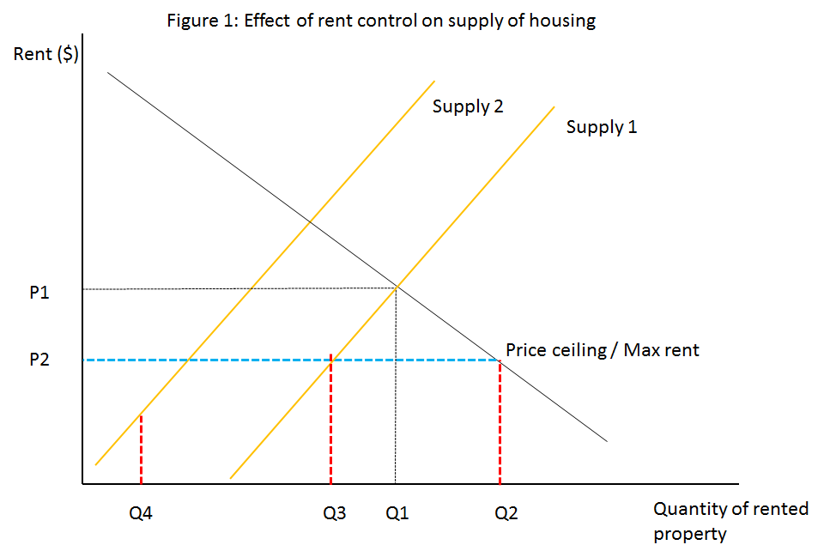
One solution which is mentioned in the article as being pursued by local communities is that of rent control and setting price ceilings. This as a solution, may in the short run cap rent increases and could potentially encourage developers to invest in affordable housing (as their profit incentive for higher-rent accomodation is limited). However, this as a solution would not fix the underlying issue of supply in the California housing market. This would act as a market distortion. As from Q3 to Q4, some landlords would likely leave the market of housing and there would be a decline in the supply of housing. The resulting force leading to the decline in the supply would be the decrease in the profit motive. If anything, the state of California should provide incentives to allow for firms to have greater profit maximization and to make development more profitable.

The proposed law in California, which would allow developers to circumvent local regulatory hurdles and environment laws would likely assist in increasing the supply of housing, however, other market-based approaches could be used more effectively. Providing tax incentives to developers for affordable housing could spur even more development, and could be more impactful as it would focus on creating an incentive for supplying housing (and help offset high property taxes and land acquisition costs), rather than the proposed bill which only streamlines the process rather than dealing with the underlying incentives.

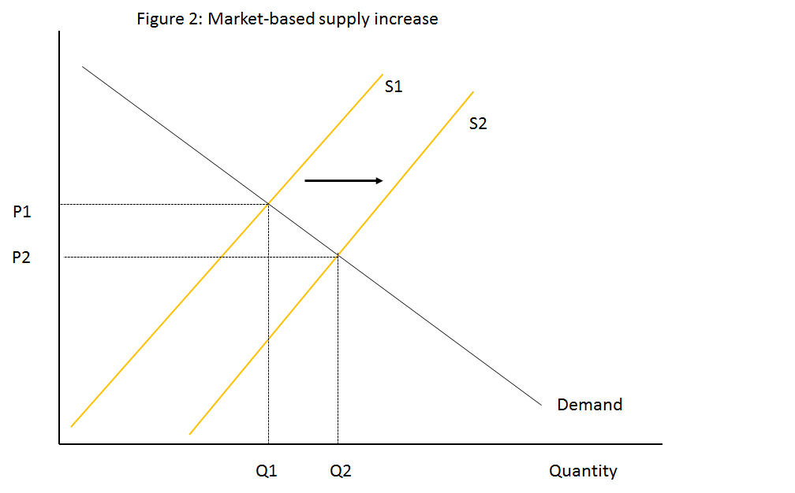
In figure 2, a tax incentive - such as a tax amnesty on property developers or more milder, reduced construction taxes, would provide greater profit incentive for firms to develop housing. Fundamentally, the issue in California is that of supply. Policies that remove barriers to developers such as reducing regulations, allowing environmental and noise exemptions and allowing streamlining of the regulatory process (consolidating regulation - as would-be developers must adhere to numerous jurisdictional regulations) would make it cheaper for the construction of new projects, and would encourage it. An assumption here is that firms would provide housing for all, seeing even low-income earners as a market to cater to. However, this has not historically been the case - and especially in high-income regions such as the Bay Area, it can be ascertained that in the long-run housing development will favor those with higher incomes. This could be avoided though, as there could be specific tax incentives and subsidies given to low-income developers.

In conclusion, to promote a long-term increase in supply, subsidies and tax benefits given to developers would reduce the financial burden of development and increase the supply. However, California’s debt crisis, and budgetary limitations could make providing overly generous tax benefits ill-advised, as it could heighten the deficit in the short run (leading to cutting in state-provided services, grants). However, in the long-term, this ‘cutting’ of taxes for developers could be recouped in the future collection of property taxes and the knock-on effects of increased housing construction and increase in demand for jobs related to it.

ARTICLE:

SACRAMENTO — A full-fledged housing crisis has gripped California, marked by a severe lack of affordable homes and apartments for middle-class families. The median cost of a home here is now a staggering $500,000, twice the national cost. Homelessness is surging across the state.
In Los Angeles, booming with construction and signs of prosperity, some people have given up on finding a place and have moved into vans with makeshift kitchens, hidden away in quiet neighborhoods. In Silicon Valley — an international symbol of wealth and technology — lines of parked recreational vehicles are a daily testimony to the challenges of finding an affordable place to call home.
Heather Lile, a nurse who makes $180,000 a year, commutes two hours from her home in Manteca to the San Francisco hospital where she works, 80 miles away. “I make really good money and it’s frustrating to me that I can’t afford to live close to my job,” said Ms. Lile.
The extreme rise in housing costs has emerged as a threat to the state’s future economy and its quality of life. It has pushed the debate over housing to the center of state and local politics, fueling a resurgent rent control movement and the growth of neighborhood “Yes in My Back Yard” organizations, battling long-established neighborhood groups and local elected officials as they demand an end to strict zoning and planning regulations.
Now here in Sacramento, lawmakers are considering extraordinary legislation to, in effect, crack down on communities that have, in their view, systematically delayed or derailed housing construction proposals, often at the behest of local neighborhood groups.
The bill was passed by the Senate last month and is now part of a broad package of housing proposals under negotiation that Gov. Jerry Brown and Democratic legislative leaders announced Monday was likely to be voted on in some form later this summer.
“The explosive costs of housing have spread like wildfire around the state,” said Scott Wiener, a Democratic senator from San Francisco who sponsored the bill. “This is no longer a coastal, elite housing problem. This is a problem in big swaths of the state. It is damaging the economy. It is damaging the environment, as people get pushed into longer commutes.”
For California, this crisis is a price of this state’s economic boom. Tax revenue is up and unemployment is down. But the churning economy has run up against 30 years of resistance to the kind of development experts say is urgently needed. California has always been a desirable place to live and over the decades has gone through periodic spasms of high housing costs, but officials say the combination of a booming economy and the lack of construction of homes and apartments have combined to make this the worst housing crisis here in memory.
Housing prices in Los Angeles, San Francisco, San Jose and San Diego have jumped as much as 75 percent over the past five years.
The bill sponsored by Mr. Wiener, one of 130 housing measures that have been introduced this year, would restrict one of the biggest development tools that communities wield: the ability to use zoning, environmental and procedural laws to thwart projects they deem out of character with their neighborhood.
It is now the subject of negotiations between Mr. Brown and legislative leaders as part of a broader housing package intended to encourage the construction of housing for middle- and lower-income families that is also likely to include the more traditional remedy of direct spending to build more housing units.
[Photo]
State Senator Scott Wiener, who sponsored a bill restricting communities’ ability to quash housing projects. “We’re at a breaking point in California,” he said. Credit Jim Wilson/The New York Times
This is not the first time this state has sought to prod recalcitrant local governments to build housing. Mr. Brown tried to push through a measure to force communities to build more affordable housing around a year ago. That effort, like most in recent years, faltered in the face of opposition from local officials, homeowners and environmentalists, who often see these kinds of measures as enriching developers while threatening the character of some of the most visually striking parts of this state, along the coast and in the mountains.
“It’s giving developers a great gift and not giving residents and voters a chance to cast their opinions about what happens in their own neighborhood,” Helene Schneider, the mayor of Santa Barbara, said of Mr. Wiener’s new bill.
But the worsening housing crisis here has created a political environment where prospects for a state housing intervention appear more likely than ever.
“There is a consensus that there is a crisis and we have to address it,” said David Chiu, a San Francisco Democrat who leads the Assembly Housing and Community Development Committee. Mr. Wiener compared the political atmosphere now to how Californians embraced mandatory water-rationing in response to the five-year drought here.
“We’re at a breaking point in California,” Mr. Wiener said. “The drought created opportunities to push forward water policy that would have been impossible before. Given the breadth and depth of the housing crisis in many parts of California, it creates opportunities in the Legislature that didn’t exist before.”
The debate is forcing California to consider the forces that have long shaped this state. Many people were drawn here by its natural beauty and the prospect of low-density, open-sky living. They have done what they could to protect that life. That has now run up against a growing generational tide of anger and resentment, from younger people struggling to find an affordable place to live as well as from younger elected officials, such as Mayor Eric M. Garcetti of Los Angeles, who argue that communities have been failing in what they argue is a shared obligation.
For the past several decades, California has had a process that sets a number of housing units, including low-income units, that each city should build over the next several years based on projected growth. Mr. Wiener’s bill targets cities that have lagged on building by allowing developers who propose projects in those places to bypass the various local design and environmental reviews that slow down construction because they can be appealed and litigated for years.
The bill applies only to projects that are already within a city’s plans: If the project were higher or denser than current zoning laws allow, it would still have to go through the City Council. But by taking much of the review power away from local governments, the bill aims to ramp up housing production by making it harder to kill, delay or shrink projects in places that have built the fewest.
It is hard to say exactly which projects might benefit if the various bills were passed, since it’s impossible to know which projects local governments might reject in the future. But there are various examples where it might have pushed a development along.
In Los Gatos, about 60 miles south of San Francisco, for instance, a long-running dispute over a proposed development for 320 homes that the city rejected led to a lawsuit by the developer, which resulted in a judge directing the city to reconsider the plans. Also, cities regularly make developments smaller than their zoning allows, something that gradually chips away at future housing production.
California is the toughest market for first-time home buyers and the cost of housing is beyond reach for almost all of this state’s low-income population. Despite having some of the highest wages in the nation, the state also has the highest adjusted poverty rate.
Photo
Houses under construction in Manteca, Calif. Many who cannot afford homes San Francisco or Oakland are moving there — nearly two hours away. Credit Jim Wilson/The New York Times
And Proposition 13, the sweeping voter initiative passed in 1978 that capped property taxes, has made things worse: It had the effect of shrinking the housing stock by encouraging homeowners to hold on to properties to take advantage of the low taxes.
“California is a beautiful place with great weather and a terrific economy,” said Issi Romem, the chief economist with BuildZoom, a San Francisco company that helps homeowners find contractors. “To accommodate all those people you need to build a lot, and the state’s big metro areas haven’t since the early ’70s. To catch up, cities would need to build housing in a way that they haven’t in two generations.”
Coastal cities — which tend to have the worst housing problems — have the most scarce land. Still, economists say, the high cost of all housing is first and foremost the result of a failure to build. The state has added about 311,000 housing units over the past decade, far short of what economists say is needed.
“Cities have proven time and time again that they will not follow their own zoning rules,” said Brian Hanlon, policy director of the San Francisco Yimby Party, a housing advocacy group. “It’s time for the state to strengthen their own laws so that advocates can hold cities accountable.”
Still, few elected officials are eager to risk community anger by forcing through construction that would, say, put a 10-story apartment building at the edge of a neighborhood of single-family homes. That has turned California into a state of isolated and arguably self-interested islands.
The situation has been aggravated by places such as Brisbane, just south of San Francisco, which has encouraged extensive office development while failing to build housing.
“We have cities around California that are happy to welcome thousands of workers in gleaming new tech and innovation campuses, and are turning a blind eye to their housing need,” said Mr. Chiu.
In the Bay Area, the explosive growth of the tech industry has led to escalating rents, opening a tough debate over gentrification and brutal commutes for workers. “Cities that deny housing are contributing to skyrocketing rents, unfair evictions and homelessness,” said Lori Droste, a member of the Berkeley City Council.
The measure has raised considerable opposition as well, including from lawmakers who argued that letting state take power away from local governments strips communities of the ability to control the fundamental character of their own neighborhoods.
“People here feel like this is a special place, like people in any town or city do,” said Chris Coursey, the mayor of Santa Rosa. “And they want decisions about the future of the community to be made by people in the community who they can actually talk to about this.”
Richard Bloom, a Democratic state assemblyman and a former mayor of Santa Monica, said even communities like his were no longer reflexively trying to derail housing projects.
“More and more people are becoming well aware that we have a housing affordability crisis on our hands,” he said. “The issue is just reaching critical mass with the Legislature and the public.”

Portfolio (SL/HL) -
Criterion A: Diagrams
• This criterion assesses the extent to which the student is able to construct and use diagrams.
Level Descriptor
0 The work does not reach a standard described by the descriptors below.
1 Relevant diagram(s) are included but not explained, or the explanations are incorrect.
2 Relevant, accurate and correctly labelled diagram(s) are included, with a limited explanation.
3 Relevant, accurate and correctly labelled diagram(s) are included, with a full explanation.

Criterion B: Terminology
• This criterion assesses the extent to which the student uses appropriate economic terminology.
Level Descriptor
0 The work does not reach a standard described by the descriptors below.
1 Terminology relevant to the article is included in the commentary.
2 Terminology relevant to the article is used appropriately throughout the commentary.

Criterion C: Application
• This criterion assesses the extent to which the student recognizes, understands and applies economic information in the context of the article.
Level Descriptor
0 The work does not reach a standard described by the descriptors below.
1 Relevant economic concepts and/or theories are applied to the article.
2 Relevant economic concepts and/or theories are applied to the article appropriately throughout the commentary.

Criterion D: Analysis
• This criterion assesses the extent to which the student can explain and develop appropriate economic theories and/or concepts in the context of the article.
Level Descriptor
0 The work does not reach a standard described by the descriptors below.
1 There is limited economic analysis relating to the article.
2 There is appropriate economic analysis relating to the article.
3 There is effective economic analysis relating to the article.

Criterion E: Evaluation
• This criterion assesses the extent to which the student synthesizes his or her analysis in order to make judgments that are supported by reasoned arguments.
Level Descriptor
0 The work does not reach a standard described by the descriptors below.
1 Judgments are made that are unsupported, or supported, by incorrect reasoning.
2 Judgments are made that are supported by limited reasoning.
3 Judgments are made that are supported by appropriate reasoning.
4 Judgments are made that are supported by effective and balanced reasoning.

Criterion F: Rubric requirements
• This criterion assesses the extent to which the student meets the five rubric requirements for the
complete portfolio.
–– Each commentary does not exceed 750 words.
–– Each article is based on a different section of the syllabus.
–– Each article is taken from a different and appropriate source.
–– Each article was published no earlier than one year before the writing of the commentary.
–– The summary portfolio coversheet, three commentary coversheets and the article for each
commentary are included.
Level Descriptor
0 The work does not reach a standard described by the descriptors below.
1 Three rubric requirements are met.
2 Four rubric requirements are met.
3 All five rubric requirements are met.

13/15 - WELL WRITTEN – I HAVE A PROBLEM WITH THE PREMISE THAT THIS IS A MARKET FAILURE – PROVE IT>
DIAGRAMS REQUIRE DEVELOPMENT, SEE COMMENTS

