Microeconomics

Question 1:

(a) Using income elasticity of demand, explain the difference between a normal good, a necessity, and an inferior good.​ [10 marks]
Answers may include:
- Definition of YED, normal goods, necessities, and inferior goods.
- Explanation of the meaning of the different possible values of YED and their relationship with the type of good it refers to.
- Diagrams to illustrate the effects of changes in income on the demand curves or quantity demanded of normal and inferior goods.
- Examples of normal goods, necessities and inferior goods.
Level | Descriptor | Marks
0 | The work does not reach a standard described by the descriptors below. | 0
1 | There is little understanding of the specific demands of the question.  Relevant economic terms are not defined.  There is very little knowledge of relevant economic theory.  There are significant errors. | 1-3
2 | There is some understanding of the specific demands of the question.  Some relevant economic terms are defined.  There is some knowledge of relevant economic theory.  ​There are some errors. | 4-6
3 | There is understanding of the specific demands of the question.  Relevant economic terms are defined.  Relevant economic theory is explained and applied.  Where appropriate, diagrams are included and applied.  Where appropriate, examples are used.  ​There are few errors. | 7-8
4 | There is clear understanding of the specific demands of the question.  Relevant economic terms are clearly defined.  Relevant economic theory is clearly explained and applied.  Where appropriate, diagrams are included and applied effectively.  Where appropriate, examples are used effectively.  ​There are no significant errors. | 9-10

Example answer and teacher comments

Exam tip
Think DDEEE! Define, Diagram, Explain, Evaluate, Examples – all of these skills are in this question!
Teacher comment
Can you find each element of DDEEE in this question?
Income elasticity of D (YED) is the measure of responsiveness of D to a change in income (Y). Because Y is a non-P determinant, changes in Y are represented by a D shift, rather than movement along the curve.
A normal good is a good whose D increases when Y increases and vice versa; it has a positive YED. An increase in Y will cause a shift outward of D, and vice versa. Most goods are normal goods, including things like clothes. So, for example, in the graph below, if a person’s Y increases, they buy more clothes; D shifts out from D to D1.
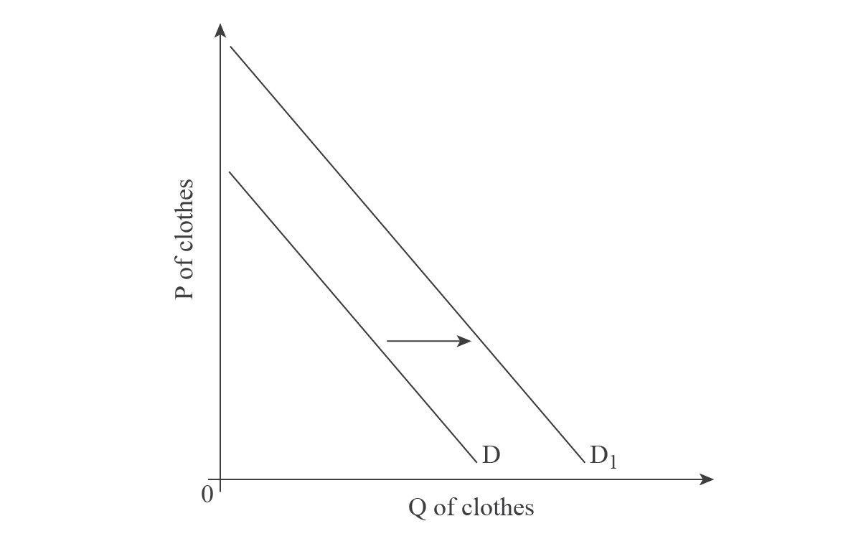
An inferior good is a good whose D decreases when Y increases and vice versa; it has a negative YED. An increase in Y will cause a shift in of D, and vice versa. For example, subway trips are an inferior good because when incomes increase, people substitute the subway for private cars. In the below graph, if a person’s Y increases, they buy fewer subway trips; D shifts inward from D to D1.
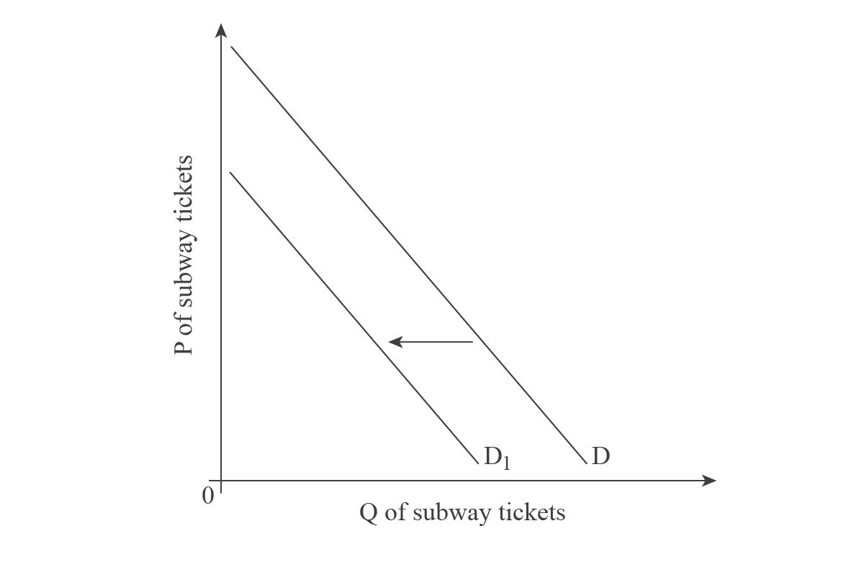
Unlike normal and inferior goods, which assess YED as positive or negative, necessities relate to YED to 1. These are goods that have a positive YED, so when Y increases, D increases. But these goods are also less than 1, meaning they are inelastic. As income increases, D does too, but the percentage increase in QD is less than the percentage increase in Y. Since it has a positive YED, it is graphed the same as normal goods (above). A good example of a necessity is food. As income increases, so does the QD of food, but the percentage increase of the QD of food is less than the percentage increase of Y. After all, we can only eat so much! So even if a person’s income goes up, they will increase their QD of food by a lower percentage than their income increase.
Teacher comment
Have you spotted DDEEE yet? Maybe you’re missing Evaluation and Examples? Keep reading!

(b) Evaluate two measures that the government might take to eliminate a surplus for agricultural products when a minimum price is set. [15 marks]​
Answers may include:
- Definition of minimum wage and demand for labour.
- Diagram showing the effect of a minimum wage on the labour market.
- Diagram showing the effects of two possible measures taken by the government to increase demand for labour.
- Explanation the effects of setting a minimum wage on the demand and supply of labour.
Evaluation may include:
- Explanation of two possible solutions, with advantages and disadvantages to the excess of supply of labour generated by the minimum wage.
- Examples of real-world cases where these policies have been used.
Level | Descriptors | Marks
0 | The work does not reach a standard described by the descriptors below. | 0
1 | There is little understanding of the specific demands of the question.  Relevant economic terms are not defined.  There is very little knowledge of relevant economic theory.  There are significant errors. | 1-5
2 | There is some understanding of the specific demands of the question.  Some relevant economic terms are defined.  There is some knowledge of relevant economic theory.  ​There are some errors. | 6-9
3 | There is understanding of the specific demands of the question.  Relevant economic terms are defined.  Relevant economic theory is explained and applied.  Where appropriate, diagrams are included and applied.  Where appropriate, examples are used.  There is an attempt at synthesis or evaluation.  ​There are few errors. | 10-12
4 | There is clear understanding of the specific demands of the question.  Relevant economic terms are clearly defined.  Relevant economic theory is clearly explained and applied.  Where appropriate, diagrams are included and applied effectively.  Where appropriate, examples are used effectively.  There is evidence of appropriate synthesis or evaluation.  ​There are no significant errors.

Example answer and explanation
A minimum or floor price is an example of a P control set by government. The P of a good or service is set above the market E P. The point of a minimum P is to help producers by making the P higher than it would be in a free market.
Teacher comment
You first must establish the problem, which is a surplus. To do that, you need a graph and an explanation…
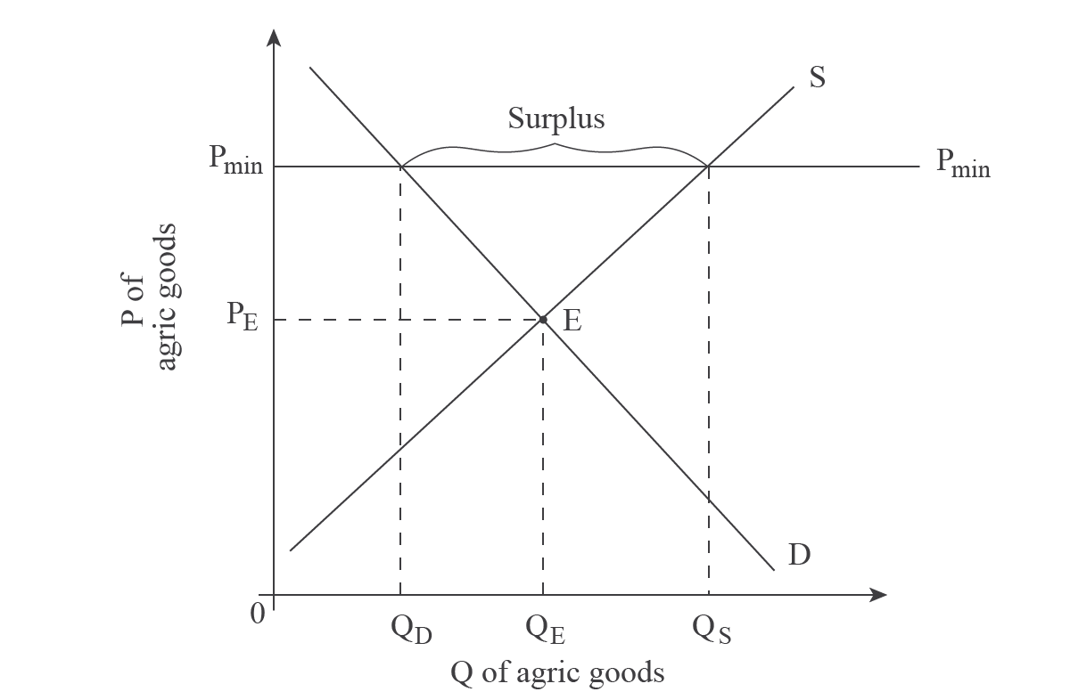
As can be seen on the above graph, a G has set the P of agricultural products at P_{min}, which is above P_{E}. At this higher P, producers are willing and able to produce more, so S increases to Q_{S}. However, at this higher P, due to the Law of D, consumers will buy less, at QD. Since Q_{S} > QD, a surplus is created.
Teacher comment
Now you are ready to Evaluate…
One method a G might take to deal with the surplus is to pay producers not to produce. This literally means US corn producers, for example, are paid the leave their fields fallow. In this case, the surplus is eliminated, so the minimum P measure does meet the G’s goal.
Teacher comment
Note that 'set-aside scheme', which is the technical name of the above measure, is not included. You are being graded, to some extent, on how much like an economist you sound, so if you don’t include economic terms, your score will be lower.
A major negative with this plan is that it requires G spending, thus creating an opportunity cost. So, for example, instead of G spending money on education, they are paying farmers not to grow corn.
Teacher comment
Another obvious topic here is the decrease in production, which could be argued as a negative. But remember, quality over quantity.

Exam tip
Quality over Quantity! To score well you must Explain your points in depth, and tie them to the question. Due to time constraints, you will probably only have time to include 1-2 points for each side of an issue, so be sure to choose the topics you’ll include carefully.
Another measure the G might take to eliminate a surplus is to purchase and store it, then and sell it onto the market when the P rises above P_{min}. This concept is known as a buffer stock. For example, the New Zealand G used to have a min P on sheep wool, to support their sheep farmers. In years when the amount of sheep’s wool was low, the G sold the stored wool onto the market.
A good thing about this policy is that, like with paying producers not to produce, it works to eliminate the surplus. Also, it can be argued that it’s better than paying producers not to produce, because the production is happening. In addition, the G can then sell the product and recover some (or all) of their expenditure when they purchased the product.
However, this policy only works with certain goods. Wool, for example, can be stored for long periods of time; bananas, for example, cannot. So this policy would only be a good idea with a limited number of agricultural goods.

Question 2:

(a) Explain, using an appropriate diagram, why the consumption of education might be a market failure. [10 marks]
Answers may include:
- Definition of market failure and merit goods.
- Explanation of why the under-consumption of education creates a potential welfare loss for society and an inefficient allocation of resources.
- Diagram to show the market failure where MSB > MPB of consuming education.
Level | Descriptor | Marks
0 | The work does not reach a standard described by the descriptors below. | 0
1 | There is little understanding of the specific demands of the question.  Relevant economic terms are not defined.  There is very little knowledge of relevant economic theory.  There are significant errors | 1-3
2 | There is some understanding of the specific demands of the question.  Some relevant economic terms are defined.  There is some knowledge of relevant economic theory.  ​There are some errors. | 4-6
3 | There is understanding of the specific demands of the question.  Relevant economic terms are defined.  Relevant economic theory is explained and applied.  Where appropriate, diagrams are included and applied.  Where appropriate, examples are used.  ​There are few errors. | 7-8
4 | There is clear understanding of the specific demands of the question.  Relevant economic terms are clearly defined.  Relevant economic theory is clearly explained and applied.  Where appropriate, diagrams are included and applied effectively.  Where appropriate, examples are used effectively.  ​There are no significant errors. | 9-10
Example answer and teacher comments

Exam tip
In a Paper 1, you have to choose 1 micro and 1 macro question, from a choice of 2 micro and 2 macro questions. Think about the expression, 'If it looks like a duck, and quacks like a duck, it’s probably a duck!' – meaning, don't overanalyse and make it more complicated than it really is. if a question looks really straightforward, it is! If you know the content for that question, it’s probably a good decision to choose to answer it!
In this example question, it is very straightforward. Just do DDE – Define, Diagram, Explain. Following that structure will earn you high marks on this part.
Market failure is a situation in which the market fails to allocate resources efficiently, leading to over- or under-provision. Education is generally regarded as a merit good, meaning it has positive externalities, is rivalrous and excludable. In the free market, it is under-consumed and is therefore an example of market failure.
Teacher comment
Notice how, in the above paragraph, only 2 terms are defined. Remember, you are not being graded on how many terms you define, but how correctly you use them. Defining the 1-2 key terms in a question, i.e. market failure and merit goods in this question, is a good idea, but you do not need to define every term you use (i.e. rivalrous and excludable).
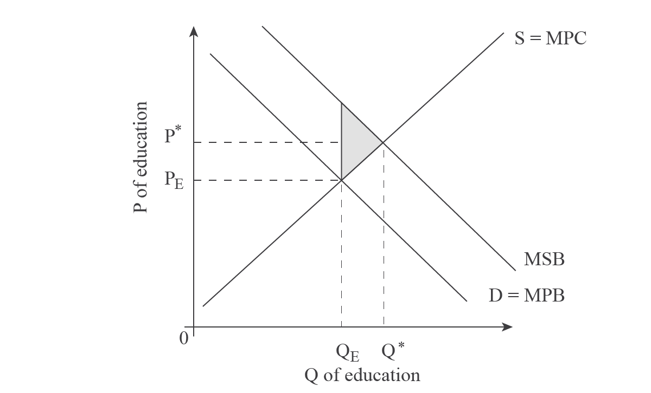
Teacher comment
There are several options with the above graph:
- You can label the vertical distance 'positive externalities'
- Instead of S, you can label that MPC
- Instead of P* and Q*, you can label them P_{opt} and Q_{opt}
- Instead of D, you can label it only MPB
As you can see on the above graph, the marginal private benefits (MPB) are lower than the marginal social benefits (MSB). In other words, the value third parties or society get out of the consumption of education is greater than the value private individuals place on education. Thus, there is under-consumption of education, or inefficiency in the market.
Teacher comment
Do you see the error in the explanation of the graph?
It’s incomplete! The student hasn’t explained the axis, so the concluding sentence isn’t well justified!
Look at the rubric, level 4. It says “…diagrams are included and applied effectively”. If you don’t fully explain graphs, your applications will be incomplete, and your essay will not reach the high marks.
A better conclusion to this paragraph is:
If the value society gets from the consumption of education were included, the P, or value, of education would be at P* instead of P_{E} and the Q of education consumed would be Q* instead of Q_{E}. Thus, there is under-consumption of education, or inefficiency in the market.

(b) Evaluate the following statement: 'Taxing sugary food and sodas might be a partial solution to obesity'. [15 marks]
Answers may include:
- Definition of indirect taxes, market failure, negative externality of consumption and demerit goods.
- Diagram showing the negative externality of consumption of sugary food.
- Diagram showing the effect of a tax on sugary food as a means to reduce its consumption.
- Explanation of the reasons to set a tax on sugary food.
Evaluation may include:
- Explanation of the effects of setting an indirect tax and the advantages and disadvantages that it may have.
- Explanation of other possible solutions to the negative externality of consumption caused by the excess consumption of sugary food, like negative advertisement or health awareness campaigns.
- Examples of real-world cases where these policies are used.
Level | Descriptors | Marks
0 | The work does not reach a standard described by the descriptors below. | 0
1 | There is little understanding of the specific demands of the question.  Relevant economic terms are not defined.  There is very little knowledge of relevant economic theory.  There are significant errors. | 1-5
2 | There is some understanding of the specific demands of the question.  Some relevant economic terms are defined.  There is some knowledge of relevant economic theory.  ​There are some errors. | 6-9
3 | There is understanding of the specific demands of the question.  Relevant economic terms are defined.  Relevant economic theory is explained and applied.  Where appropriate, diagrams are included and applied.  Where appropriate, examples are used.  There is an attempt at synthesis or evaluation.  ​There are few errors. | 10-12
4 | There is clear understanding of the specific demands of the question.  Relevant economic terms are clearly defined.  Relevant economic theory is clearly explained and applied.  Where appropriate, diagrams are included and applied effectively.  Where appropriate, examples are used effectively.  There is evidence of appropriate synthesis or evaluation.  ​There are no significant errors.

Example answer and teacher comments

Exam tip
Evaluations – A common error is going off-topic while writing. Be sure to refer to the question often and/or plan the topics you’ll include to ensure you answer the question.
Teacher comment
Notice that this answer begins with a definition and a diagram, then an explanation of the diagram.
Consumption of sugary foods and sodas creates negative externalities, meaning costs that fall on a third party, as illustrated below:
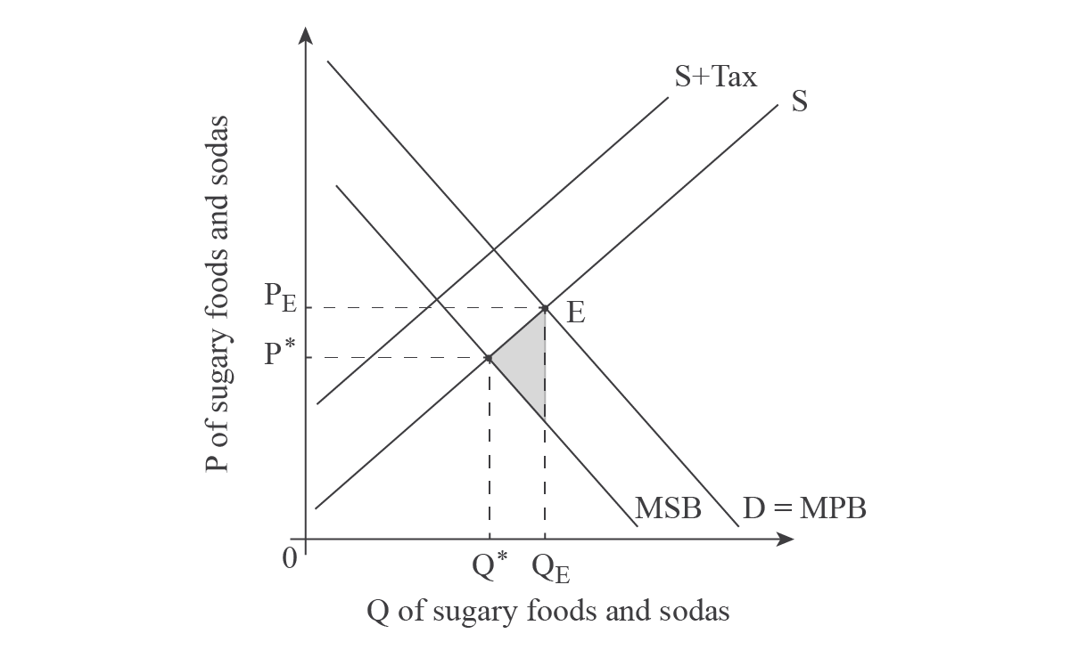
The marginal private benefit (MPB) is the value the individual gets out of the consumption of a good or service. Where MPB intersects the S curve determines where the individual consumes and the P, namely QE and PE. This, however, does not take into account society’s benefit, which is less. The difference is the spill-over effects of obesity onto the third party, such as increased health care costs. Where marginal social benefits (MSB) and the S curve intersect determines the socially optimum level of Q, which is less than QE. P* illustrates how much society values sugary foods and soda, which is less than the individual’s value, or PE. Where marginal social benefits (MSB) and the S curve intersect determines the socially optimum level of Q, represented by Q*, which is represented by the shaded area, and is less than QE. P* illustrates how much society values sugary foods and soda, which is less than the individual’s value, or PE.
Teacher comment
A common mistake is to say that Q* is the socially desirable Q at P*, but that doesn’t make a lot of sense because P* is lower than PE. Re-read the above sentence about what P* represents to ensure you understand what it means.
As explained in part (a), a tax causes the S curve to shift inward, thereby increasing the P of a product, thus decreasing QD due to movement along the D curve. This is represented in the above graph by S+tax. Thus, a tax does help to solve the problem of obesity by creating less consumption. However, the trick is to figure out how much tax to impose in order to create just the right amount of S shift to reach the socially desirable Q*.
Teacher comment
The paragraph above connects the theory to the question. This is a good example of how to construct and complete a point in an evaluation question.
But an evaluation MUST include two (or more) perspectives on this issue. So the next two paragraphs look at the other side of the tax...
However, how much QD changes is dependent on numerous other factors, which is why a tax might be only a partial solution to obesity. For example, if the D of sugary foods and sodas is highly inelastic, the tax will not change QD significantly, thus the tax won’t impact consumption very much, minimising the effects of the tax as a solution.
In addition, the market tends to find ways around G intervention and a tax on certain sugary foods and sodas may spark innovation on both the S and D sides. For example, in the UK, to avoid the recent sugar tax, many soda producers are switching their formulas to include other sweeteners. The side effects of these changes may cause other, unintended health issues in the long run. In addition, on the D side, some consumers are simply eating or drinking more than before, in order to get the same amount of sugar intake. Both of these reactions to the tax suggest that the goal of decreasing obesity will be ineffective.
Teacher comment
Then, finally, an approach you may or may not want to include is a different perspective; in this case, a different policy...
Instead of, or in addition to, a sugar tax, a G may be better off using other types of intervention to tackle the obesity problem. Advertising the negative effects of obesity, for example, might be a greater incentive to decrease consumption of sugary foods and sodas compared to the increase in P caused by the tax. Another method could be direct provision, i.e. via schools, of exercise and nutrition programs designed to decrease obesity. However, both of these policies will require G spending rather than creating G revenue, so both incur an opportunity cost, or money that could have been used on other public services.
Teacher comment
Overall, this answer will score very well because it fully answers the question, in a logical way.

Exam tip
Quality over Quantity! To score well you must explain your points in depth, and tie them to the question. Due to time constraints, you will probably only have time to include 1-2 points for each side of an issue, so be sure to choose the topics you’ll include carefully.

Question 3

(a) Explain why a firm in perfect competition can only make economic profits in the short run. [10 marks]
Answers may include:
- Definitions of perfect competition, economic profits and short run.
- Diagrams of economic (abnormal) profit in the short run and normal profit (zero economic profit) in the long run.
- An explanation of how economic (abnormal) profit acts as a signal for new firms to enter the market, shifting market supply to the right until normal profits are restored.
- Examples of markets where this might occur.
Level | Descriptor | Marks
0 | The work does not reach a standard described by the descriptors below. | 0
1 | There is little understanding of the specific demands of the question.  Relevant economic terms are not defined.  There is very little knowledge of relevant economic theory.  There are significant errors. | 1-3
2 | There is some understanding of the specific demands of the question.  Some relevant economic terms are defined.  There is some knowledge of relevant economic theory.  There are some errors. | 4-6
3 | There is understanding of the specific demands of the question.  Relevant economic terms are defined.  Relevant economic theory is explained and applied.  Where appropriate, diagrams are included and applied.  Where appropriate, examples are used.  There are few errors. | 7-8
4 | There is clear understanding of the specific demands of the question.  Relevant economic terms are clearly defined.  Relevant economic theory is clearly explained and applied.  Where appropriate, diagrams are included and applied effectively.  Where appropriate, examples are used effectively.  There are no significant errors. | 9-10

Example answer and teacher comments
Teacher comment
Think DDE – Define, Diagram, Explain!
Characteristics of perfect competition include many sellers and no barriers to entry or exit. These two main characteristics create a market structure where no one firm can have any effect over P, since each produces only a 'drop in the bucket' of total production. Each firm, therefore, is a P taker.
At the market P, each firm can make economic profit, but this will last only for the short run (SR), as illustrated in the graphs below :
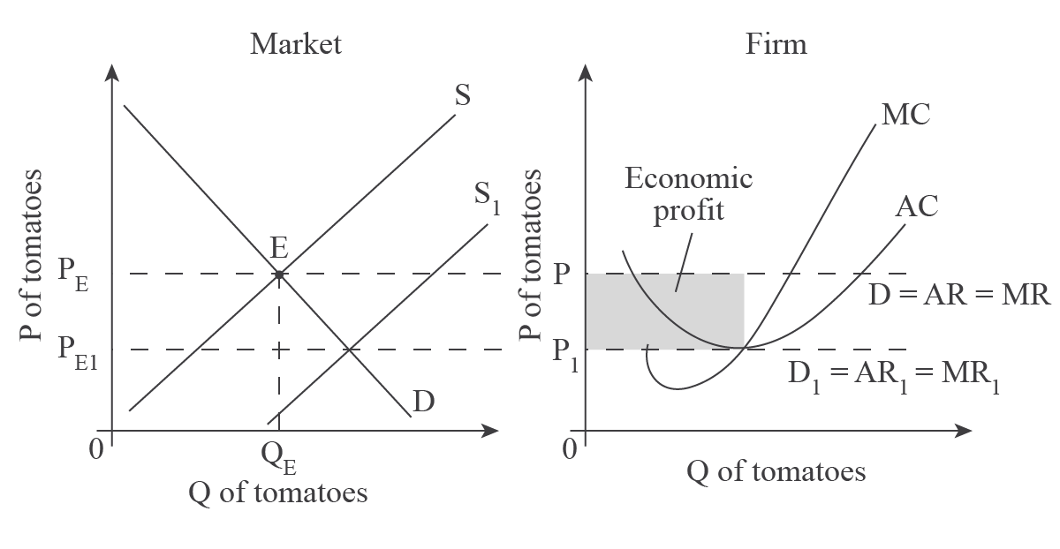
Teacher comment
It doesn’t matter if you draw the graphs in the above order or opposite, but it probably makes more sense to order them this way. Remember that you begin with the PE from the market (or industry), which determines the firm’s D/AR (average revenue)/MR (marginal revenue) curves. Then you add the firm’s marginal cost (MC) and average cost (AC) curves and identify the economic profit. Next, you identify the point of normal profit for the firm, and that point (where MC = AC) determines the amount of the S shift in the industry. So, you go from one graph to the other twice.
As the Market graph shows, the market determines the P_{E} of tomatoes, which is the P firms must take, and determines their D, average revenue (AR), and marginal revenue (MR). As shown in the Firm graph, this is illustrated as a horizontal, perfectly elastic curve labelled D/AR/MR. At this P, the firm’s average costs (AC) are lower, thus the firm is making economic (or abnormal) profit, as illustrated by the shaded box.
Since firms are making economic profit in the SR, this will attract more suppliers (a determinant of S) to the market. Combined with no barriers to entry, the S curve will shift out, and this will continue to happen until the P_{E} in the market decreases to the point that each firm is making a normal profit. On the above graphs, this is at P_{E1}. Firms now must take P_{E1}, which determines their new D₁/AR₁/MR₁ curve. Since this curve intersects the AC curve at its lowest point, the firm is covering all of its costs, but has no revenue beyond that. In other words, it is making a normal profit.
So, in the SR perfectly competitive firms can make economic profit, but in the LR, due to the increased number of suppliers, they can only make normal profit.
Teacher comment
This is an excellent essay; in addition to including definitions, a diagram and an explanation, it is well written. Notice how not all terms are defined at the beginning, but are worked into the essay. Perfect competition is defined at the beginning, because it’s the key term. Then short run and economic/normal profit are defined, but in the explanation. Since the essay meets all the requirements and is written well, it should score well.

Exam tip
Manage your time! You have 45 minutes for the whole question and part b counts for 60% of your grade, so you should spend about 18-20 minutes on part a and 25-27 minutes on part b.

(b) Discuss the view that the market for food is more beneficial to consumers if dominated by a monopoly retailer (supermarket) in relation to other market structures. [15 marks]
Answers may include:
- Definitions of monopoly and other type of market structures.
- An explanation of theory of the firm related to retail markets, and how monopoly has its advantages and disadvantages in terms of costs, price and output.
- Diagram to show the possible impact on consumers under monopoly in terms of price.
- Examples of relevant market structures.
Evaluation may include:
- Explanation that there may be some circumstances in which monopolies are desirable.
- Comparison with other possible market structures as monopolistic competition or perfect competition.
- Factors considered may include: the effects on efficiency and customer service, welfare effects, price and output, and economies of scale.
Level | Descriptors | Marks
0 | The work does not reach a standard described by the descriptors below. | 0
1 | There is little understanding of the specific demands of the question.  Relevant economic terms are not defined.  There is very little knowledge of relevant economic theory.  There are significant errors. | 1-5
2 | There is some understanding of the specific demands of the question.  Some relevant economic terms are defined.  There is some knowledge of relevant economic theory.  There are some errors. | 6-9
3 | There is understanding of the specific demands of the question.  Relevant economic terms are defined.  Relevant economic theory is explained and applied.  Where appropriate, diagrams are included and applied.  Where appropriate, examples are used.  There is an attempt at synthesis or evaluation.  There are few errors. | 10-12
4 | There is clear understanding of the specific demands of the question.  Relevant economic terms are clearly defined.  Relevant economic theory is clearly explained and applied.  Where appropriate, diagrams are included and applied effectively.  Where appropriate, examples are used effectively.  There is evidence of appropriate synthesis or evaluation.  There are no significant errors. | 13-15

Example answer and teacher comments
A monopoly is a market structure where a single firm dominates the industry. In addition, there are significant barriers to entry, so that firm can dominate in both the short and long run (LR). For these reasons, a monopoly can realise economies of scale, which can produce lower prices and increased Q for consumers.
Teacher comment
Notice that the focus of this essay has been set – economies of scale. This, however, is not the only way you could approach this question. If you know and can explain the theory of economies of scale, it’s a great approach. If you don’t know it, choose another approach you are better prepared to explain (see the markscheme for ideas).
Economies of scale is a situation in which, as total output increases, a firm realises decreasing per-unit costs. Monopolies, unlike perfectly competitive firms, can take advantage of this.
The situation is illustrated using a long-run average total cost curve (LRATC) on the graph below. In the range labelled 'economies of scale', the firm is realising reduced per unit costs as they increase Q. This occurs because the firm becomes more efficient with the increase in size in the long term.
This might occur because of managerial economies (when administrative functions specialise), purchasing economies (when a firm buys large quantities so gets each unit at a lower P), or marketing economies (when per-unit advertising costs decrease).
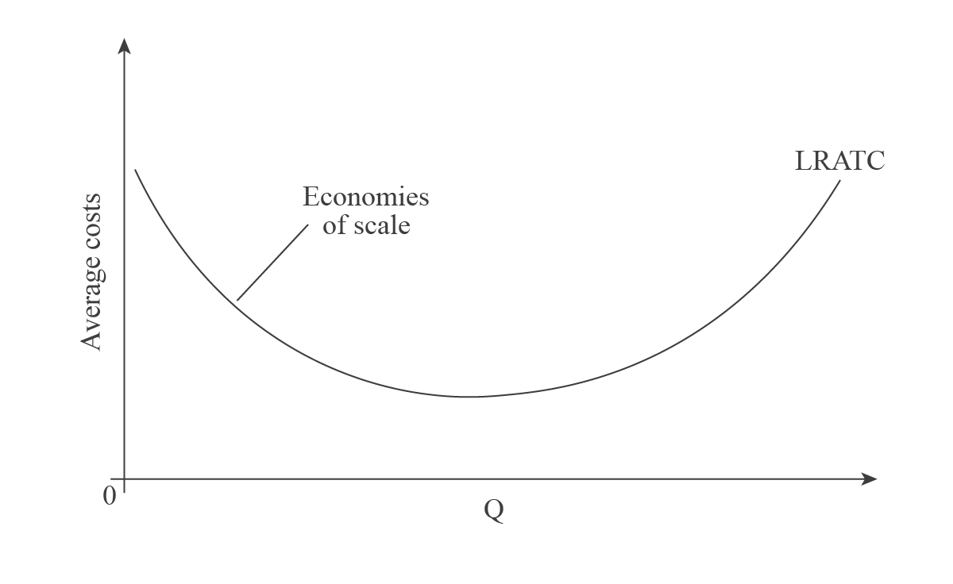
With decreased AC, marginal costs (MC) will also decrease, causing the MC curve to shift out, as illustrated on the graph below.
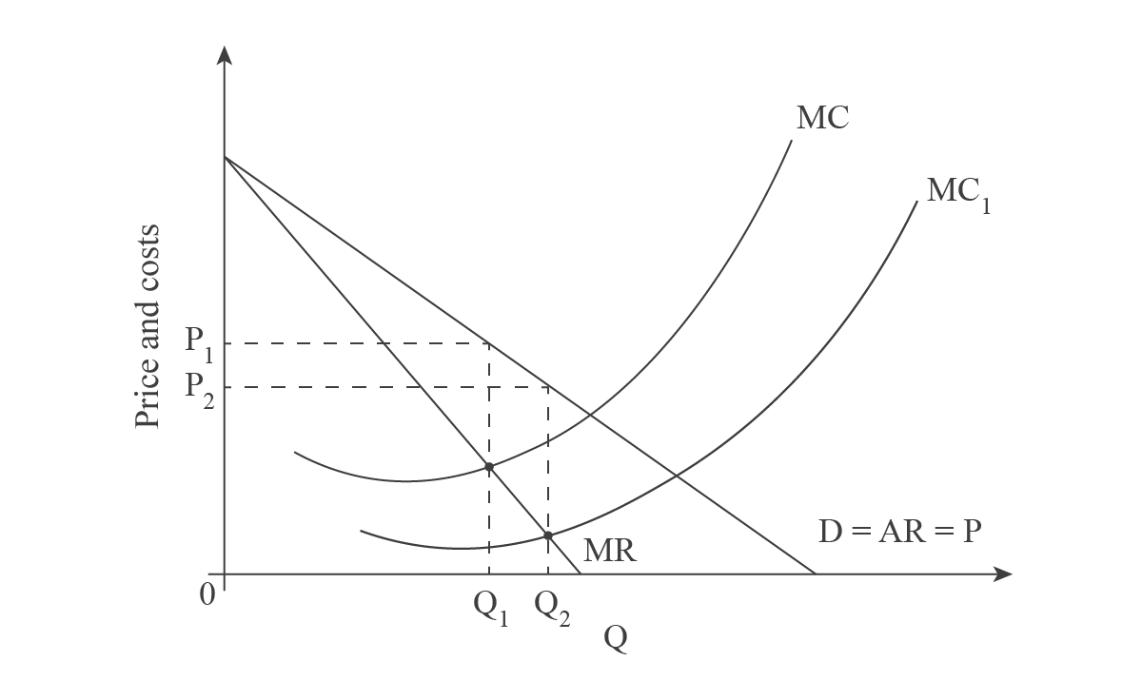
Since firms produce at the profit maximising point, or where MR = MC, the P of the product in the market decreases from P₁ to P₂ and Q increases from Q₁ to Q₂.
Thus, economies of scale can result in lower prices and increased Q, which will clearly benefit consumers.
The reason monopolies can experience economies of scale and other market structures can’t is simply because of size. Because of the characteristics of each market structure, only monopolies are protected from competition from other suppliers, so are the only structure that can monopolise a market. Therefore, only monopolies can take advantage of economies of scale.
Teacher comment
This essay could be better by adding on more explanation of why monopolies can realise economies of scale and other market structures can’t. However, given time constraints, this is probably about all you will have time to write. But QUALITY over QUANTITY will always score better and this essay is a thorough analysis of why economies of scale are beneficial to consumers.

