IGCSE Geography – Measuring the Weather

Name of the instrument | Photo or diagram | Key components/How it works
Anemometer (wind speed) | 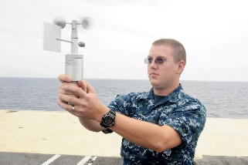  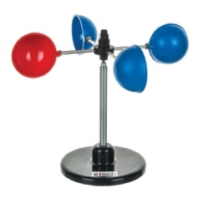 | - An anemometer is used to measure wind speed.  - An anemometer has 3 or 4 metal cups that are fixed to metal arms that rotate freely on a vertical shaft.  - When there is wind the cups rotate.  - The stronger the wind the faster the rotation.  - The number of rotations is recorded on a meter to give the speed in kmph.  - An anemometer should be placed well away from buildings or trees that may interfere with the free movement of air – buildings may channel air through narrow passages between two buildings or decrease the flow of air by blocking its path.  - Winds are shown by arrows on a weather map – the shaft of the arrow shows wind direction and the feathers on the arrow indicate wind speed.
Wind vane (wind direction) | 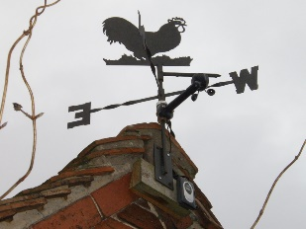 | - A wind vane is used to measure wind direction.  - A wind vane has the points of the compass (i.e. NESW) fixed and sited so that they point in the correct directions.  - Above the is an arrow that can be moved by very light winds.  - When the wind blows it moves the arrow and swings it around so that the arrow is pointing to the direction from which the wind is coming.  - Winds are shown by arrows on a weather map – the shaft of the arrow shows wind direction and the feathers on the arrow indicate wind speed.
Barometer (air pressure) | Mercury barometer  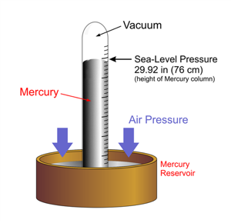  Aneroid barometer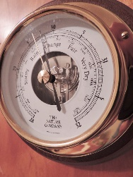 | - Pressure is the amount of air pressing down on the earth’s surface.  - The unit of measurement for air pressure is millibars (mb)  - The mean average pressure at sea level is said to be 1013 mb, so pressures below these are usually said to be low and pressures above this high.  - Low air pressure is associated with unsettled conditions (as warm air is rising off the surface of the earth – which later cools and condenses forming clouds and potentially rain).  - High pressure is associated with settled/clear conditions as cool air is descending and warming up.  - A barometer is an instrument that can be used to measure air pressure.  - A mercury barometer is a hollow tube from which air is extracted before being placed in a dish (bath) of mercury.  - Mercury is forced up the tube by the pressure of the atmosphere on the mercury in the bath.  - When the pressure of the mercury in the tube balances the pressure of the air on the exposed mercury, the mercury in the tube stops rising.  - The height of the column of mercury changes as the air pressure changes – it rises when air pressure increases and falls when air pressure decreases.  - An aneroid barometer is a different kind of barometer that works by having a sealed box that can change shape.  - As the air pushes down on the box, it changes shape and moves a needle on the dial and produces a reading on a calibrated scale. A barograph is a tracing from an aneroid barometer, which records continuously for one week.  - Atmospheric pressure is measured at numerous weather stations and these pressures are then plotted on a map.  - Lines are drawn through points where pressure is the same – these lines are called isobars.  - Barometers are frequently stored inside a Stevenson Screen but they may also be kept inside.
Wet-dry thermometer  /hygrometer (relative humidity) | 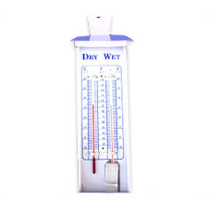 | - Humidity is the amount of water vapour in a given volume of air.  - Water vapour is an invisible gas. The amount of water vapour that any air can hold depends on the temperature – warm air can hold more water vapour than cold air.  - When air temperature increases it evaporates water from water surfaces and vegetation – this increases the air’s humidity.  - When air is cooled the amount of water vapour that it can hold reduces. If the air is cool sufficiently it reaches the maximum amount of moisture that is can hold – this is called dew point. Any further cooling will result in condensation – a process by which excess water vapour turns into water droplets or ice depending on the temperature of the air.  - Knowing how close the air is to being saturated is vital for accurately forecasting whether or not precipitation will occur.  - The relative humidity of the air is expressed as a percentage. When air is saturated the relative humidity is 100%.  - Relative humidity is measured using a wet and dry thermometer (or hygrometer).  - The dry bulb thermometer is an ordinary thermometer giving the air temperature.  - The bulb of the other thermometer has fine muslin cloth wrapped around it. Beneath it is a container of water from which the wick of the cloth leads to the muslin around the bulb – keeping the bulb constantly moist.  - If the air is not saturated water will evaporate from the muslin.  - Evaporation causes cooling of the bulb which causes the mercury to contract and register a lower temperature.  - The temperature of the wet bulb minus the temperature of the dry bulb temperature gives the depression of the wet bulb. The larger this is, the lower the relative humidity will be.  - A hygrometer should ideally be stored inside a Stevenson Screen so that temperatures may be recorded in the shade.
Maximum-minimum thermometer (temperature) | 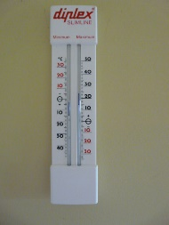 | - A maximum and minimum thermometer is a temperature measuring device that is designed to show the highest and lowest temperatures reached.  - The units of measurement are degrees Celsius or Fahrenheit.  - It works by having a thermometer that has been turned into a U-Tube shape.  - The tube contains mercury with alcohol either side of it.  - When the temperature rises the alcohol in the left arm expands, while some of the alcohol in the right arm evaporates into the space in the bulb.  - The expanding alcohol on the left is then able to push mercury up the right arm.  - This pushes an index up the tube, which is left at the maximum temperature reached.  - When the temperature cools the alcohol in the left arm contracts. Some of the alcohol vapour in the bulb turns back to liquid.  - The mercury then moves up the left arm – pushing a metal index as it does so – to indicate the minimum temperature reached.  - The instrument is read at eye level from the lower end of each index.  - It is reset by using a magnet to draw each index back to the mercury.  - Lines can be drawn on a map connecting areas of equal temperature – these lines are called isotherms.  - Thermometers at a weather station are frequently stored inside a Stevenson Screen so that temperatures may be recorded in the shade.
Rain gauge (precipitation) | 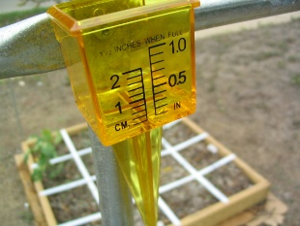 | - Amounts of precipitation e.g. rain, snow, sleet or hail are measured using a range gauge.  - This consists of a cylinder in which there is a collecting can containing a glass or plastic jar and a funnel that fits on the top of the container.  - The gauge is placed in an open space where so that only raindrops enter the funnel, rather than run off from buildings/vegetation etc.  - The gauge is sunk into the ground so that the top of the funnel is about 30cm above ground level. This is to prevent water splashing on the ground and then entering the funnel.  - Rainfall collects in the jar and this is usually emptied every 24 hours.  - It is poured into a tapered glass and measured in millimetres.  - Rainfall recorded for a day, week, month or year can be shown on a weather map.  - Isohyets are lines on a map connecting points having the same amount of rainfall in a given period.
Sunshine recorder (sunshine) | 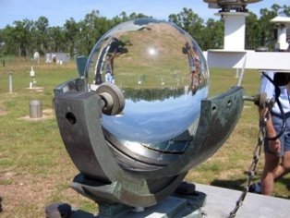 | - The number of hours and minutes of sunshine received at a place can be measured on a sunshine recorder.  - This is a glass sphere partially surrounded by a metal frame.  - A strip of special card, divided into hours and minutes is placed below the sphere.  - When the sun shines, the sphere focuses the sun’s rays on the card.  - As the sun moves, the rays burn a trace on the card. At the end of the day the card is removed and replaced.  - The length of the trace represents the amount of sunshine the area received.

Stevenson Screen
Task 2 – Annotate key information on to the diagram below

