MC Glocalization – McDonalds in India
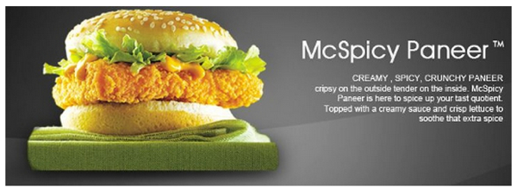

Define ‘Glocalization’

Read the BBC article on geographypods - How McDonalds has "conquered" India. Then complete the following tasks:

Task 1 - What were the major issued faced by McDonalds in setting up the restaurant chain in India? Talk about eating habits and levels of poverty.

Task 2 – Outline the plans for future McDonalds development in the country. State population numbers compared to McDonalds outlets.

Now visit the global McDonalds site and navigate your way to India (http://corporate.mcdonalds.com/corpmcd/about-us/around-the-world.html).

Task 3 - Comment on the types of burgers available and the level to which they have been glocalized for the Indian market.

Task 4 – Comment on children promotions and their socio cultural impacts on the target audience

Task 5 - Now navigate to the YouTube McDonalds channel for India and watch at least two videos making notes on the use of imagery and music to sell the glocalized products.

