Name:
Mark awarded:

Why:

Task question: To what extent does Katy, Texas show evidence of a shopping hierarchy

Mark scheme for introduction:

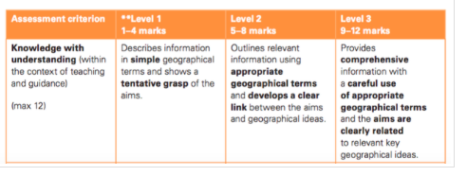
Success criteria/ Checklist for writing your coursework introduction:
Have you…. | Yes/no
Included the task question
Explained what you understand by the shopping hierarchy
Explained your understanding of the key terms related to the shopping hierarchy
Linked your study to the relevant section of the syllabus
Introduced the location- Houston and Katy
Made the locational context relevant to your study
Included annotated maps of both Houston and Katy
Made the annotations relevant to the study
Ensured maps etc. have a north arrow/ scale and figure number and clear title
Include 2- 3 sub hypothesis to break down the question
Made predictions for your hypothesis related to the locational context and theory
Done all of this in 300-400 works

