Mapping the Silk Road
On the map below, map the land routes and sea routes of the Silk Road. Use one color for land routes and another color for sea routes. In addition, please label the cities, regions, and water features listed on the back of the map. Leave the bottom space below the map blank for a future activity!

Cities: Tyre, Damascus, Babylon, Bukhara, Taskent, Samarkand, Balkh, Taxila, Kasgar, Khotan, Turfan, Dunhuang, Xi’an, Guangzhou, Anyang, Luoyang
Regions: India, Middle East, Ethiopia, China
Water Features: Arabian Sea, Red Sea, Mediterranean Sea, Bay of Bengal, Caspian Sea, Black Sea, South China Sea, Indian Ocean, Pacific Ocean, East China Sea
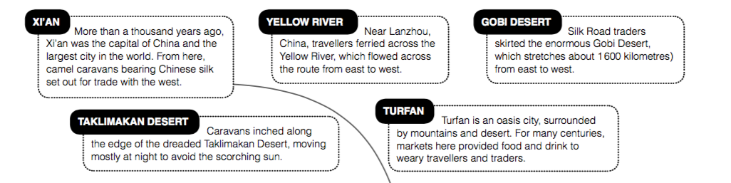
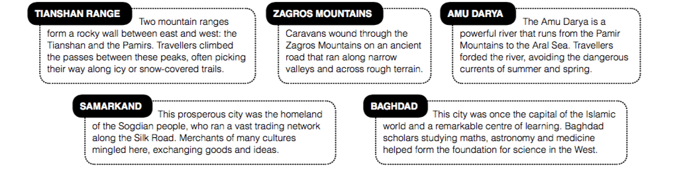
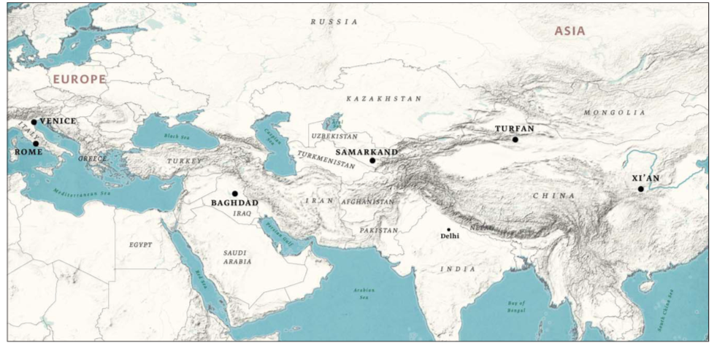

Traveling the Silk Route
 | Describe what you find there? | What goods/ideas does it offer?
Xi’an
Turfan
Samarkland

