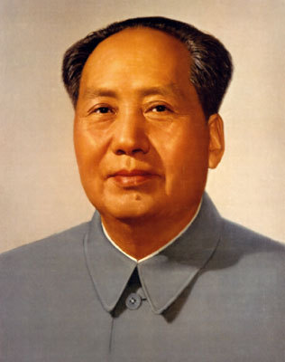
Mao’s Rule of China: Decision-Making Exercise
“How Now, Chairman Mao?!”

• As you progress through the multimedia presentation Make sure you take detailed notes throughout!

What action did Mao take?
Mao’s Action – what does this reveal about how the SPS consolidated and maintained power?
1. Administration

2. Economy
3. Politics
4. Five-Year Plan
5. Sino-Soviet Relations
6. Culture
7. Great Leap Forward
8. Lushan Conference
9. Great Famine
10. Cultural Revolution
11. Mango Fever
12. Red Guards
13. Lin Biao
14. Sino-American Relations
15. Postscript

