Maldives: Tourism
Impacts On People
Tourism can negatively impact locals because a large portion of the resorts are owned by foreign companies and that means that the locals of the Maldives won’t be receiving a high percentage of the money because it would’ve gone overseas. The foreign companies are said to have their own marketing departments and they contract out their rooms to large tour groups. This makes it harder for local agencies to attract tourists due to the competition.

Tourism has also negatively affected the interaction between locals. There is also a greater inequality in wealth and this is shown by the few local individuals who own resorts who also own several yachts and the annual salary for resort staff being only NZ $1550. This could cause disagreements with some people having way more wealth than others.

However, tourism also positively affects locals because it gives employment and also brings money back into their government which helps them all as a country. It is estimated that “11% of Maldives’ population of 314,000 [2009] are employed in tourism”. Tourism brings in about $600 million a year and generates 60% of all foreign currency earned. It also accounts for 90% of the government’s revenue.

Tourism may positively affect tourists coming in from other countries, because there are many eco tourism companies out there who are promoting sustainability. For example Naturetrek Wildlife Holidays have said “All tourism has an impact on local communities, wildlife and habitats of the host country. To maximise the positive effects of Naturetrek tours, where possible we take small groups, use locally owned accommodation and provide employment for local people. We also commit to long-term plans, which help local communities protect their environment.” Tourists may learn more about sustainability and may put that into action when they go back home.

Impacts on the Environment
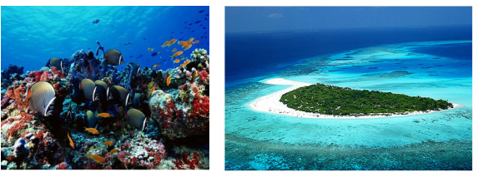

Tourism can negatively impact the environment of the Maldives because resort islands have changed many aspects of the Maldives. Also tourist activities such as snorkeling, diving and overfishing are slowly deteriorating eco systems.

For example, blasting has led to the destruction of coral reefs. This affects the water currents and changes the quality of the water so that the inhabitants of the reefs may be threatened. Also, the reefs are being damaged by tourist divers who may trample them accidentally. The reefs are very popular for tourists so if the reefs are destroyed in the future, then it would significantly damage tourism in the Maldives.

Also, during construction of resorts, trees are removed and this causes erosion of the island because the trees were what held the sediment in place. Erosion has also occurred because of rock filled jetties which stops the movement of sand around the islands which leaves some places with no sand. Habitats have already been destroyed because of construction work of resorts.

Rubbish and contamination by the mass number of tourists has led to many problems. For example, contamination of lagoons may occur due to sewage and liquid waste seeping through and into the lagoon. Algae and sea grasses which start to grow can make the sea beds look dirty and make tourists feel that the Maldives are losing their attraction as being seen as ‘the paradise destination.’ Also, Thilafushi (also known as Rubbish Island) receives hundreds of tones of rubbish from other islands in the Maldives daily. It is growing one square metre a day with rubbish but sixteen years ago it was an unspoilt coral reef. The dangers with this is that this island is only 1 metre about sea level and with rising sea levels, toxic chemicals like mercury and cadmium can be leached into the sea and harm the marine life of the area.

