**What were the main features of the Industrial Revolution?**

**Task:** Read the following information and write a short paragraph of the main features of the Industrial Revolution.

The Industrial Revolution is normally said to have occurred in Britain between 1750 and 1900. It was a period of rapid economic and social change. It was made up of many different factors which all interlinked.

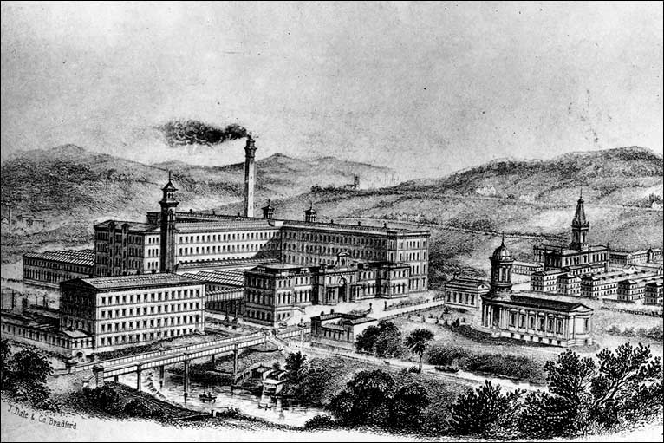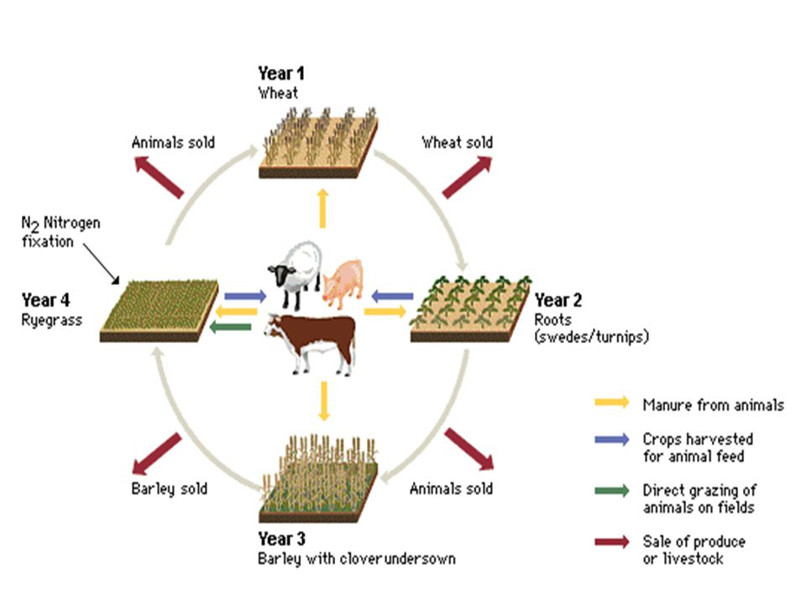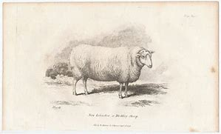

Agriculture. New methods allowed farmers grow much more food than ever before. For example ‘Turnip’ Townshend introduced the Norfolk four-course rotation of farm land and Robert Bakewell used selective breeding to develop the New Leicester sheep.

Industry. New methods of manufacturing using large factories made thousands of basic products like clothes and tools easier to build and cheaper to buy. Richard Arkwright's Mill at Cromford heralded 'the Factory Age' of the textile industry, production of iron increased 30-fold, and production of coal increased 20-fold.

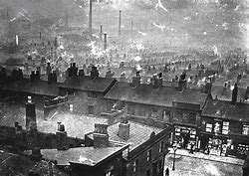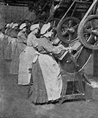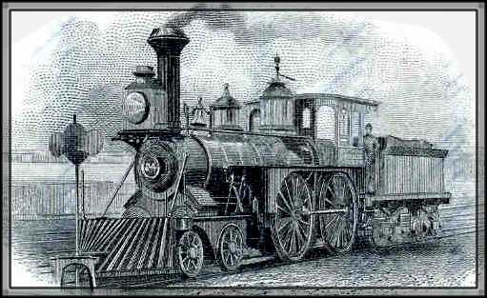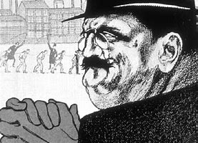

Society: Women and children began to enter the workforce and receive a salary the relationships that had held societies together began to change.

Science and technology: At the same time there occurred a long list of scientific discoveries and technological inventions that changed society and industry.

Cities: Hundreds of thousands of families left the countryside and moved to new but often cramped and small houses in the rapidly expanding cities. The skyline became dominated by large chimney and soot and smoke polluted the air.

Factory owners often became ‘super rich’ and challenged the old Lords for control over the country.

Transport and communications. Faster ways of traveling were developed and they changed the world forever. Thomas Telford built roads and canals in the 1700s, and George Stephenson and Isambard Kingdom Brunel oversaw the 'Railway Mania' of the 1800s.