4

(b) Discuss the limitations of national statistics to make country growth comparisons. [15 marks]
Answers may include:
- Definitions of real GDP, GDP, GDP per capita and growth.
- Diagram to show actual growth or potential growth of an economy.
- Explanation of all of the limitations found in the calculation of real GDP of a country which can make the calculation non-reliable (flaws in the collection of data, hidden economy, do-it-yourself work, black markets, self-subsistence production, other non-registered economic activity).
- Discussion of how nominal GDP might include changes in the price level and therefore mislead conclusions about country growth.
- Evaluation of the convenience of using GDP versus per capita GDP to compare country growth and improvements in the standards of living.
- Examples supporting each situation.
Level | Descriptors | Marks
0 | The work does not reach a standard described by the descriptors below. | 0
1 | There is little understanding of the specific demands of the question.  Relevant economic terms are not defined.  There is very little knowledge of relevant economic theory.  There are significant errors. | 1-5
2 | There is some understanding of the specific demands of the question.  Some relevant economic terms are defined.  There is some knowledge of relevant economic theory.  There are some errors. | 6-9
3 | There is understanding of the specific demands of the question.  Relevant economic terms are defined.  Relevant economic theory is explained and applied.  Where appropriate, diagrams are included and applied.  Where appropriate, examples are used.  There is an attempt at synthesis or evaluation.  There are few errors. | 10-12
4 | There is clear understanding of the specific demands of the question.  Relevant economic terms are clearly defined.  Relevant economic theory is clearly explained and applied.  Where appropriate, diagrams are included and applied effectively.  Where appropriate, examples are used effectively.  There is evidence of appropriate synthesis or evaluation.  There are no significant errors. | 13-15

Example answer and teacher comments
Teacher comment
Similar to (a), to score well on this question there are numerous terms you need to know well. Do you know which 'national statistics' this question’s intent relates to? Can you evaluate each? If you aren’t sure, this probably wouldn’t be a great choice of question.

Exam tip
Answer the question that is being asked! A common error is going off-topic while writing. Be sure to refer to the question often and/or plan the topics you’ll include to ensure you answer the question.
National statistics is a broad term that includes any stat that measures the macroeconomy, and there are hundreds of numbers governments keep up with. The 'grand-daddy' (or the single most important/most widely used) of them all, however, is GDP, which can then be measured as real GDP, nominal GDP, and GDP per capita.
Teacher comment
The above paragraph is an introduction to the essay, so will it help your score? Usually the answer is no, but this one is a bit more arguable. It does tell the examiner which statistics you’ll focus on and why. Since it provides a justification for your stats selection, it helps to evaluate, so could improve your score.
Gross domestic product, or GDP, is a measurement of all product or output in an economy. Domestic means within the country’s geographic boundaries, so includes all production in that area by the country’s citizens and foreigners.
Teacher comment
Don’t forget to start at the beginning – in this case, with a definition of the big idea.
Nominal GDP is a measurement of output at current prices, so it doesn’t account for inflation, meaning it overstates an economy’s size. Since the purpose of macro stats is to measure growth, especially for comparing growth over time, this stat is an especially poor measurement.
GDP per capita is a somewhat better measurement for growth purposes. Per capita means per head, so this measures the average output per person in an economy. It’s good in the sense that it does give some measurement about quality of life (or standard of living). Generally, it is true that countries with a high standard of living do have higher GDP per capita numbers. However, the problem with this stat is that it is an average. Firstly, it does not indicate Y distribution, so the number could be high but a significant percentage of the population could be very poor. Secondly, a country could have a very high GDP but because they have a large population the number will be very small. So this stat is both useful in making growth comparisons and also not so reliable.
Teacher comment
If you know specific GDP per capita stats, maybe from your study of Topic 4 – Development, include them if they illustrate your claims.

Exam tip
Examples – DO include them whenever possible!
Thus, the most widely used GDP statistic is real GDP. Using the GDP deflator, real GDP is determined by taking inflation out of nominal GDP, so it solves the problem of nominal and is therefore a more reliable way of measuring growth. Also, unlike GDP per capita, it is a total, not an average, so it solves those problems. However, since it’s a total, it does not indicate anything about quality of life.
In addition, there are numerous problems with measuring GDP. Firstly, it does not include any output that is not reported. This includes, for example, all illegal activity or parellel (commonly called "black") markets such as drug and prostitution transactions, any do-it-yourself work such as homemakers, any intentional or unintentional errors on tax records, and any other production that is somehow simply missed in the collection of the data.
Finally, since GDP is used to compare economies between countries, another measurement problem is that governments calculate GDP differently. This, obviously, makes international comparisons unreliable.

Exam tip
Evaluations – You must include two sides of an issue! A great way to think about how to write a good one is the CLASPP approach (conclusion, long-term and short-term effects, assumptions, stakeholders, priorities, pros and cons). For more details, see the Internal Assessment section, specifically 5.0.4.
Teacher comment
Since this is an evaluation question, you must present both sides of each statistic. Notice that the answer includes lots of transition words, such as: however, thus, in addition, and so. Those kinds of words help your writing by indicating you are moving from one side of the argument to the other. Use them!
Also, notice that there is no diagram with this question! It’s unusual but it does happen! Don’t try to force something into your answer that a question isn’t asking.

5

(a) Explain the difference between the equilibrium level of output and the full employment level of output. [10 marks]
Answers may include:
- Definition of equilibrium level of output and full employment level of output.
- Diagram showing the difference between the equilibrium level of output and the full employment level of output.
- An explanation of how equilibrium level of output is where the economy is producing at a level where everything that is produced is consumed (AD=AS), while full employment level of output is where the economy uses all of its resources to their maximum capacity (potential output).
- Explanation of how the equilibrium level of output might or might not agree with the full employment level of output.
- Real-world examples in reference to the previous explanations.
Level | Descriptors | Marks
0 | The work does not reach a standard described by the descriptors below. | 0
1 | There is little understanding of the specific demands of the question.  Relevant economic terms are not defined.  There is very little knowledge of relevant economic theory.  There are significant errors. | 1-3
2 | There is some understanding of the specific demands of the question.  Some relevant economic terms are defined.  There is some knowledge of relevant economic theory.  There are some errors. | 4-6
3 | There is understanding of the specific demands of the question.  Relevant economic terms are defined.  Relevant economic theory is explained and applied.  Where appropriate, diagrams are included and applied.  Where appropriate, examples are used.  There are few errors. | 7-8
4 | There is clear understanding of the specific demands of the question.  Relevant economic terms are clearly defined.  Relevant economic theory is clearly explained and applied.  Where appropriate, diagrams are included and applied effectively.  Where appropriate, examples are used effectively.  There are no significant errors. | 9-10

Example answer and teacher comments
Teacher comment
Is the Keynesian AS curve relevant here? Clearly the question includes the New Classical concept of LRAS, so it’s probably best to just use the New Classical graph for equilibrium, too. But either approach is acceptable.
New Classical economists argue that the equilibrium (E) level of output is where their short-run aggregate supply (SRAS) curve intersects the aggregate demand (AD) curve. This intersection determines the E price level and output. This point, however, might not intersect long-run aggregate supply (LRAS), which symbolises the economy’s capacity, or full employment level of output. This is illustrated on the graph below:
Teacher comment
Notice that the Definitions required the by question are included in the above paragraph, while also clarifying the direction of this answer (the New Classical perspective).
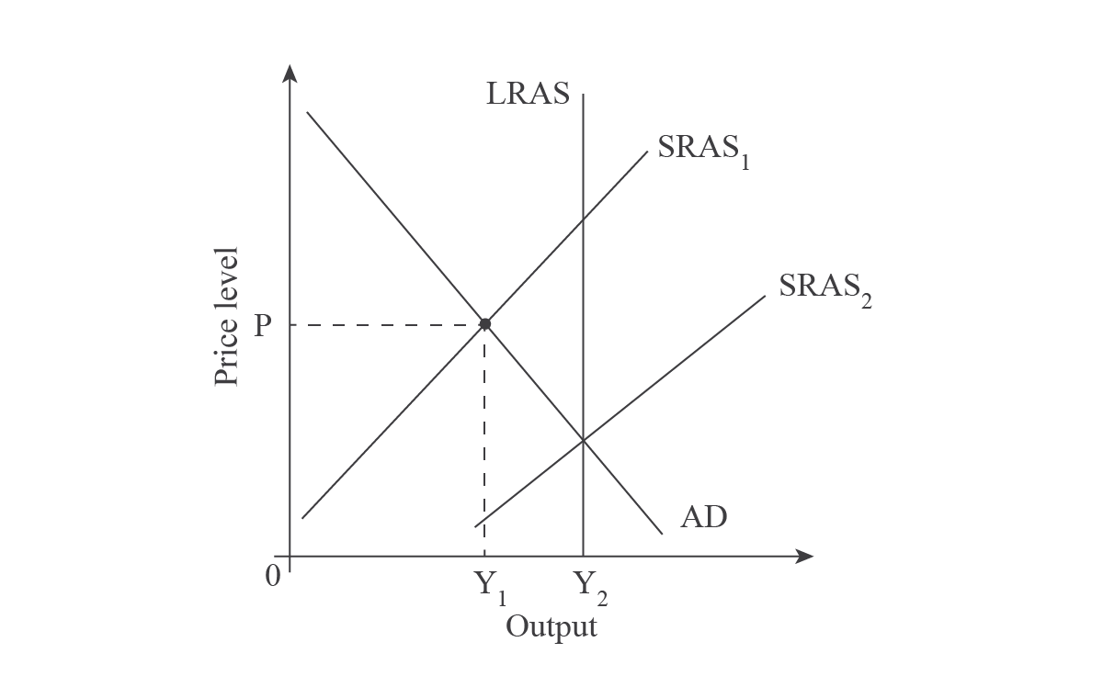
In the above graph the LRAS curve initially lies to the right of the intersection of SRAS1 and AD, the macroeconomic E point. This situation is called a recessionary gap. Since LRAS represents the full employment level of output, at Y2, and the economy is only producing Y1, some resources are not employed. In this situation, some factors of production including land, labour, capital, and entrepreneurship are sitting idle. The actual output is Y1 but the economy could produce more, meaning its potential output is Y2.

Exam tip
For Diagrams, always Explain your graphs!
If either AD or SRAS shifted out enough, the economy could produce at Y2. As illustrated on the above graph, SRAS shifted from SRAS1 to SRAS2, thereby increasing output from Y1 to Y2. Potential growth has been realised, or the full employment level of output.
Teacher comment
Can you think of a relevant Example to add onto this essay? How about The Great Recession, where unemployment was high? If you know a country that was hit by the economic downturn, and a G response to it (i.e. US President Obama’s Stimulus Bill), include it. Be sure to explain what the policy’s intent was (fiscal policy – G spending – shift out AD – decrease unemployment) and if you know any data (i.e. US unemployment was over 10% when he took office), include it, too!

Exam tip
In the exam, use Examples whenever possible!

(b) Discuss possible policies that government can apply to improve income distribution. [15 marks]
Answers may include:
- Definitions of equity and equality.
- Lorenz Curve diagram to show situations of more or less equality in the distribution of income.
- Discussion of taxation policies that improve the distribution of income (progressive taxes), transfer payments (like child support assistance, pensions, unemployment benefits, payments to disabled people, subsidies to producers), and government expenditure to provide essential goods and services (as health care, education, sanitation, water supply).
- Evaluation of redistribution of income policies.
- Numerical and/or real-world examples supporting the previous analysis.
Level | Descriptors | Marks
0 | The work does not reach a standard described by the descriptors below. | 0
1 | There is little understanding of the specific demands of the question.  Relevant economic terms are not defined.  There is very little knowledge of relevant economic theory.  There are significant errors. | 1-5
2 | There is some understanding of the specific demands of the question.  Some relevant economic terms are defined.  There is some knowledge of relevant economic theory.  There are some errors. | 6-9
3 | There is understanding of the specific demands of the question.  Relevant economic terms are defined.  Relevant economic theory is explained and applied.  Where appropriate, diagrams are included and applied.  Where appropriate, examples are used.  There is an attempt at synthesis or evaluation.  There are few errors. | 10-12
4 | There is clear understanding of the specific demands of the question.  Relevant economic terms are clearly defined.  Relevant economic theory is clearly explained and applied.  Where appropriate, diagrams are included and applied effectively.  Where appropriate, examples are used effectively.  There is evidence of appropriate synthesis or evaluation.  There are no significant errors. | 13-15

Example answer and teacher comments
Teacher comment
Don’t forget to start at the beginning! In this case, it is defining income distribution and the wider topic of equity.
An element of the macroeconomy that governments watch is income (Y) distribution, which relates to equity, meaning fairness. In free market or mixed economies, because of unequal ownership of resources (i.e. some people earn more Y because their skills are more scarce), Y distribution is unequal. This creates 'rich' and 'poor', or a lack of equity, which some argue is a type of market failure. If severe, it can cause social unrest. To prevent this, governments often intervene in the economy to redistribute Y.
The most obvious way to even out Y is via taxes. G (government) imposes taxes two ways – indirect taxes are taxes on spending and direct taxes are taxes on Y. The more relevant type for Y distribution is Y taxes, which can be structured as progressive (tax rate increases as Y increases), regressive (tax rate increases as Y decreases) and proportional (everyone pays the same percentage). Since regressive taxes do exactly the opposite of creating equity, and, for example, were one of the main causes of the French Revolution, and proportional is also generally viewed as not as effective in creating equity, most countries today use a progressive tax system.
Although the progressive system does redistribute Y, it has a big weakness: it is inefficient. The process of collecting and redistributing Y has costs, including administration of programs and the possibility of creating a disincentive to work. This was addressed by Arthur Laffer in the Laffer Curve, which argued for tax cuts, which, theoretically, would increase output and therefore G tax revenue. This later became known as 'trickle-down' or 'voodoo' economics. So, like all macro topics, taxes have two ways of looking at them.
Teacher comment
Do you think you could write about taxes in this much depth? Do you even have time to? The above two paragraphs offer an in-depth analysis of taxes, but that’s only one policy governments use to solve the issue. To score well, you really need to cover at least two policies well.

Exam tip
Quality over Quantity! To score well you must explain your points in depth, and tie them to the question. Due to time constraints, you will probably only have time to include 1-2 points for each side of an issue, so be sure to choose the topics you’ll include carefully.
A second policy governments often use to redistribute Y is directly providing or subsidising key services. For example, most governments have a public education system to ensure all citizens have at least a basic education so that they can function in the economy, meaning get a job and have a Y. Additionally, most governments have a public healthcare system to ensure everyone can stay healthy, again ensuring they can participate in the economy. Finally, governments often subsidise key utilities such as water, sewage, and electrical systems, to ensure a basic standard of living.
Since this policy uses tax revenue to support those services it has the same problems as taxes. On the one hand it creates greater equity, but is again inefficient.
Finally, a third policy governments use to redistribute Y is transfer payments, also known as 'welfare'. This idea is more of a direct movement of money from those who 'have' to those who 'have not'. The most obvious of these is unemployment benefits, also known as 'the dole'. Since direct taxes tax Y, when G revenue is given to the unemployed, it is a method of transferring Y from those with jobs to those without. There are many other types of transfer payments, however, including supporting disabled people, food support, subsidies for university education, programs for the elderly, etc.
Like the above two policies, transfer payments rely on taxes, so although they help create greater equity, they are inefficient.
Overall, on the one hand equity is good for societies because, some would argue, it’s simply the right thing to do and prevents class conflict. On the other hand, if people are being taxed too much, or disagree with how their tax money is being spent, it could de-motivate people from working. This applies to business taxes, as well, and in the last couple of decades the world has seen businesses shift their operations from one country to another to avoid high tax rates. As the world becomes smaller, this trend could increase, forcing countries into a situation where they vie for the lowest tax rates to attract production. So, what’s right is a judgement call.
Teacher comment
This is a very thorough and organised essay but it is very unlikely you would have time to write this much. What would you keep, and what would you skip?

6

(a) Explain, using production possibility diagrams, the distinction between growth in actual output and growth in the production possibilities for a country’s economy.[10 marks]
Answers may include:
- Definition of economic growth.
- Definition of economic potential.
- An explanation that the productive potential of an economy is determined by the quality and/or quantity of the factors of production.
- An explanation that the factors of production include land, labour, capital and entrepreneurship.
- A diagram showing the economy under-performing relative to potential and showing an increase in actual output.
- An explanation that growth in actual output will occur when unused resources become employed.
- A diagram showing a shift in the PPC.
- An explanation that growth in potential output will occur when there is an increase in the quantity/quality of the factors of production.
Level | Descriptors | Marks
0 | The work does not reach a standard described by the descriptors below. | 0
1 | There is little understanding of the specific demands of the question.  Relevant economic terms are not defined.  There is very little knowledge of relevant economic theory.  There are significant errors. | 1-3
2 | There is some understanding of the specific demands of the question.  Some relevant economic terms are defined.  There is some knowledge of relevant economic theory.  There are some errors. | 4-6
3 | There is understanding of the specific demands of the question.  Relevant economic terms are defined.  Relevant economic theory is explained and applied.  Where appropriate, diagrams are included and applied.  Where appropriate, examples are used.  There are few errors. | 7-8
4 | There is clear understanding of the specific demands of the question.  Relevant economic terms are clearly defined.  Relevant economic theory is clearly explained and applied.  Where appropriate, diagrams are included and applied effectively.  Where appropriate, examples are used effectively.  There are no significant errors. | 9-10

Example answer and teacher comments

Exam tip
Think DDE – Define, Diagram, Explain!
Economic growth means an increase in the total output of an economy or real GDP. Actual growth is when an economy uses its resources (land, labour, capital, entrepreneurship) more efficiently, or when there is a decrease in unemployment of resources, as seen on the graph below:
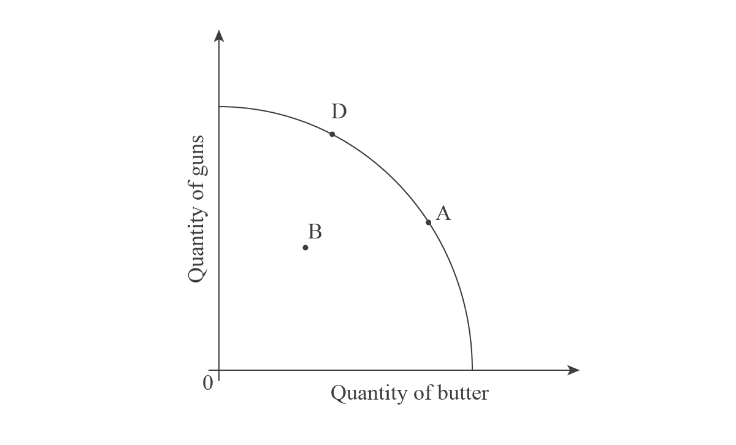
In the above graph, A represents full employment of the economy’s resources, meaning all resources are fully utilised. B, however, represents where the economy is actually producing, or at a point below what’s possible. When an economy uses more of its resources and/or uses them more efficiently, it will realise an increase in actual growth from B to A. In this case, the economy can produce more guns and butter, rather than experiencing a trade-off between the two products such as from A to D.
Potential growth is when there is an increase in the quality or quantity of any resource. For example, advancements in technology have increased the productivity of labour in agriculture immensely. In the developed world, a few people can cultivate huge areas of land because of the advancements in machinery. This causes a change in potential output, as illustrated below:
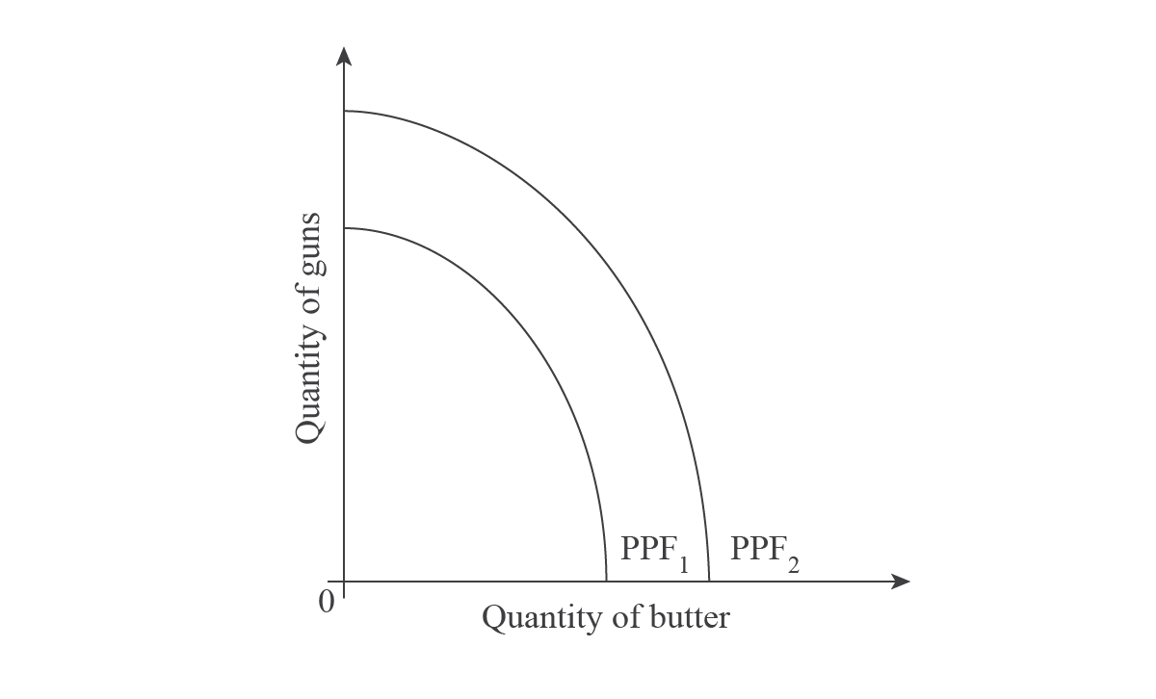
A change in quality or quantity of resources causes the PPF to shift from PPF₁ to PPF₂. In this case, the economy can produce more of both guns and butter without a trade-off between the two.
Teacher comment
Do you think you’re done with this question? It does ask you to use the PPF to explain actual and potential growth and that’s been covered. But why do you think this foundational question is in the macro section? Can you see the connection of the PPF to macro?
Answer: LRAS!
The outward shift of the PPF represents the same thing that the New Classical economists graph as an outward shift of LRAS. Since LRAS represents the full employment level of output, which is what the PPF represents, an outward shift of PPF as in the above graph is the same as the outward shift of LRAS from LRAS1 to LRAS2 in the graph below:
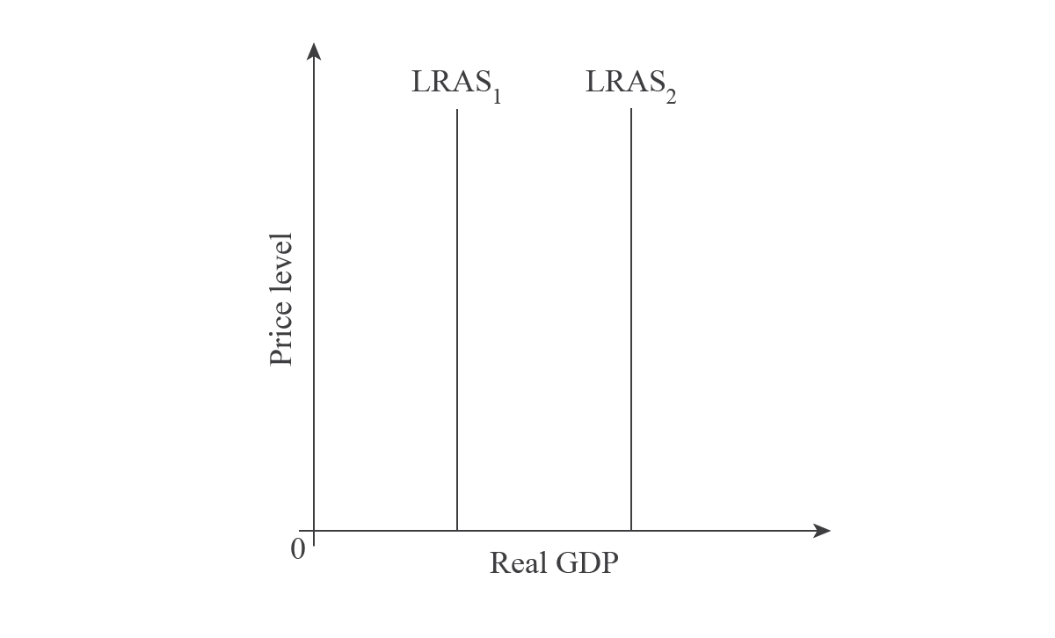
Like the PPF, the shift is caused by changes in the quality and/or quantity of resources.
Teacher comment
Now your answer is finished and it should score very well!

(b) HL only: 'There is always an inverse relationship between the unemployment rate and inflation.' Discuss. [15 marks]
Answers may include:
- Definition of unemployment.
- Definition of inflation.
- An explanation that there is an inverse relationship between inflation and unemployment when aggregate demand increases and decreases.
- A diagram illustrating the short-run Phillips curve.
- An explanation that the inverse relationship only holds when aggregate supply remains constant.
- An explanation of how short-run aggregate supply might decrease.
- A diagram showing short run aggregate supply decreasing.
- A diagram showing the long-run Philips curve.
- A discussion of the existence of price flexibility in markets.
Any reasonable discussion.
Level | Descriptors | Marks
0 | The work does not reach a standard described by the descriptors below. | 0
1 | There is little understanding of the specific demands of the question.  Relevant economic terms are not defined.  There is very little knowledge of relevant economic theory.  There are significant errors. | 1-5
2 | There is some understanding of the specific demands of the question.  Some relevant economic terms are defined.  There is some knowledge of relevant economic theory.  There are some errors. | 6-9
3 | There is understanding of the specific demands of the question.  Relevant economic terms are defined.  Relevant economic theory is explained and applied.  Where appropriate, diagrams are included and applied.  Where appropriate, examples are used.  There is an attempt at synthesis or evaluation.  There are few errors. | 10-12
4 | There is clear understanding of the specific demands of the question.  Relevant economic terms are clearly defined.  Relevant economic theory is clearly explained and applied.  Where appropriate, diagrams are included and applied effectively.  Where appropriate, examples are used effectively.  There is evidence of appropriate synthesis or evaluation.  There are no significant errors. | 13-15

Example answer and teacher comments
Teacher comment
Whenever you have done something in (a) that relates to your answer in (b), you can refer to that part of (a) rather than repeating it. However, notice that this question asks about the unemployment rate, rather than unemployment! Be sure to read questions carefully!
The unemployment rate is the percentage of the labour force who are unemployed. Inflation is the sustained upward movement in the average level of prices. The Keynesians argue that there is an inverse relationship between them, because that is how they graph the macroeconomy, assuming the economy is in Range 2 of their AS curve, or a normal economy.
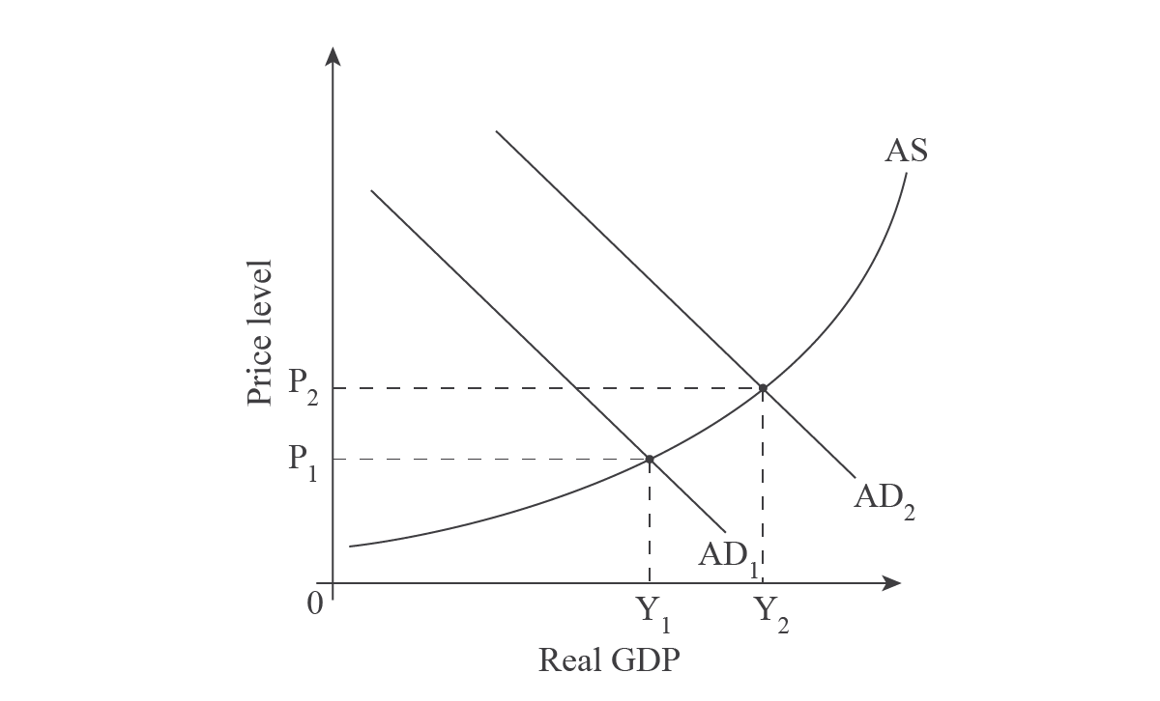
Teacher comment
There are numerous ways to label the axis on a macro graph. The vertical axis is always 'Price level', but the horizontal axis can be 'Real GDP', 'rGDP', 'Y' (income – meaning national income), or 'Output'.
As illustrated on the above graph, the economy is initially producing where AD₁ intersects AS, or at price level P₁ and an output of Y₁. When the economy grows, or AD shifts out to AD₂, the price level increases to P₂, representing inflationary pressure. This is a negative thing, because real incomes (or purchasing/buying power) decreases. However, national income has increased from Y₁ to Y₂, meaning there is greater output in the economy. This is a positive thing because to produce more, firms will require more resources, including labour, causing a decrease in unemployment. This is why Keynesians argue there is a negative or inverse relationship between inflation and unemployment.
The relationship is illustrated by a Phillips curve. Based on a study of the relationship between the inflation and unemployment rates in which lots of data was collected from industrialised countries, Phillips concluded the following graph.
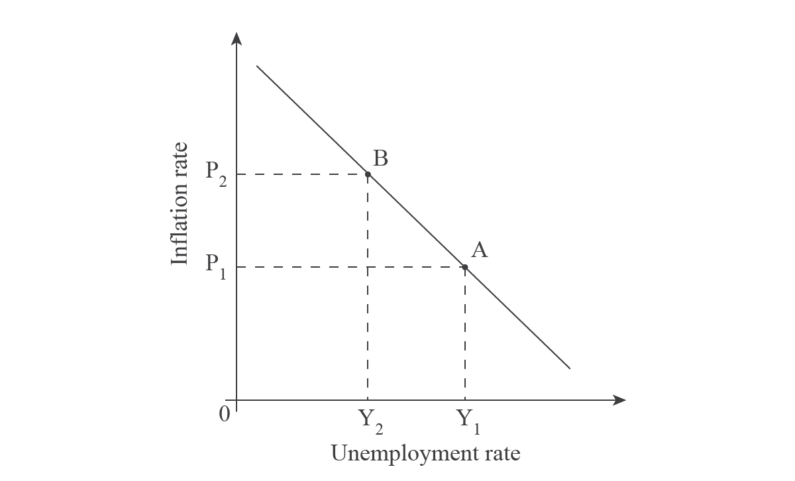
When AD shifts out, as in the Keynesian graph above, there is movement along the Phillips ccurve from A to B. Inflation increases, but unemployment decreases: an inverse relationship.
Although the theory seemed to make sense for some decades, it was called into question in the early 1970s when stagflation began in many Western nations. The economy had both high unemployment and high inflation, which, according to the Keynesian theory, couldn’t happen.
Most economists believe that the theory didn’t hold true anymore because of the oil crisis, or OPEC’s tightening of the S of oil, which led to huge increases in the P of oil. Since oil is a pervasive resource, this caused a S-side shock, or a shift in of SRAS. Since the Keynesian theory focuses solely on D-management, or AD, their theory couldn’t account for this change.
The Phillips curve theory was then revised and now includes the ability of the SR Phillips Curve to shift and a LR Phillips curve, as illustrated below.
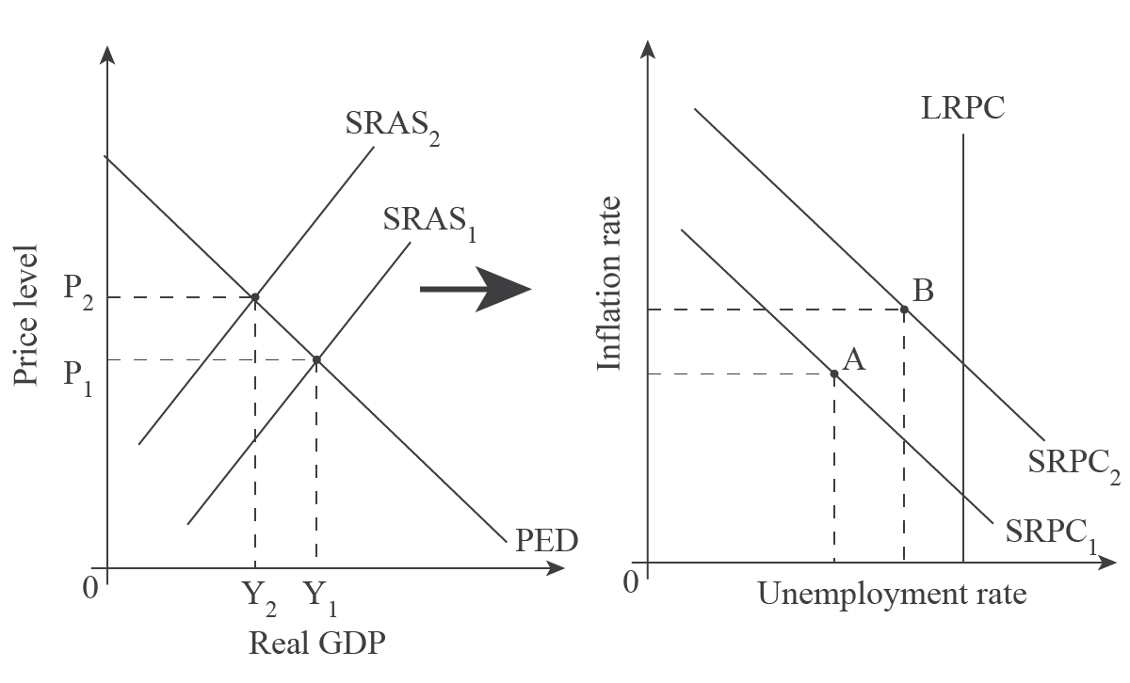
The oil crisis caused SRAS to shift in from SRAS₁ to SRAS₂, thereby increasing inflation and unemployment. The Phillips theory argued that the SR Phillips curve then shifts out, allowing both unemployment and inflation to increase (from A to B). In addition, they added the theory of a long-run Phillips curve, LRPC, which represents capacity, like the New Classical theory of LRAS.
Since the new Phillips curve theory represents a mixture of New Classical and Keynesian theories, it has caused questioning of the validity of the Phillips curve and Keynesian theory.
Teacher comment
This theory isn’t one of the bigger topics in macro and is very complex. If you can explain this much depth about the Phillips curve, then it’s a good choice. But if you can’t, this probably isn’t the best question to choose.

