The Japanese Earthquake March 2011
The 8.9-magnitude earthquake, on Friday 11th March at 2.46pm, was the largest ever recorded in Japan and one of the largest in the world. The quake struck at a depth of 6 miles, about 80 miles off the eastern coast in an area 240 miles northeast of Tokyo.
The chart below shows the seismograph reading for the quake. Place each of the events at appropriate places on the seismograph.
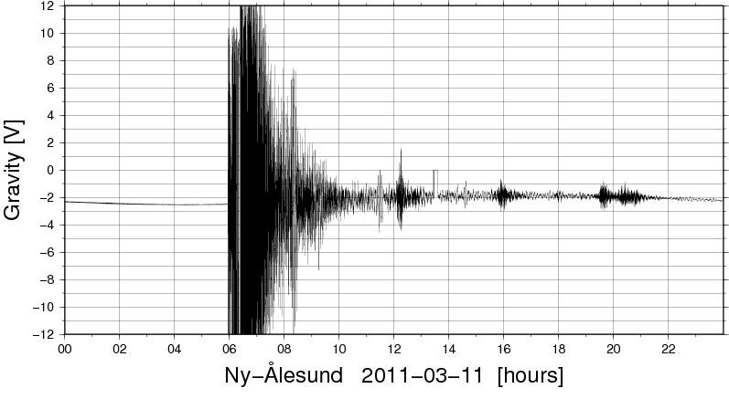
- Aftershock of 6.0 on the Richter scale occurs
- Dawn reveals miles of highways destroyed by the tsunami
- Tsunami Warning Centre issues a warning for the Pacific Ocean from Japan to the US
- Several thousand people living within a mile and a half of the Fukushima power plant are evacuated
- Within an hour after the quake a wall of water 30 feet high washes over the Japanese coast
- Cooling system at the Fukushima nuclear plant are reported to be not working
- Casualty reports start to come in
- 25 countries offer aid and assistance
- Stores begin to run out of food, water and gasoline
- Japanese government declares emergency for nuclear power plant
- Thousands of Japanese people travel south away from their earthquake stricken homes
- Rescuers struggle to pull survivors from collapsed buildings
- Radiation starts to leak from the power plant
- Death toll put at 427
- Lots of small aftershocks are felt

