Living graph: Hurricane Harvey

- Cut out these statements
- Put them into the order you think they occurred in
- Place them on the living graph to reflect the emotion that may have been felt at this time
- Add your own hurricane Harvey experiences and emotions to the living graph

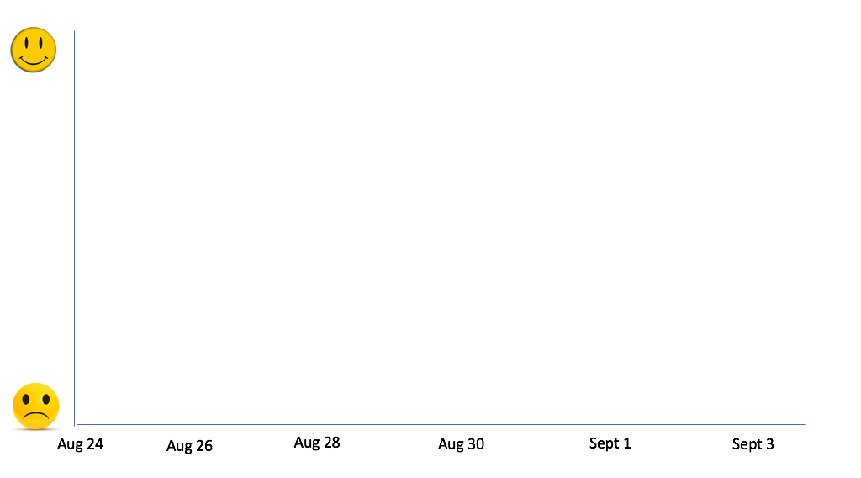

Mr. Derry informs the school community that the school will close | A tropical depression develops in the Atlantic | Flood maps are released by Harris county flood department which shows the houses that will flood because of the release of the Barker reservoir- Mrs. Bennett’s house is predicted to flood because of its elevation
Mrs. Bennett was due to go and watch Coldplay at the NRG – it was postponed due to the forecasted hurricane | Many people go to local stores to buy bottled water, food and other supplies- many shops are empty! | Hurricane Harvey hits Rockport as category 4 hurricane
News reports highlight that Hurricane Harvey is predicted to be a major disaster | The emergency alerts buzz on the phone all day warning of tornadoes in the area and warning people to take shelter | Heavy rains hit in Houston. Downtown Houston is flooded
News reports show that the Barker and Addicks reservoir will not hold the amount of water that is predicted to enter them because of the storm. They are going to start releasing water from them. | News reports show many people being rescued from the roofs of their houses and the devastation across the city | Many houses in Mrs. Bennett’s street start to flood and we see people having to evacuate. The water is half way up our driveway
We return back to school after being off for 10 days. | A police car with a loud speaker comes around Mrs. Bennett’s neighborhood saying we have to evacuate because of the flooding that will happen | The sun comes out after 5 days of rain.
The sun coming out means that the weather forecasters change their projections of the houses that will flood. Mrs. Bennett’s house will be OK! | Deer and snakes are all around Mrs. Bennett’s neighborhood. | Helicopters and boats are all over Cinco Ranch helping to evacuate people from their flooded homes.

