Water cycle key terms

Precipitation |  | When water vapour cools and turns into clouds
Condensation | 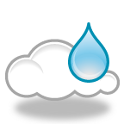 | Rain, hail, sleet and snow that falls from the clouds
Evaporation | 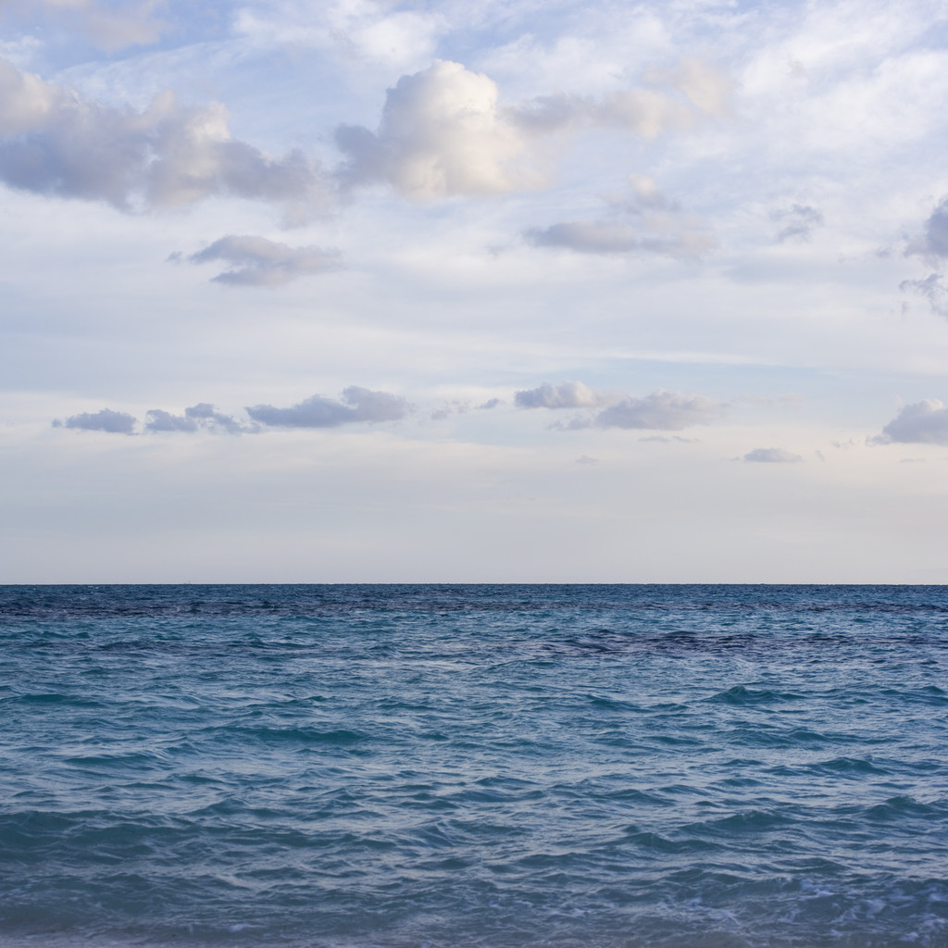 | When the sun heats up water from the leaves of trees.
Groundwater flow | 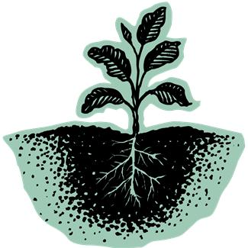 | When the water runs off the surface of the ground.
Surface run-off | 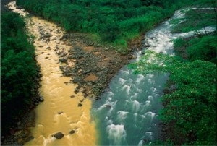 | When water flows through the rocks and soil underground.
Transpiration | 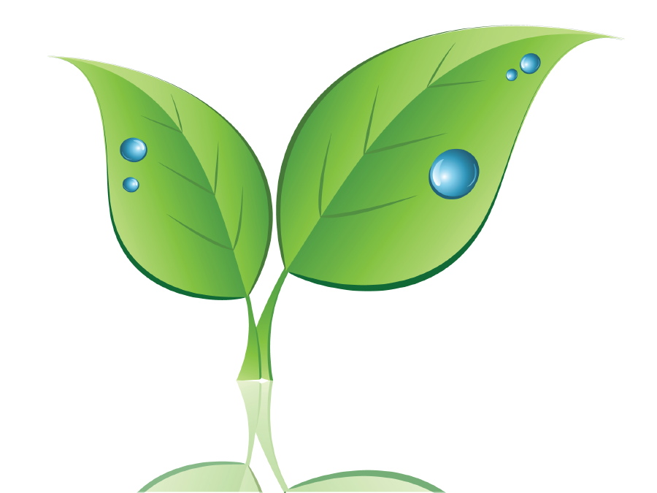 | When the sun heats up water from the sea and it goes into the air.

Water cycle key terms
Precipitation |  | When water vapour cools and turns into clouds
Condensation |  | Rain, hail, sleet and snow that falls from the clouds
Evaporation |  | When the sun heats up water from the leaves of trees.
Groundwater flow |  | When the water runs off the surface of the ground.
Surface run-off |  | When water flows through the rocks and soil underground.
Transpiration |  | When the sun heats up water from the sea and it goes into the air.

Water cycle key terms

Precipitation
R________, hail, sleet and snow that falls from the clouds

Condensation
When water vapour cools and turns into c_______

Evaporation
When the sun h________ up water from the s______ and it goes into the air.

Groundwater flow
When water flows through the r________ and soil underground.

Surface run-off
When the water runs off the s__________ of the ground.

Tr________________
When the sun heats up water from the leaves of trees.
Key words

Transpiration clouds sea rain rocks heats surface

