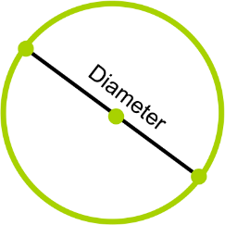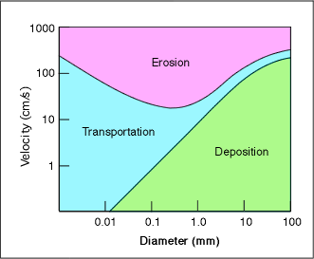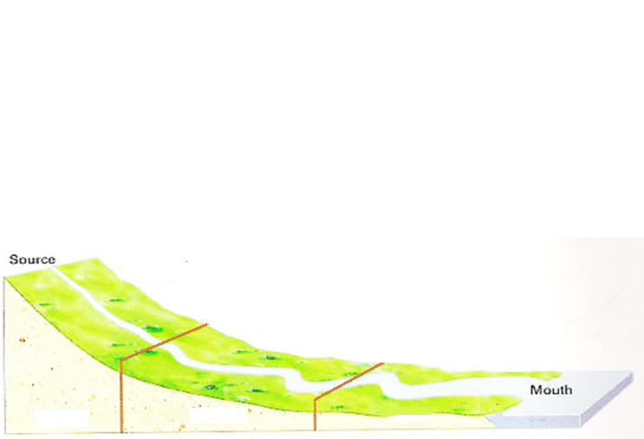

**Tr_________**

**Suspension**

**Solution**

**(Dissolved Load)**

**______________**

**Sa__________**

**Atr__________**

**___________**

**Hydraulic**

**Action**



**DEMONSTRATE**

**Label** the upper, lower and middle course of the river. **Identify** where fluvial processes occur. **Draw** a diagram of the fluvial processes in the course of the river they are likely to occur in.

**Fluvial Processes along the Course of a River**