|

**Changing Profile of a River and its Valley**

ACTIVATE

**Examine** the long and cross profiles of a river and its valley. Cut out the statements at the bottom of this page and glue them in the correct course of the river to **describe** the characteristics. Each box should have a statement about the valley and one about the channel.

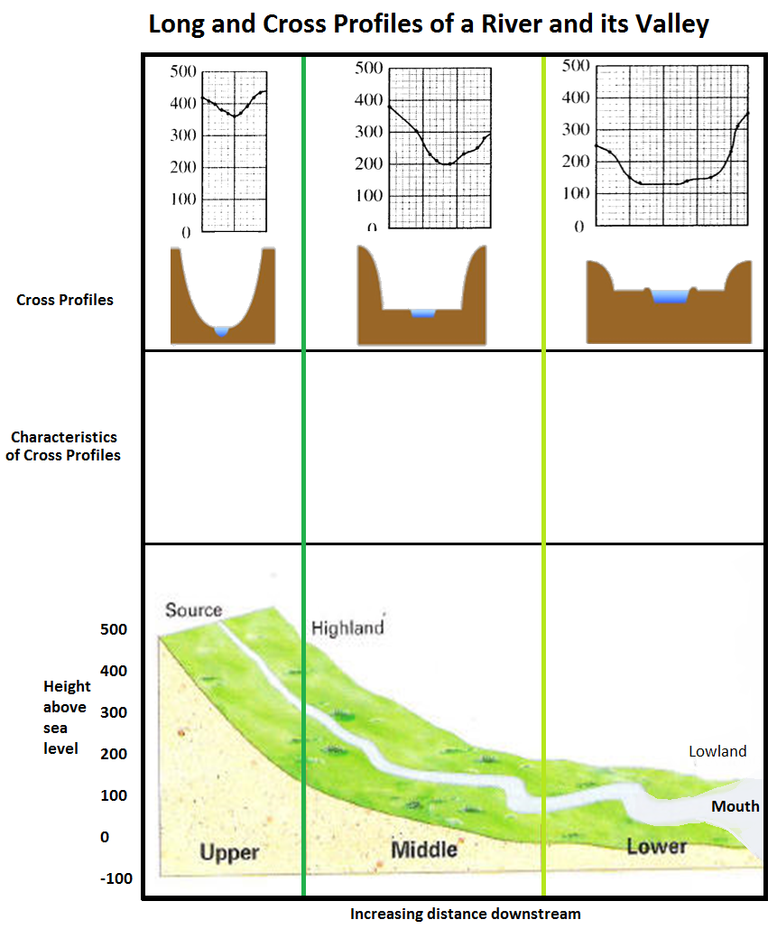

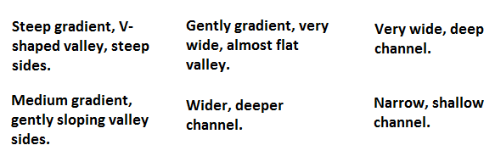

**Vertical erosion**

**Lateral erosion**

**Examine** the long and cross profiles of a river and its valley. Cut out the statements at the bottom of this page and glue them in the correct course of the river to **describe** the characteristics. Each box should have a statement about the valley and one about the channel.

ACTIVATE

**Changing Profile of a River and its Valley**





**Vertical erosion**

**Lateral erosion**