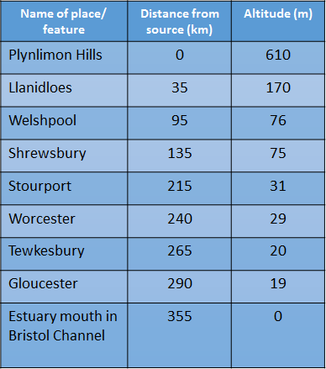

Upper

Middle

Lower

Use the data to **draw** a graph to show the long profile of a river.

DEMONSTRATE