Managed Retreat |  |  |  | Gabions
How does it work? |  |  |  | How do they work?
This doesn’t stop erosion it allows some coastal areas to erode and flood naturally. Usually this will be areas of low value like nature reserves or farmland. |  |  |  | Steel mesh cages filled with boulders to absorb wave energy. They are placed at the bottom of cliffs like a sea wall.
Cost |  | Millions |  | Cost |  |  | £50 000 per 100m
Environmental impact |  | 9/10 |  | Environmental impact |  |  | 5/10
These retain the natural coastal environment. They create wetlands habitats for wildlife. |  |  |  | These don’t look lovely but they actually blend in very well after a few years as grasses and plants start to grow on top of them creating new habitats.
Appearance | 10/10 |  |  | Appearance | 2/10
This creates a beautiful natural environment. |  |  |  | They are ugly and don’t look natural for years until vegetation covers them.
Life span |  |  | Forever | Life Span |  | 5-10 years
Issues  This is often unpopular as much of the land |  |  |  | Issues  The cages can be sharp so tourists who
flooded is rural and attractive so popular for walking, bird watching etc. |  |  |  | People that walk on them can hurt themselves.
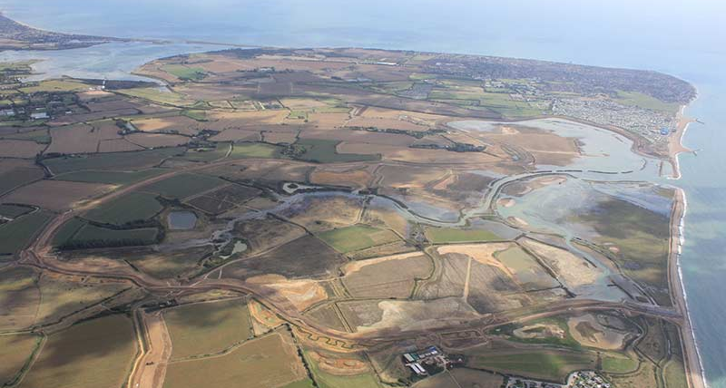 |  |  |  | 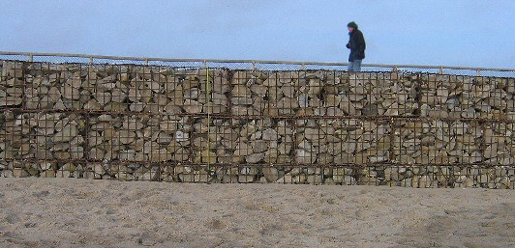

Dune Stabilising |  |  |  | Beach Nourishment
How does it work? |  |  |  | How does it work?
Dunes are a natural defence against wave energy. The roots of plants like couch grass bind the sand. By planting these and keeping tourists and grazing animals away, the dunes can develop. |  |  |  | Sand is added to the beach to replace sand washed away. The beach them absorbs the wave energy protecting the cliffs. The sand needs to be replaced regularly.
Cost |  | £200 - £2000 per metre |  | Cost |  |  | £3-£10 per metre
Environmental Impact |  | 10/10 |  | Environmental Impact |  |  | 8/10
These defence the natural environment |  |  |  | Collecting sand from the sea bed can kill organisms like sponges and corals.
Appearance | 9/10 |  |  | Appearance | 9/10
These don’t look like a defence method other than fencing and signage |  |  |  | Other than when the sand is being collected or replaced this look natural and creates a wide open beach
Life Span |  |  | Forever (if maintained) | Life Span |  | Up to 5 years
Issues |  |  |  | Issues
The fencing and planting can be time consuming and the dunes will never be as strong as a man-made defence |  |  |  | This needs constant upkeep and as a result is only really suitable for tourist areas.
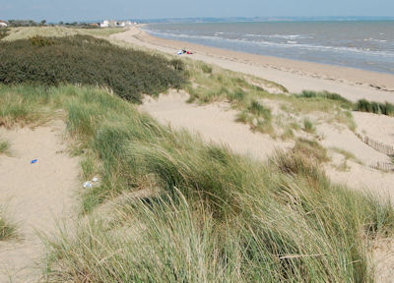 |  |  |  | 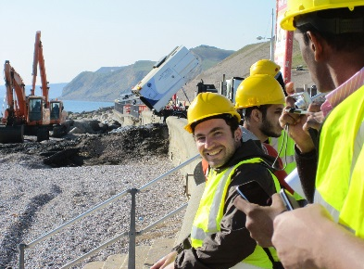

Groynes |  |  |  | Sea Wall |  |  |  | Rip Rap / Rock Armour
How do they work?  These fences are placed at right angles to |  |  |  | How do they work?  Concrete walls built to protect towns. They |  |  |  | How does it work?  Large boulders piled on the beach absorb the
These fences are placed at right angles to the beach to trap sand being moved by longshore drift. This creates a wider beach to absorb the waves energy. |  |  |  | Concrete walls built to protect towns. They absorb the wave energy and protect the cliffs behind. They often have a curved top to reflect the waves back out to sea. |  |  |  | Large boulders piled on the beach absorb the wave energy so reducing erosion of the beach or cliff. They can be moved if needed.
Cost |  | £150 000 each every 200m |  | Cost |  | £5000 – £10 000 per metre |  | Cost |  | £200 000 per 100m
Environmental impact | 5/10 |  |  | Environmental impact |  | 6/10 |  | Environmental impact |  | 8/10
They cause erosion down the coast to increase by trapping all of the sand. |  |  |  | They create an artificial environment and encourage tourism which can lead to litter. |  |  |  | Rock armour has minimal effect on wildlife; in some cases, it creates new habitats.
Appearance |  |  | 5/10 | Appearance | 5/10 |  |  | Appearance | 8/10
They make beaches look messy. |  |  |  | It can look obtrusive and unnatural. |  |  |  | These are one of the most natural looking defences.
Life Span |  |  | 25 years | Life Span |  |  | 100 years | Life Span |  | 100-500 years
Issues |  |  |  | Issues |  |  |  | Issues
They starve other beaches making them narrower so they offer less protection against erosion. |  |  |  | The walls can create a strong backwash which erodes under the wall. |  |  |  | They do lose marks for the environmental damage due to transportation.
 |  |  |  |  |  |  |  | 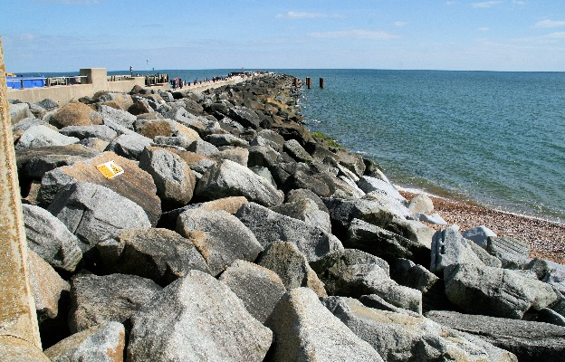
ff

